**The REV-10 Guide on How to Package Geiger Kits**

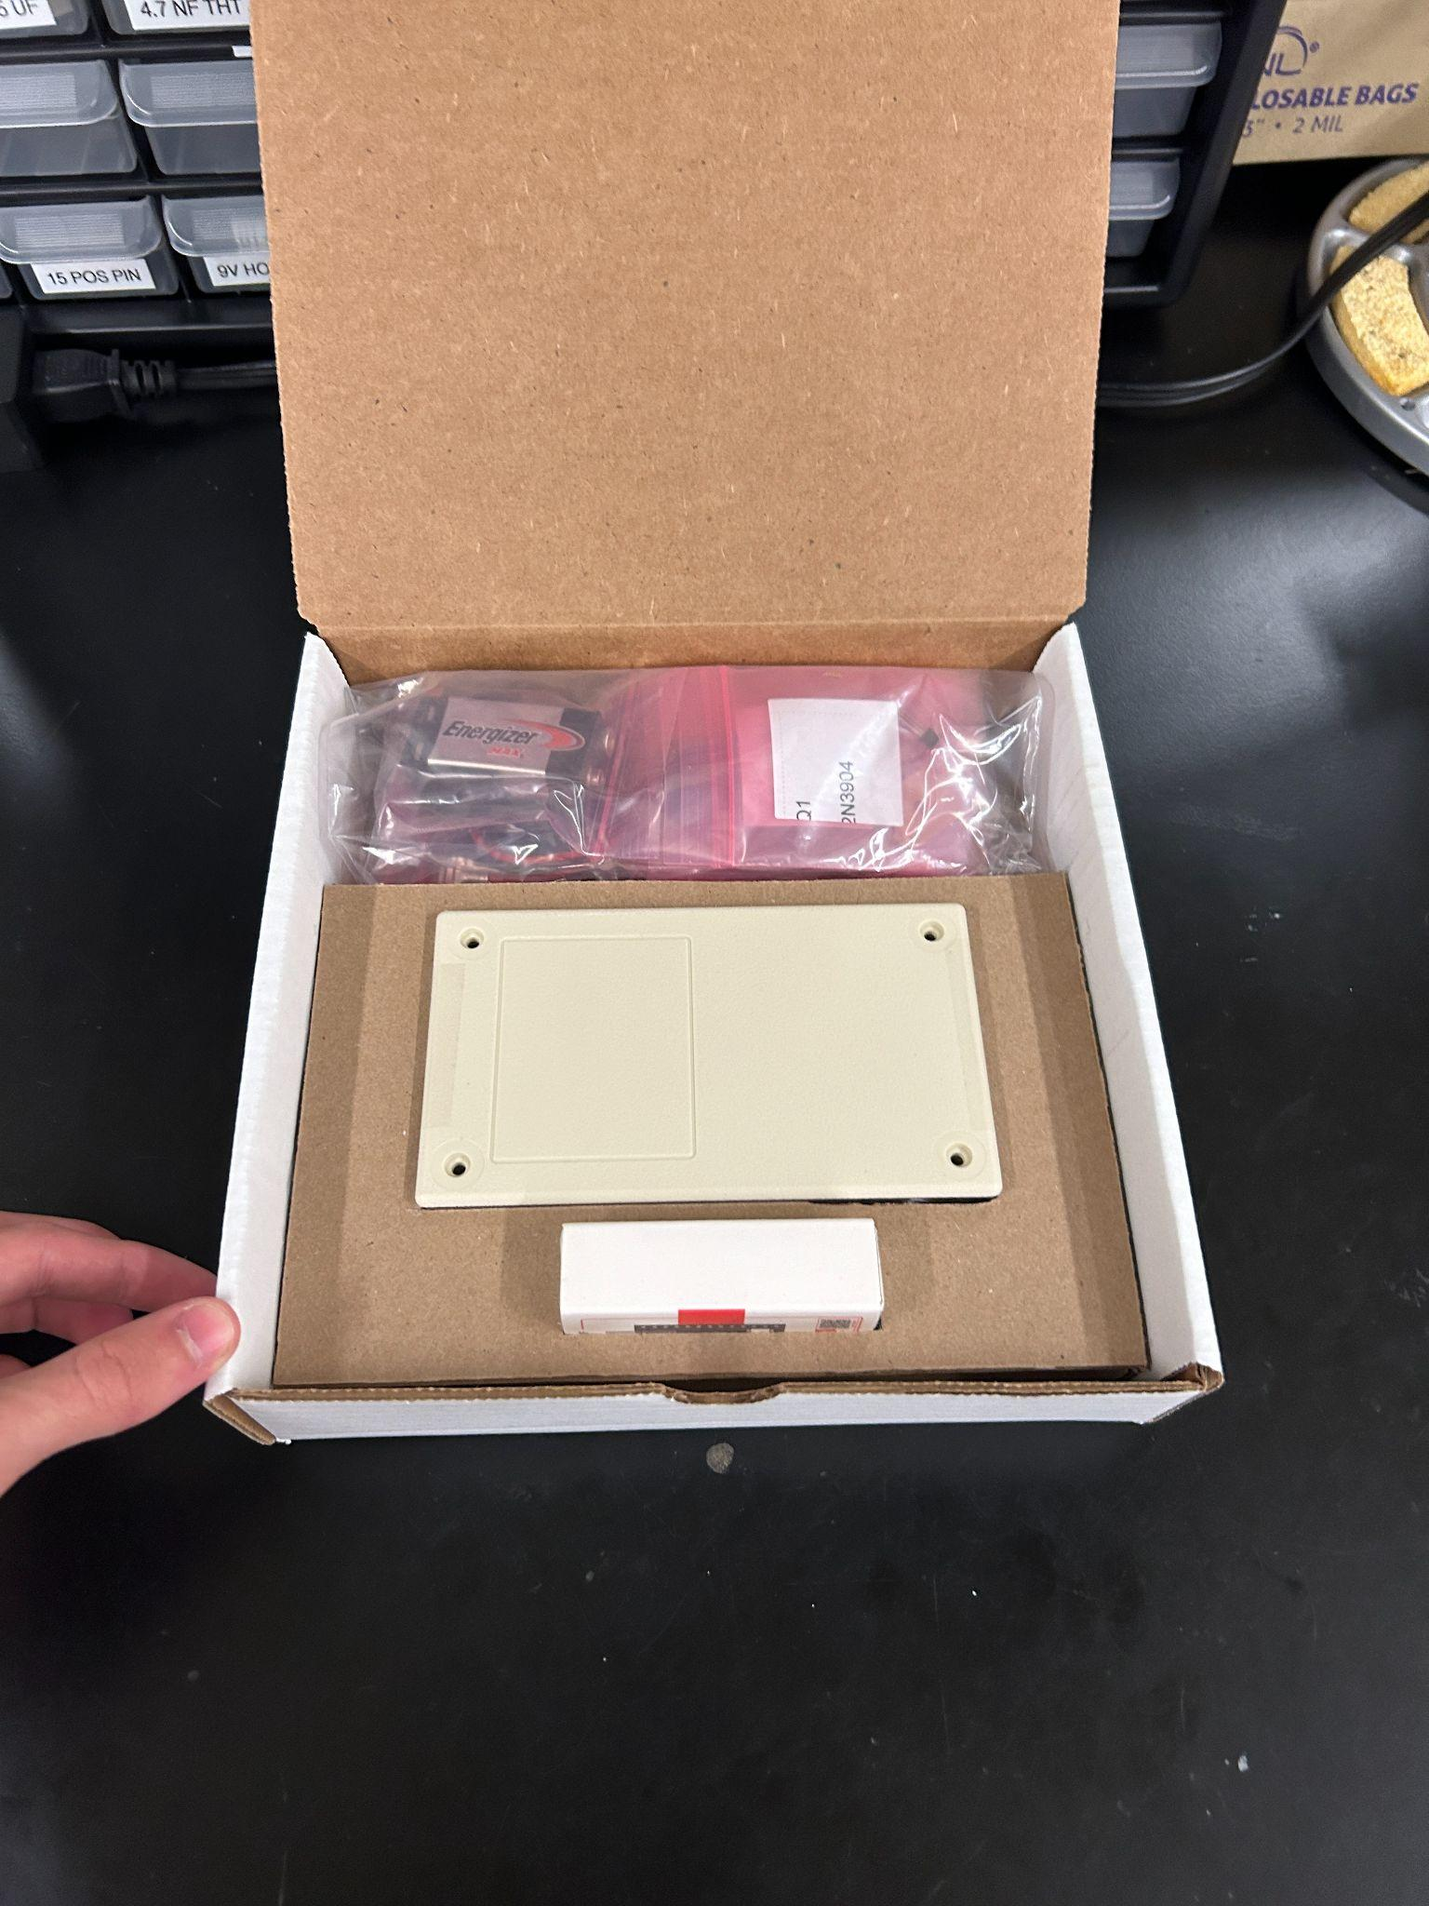

**Please read each step in full before performing it**

**Step 1:**

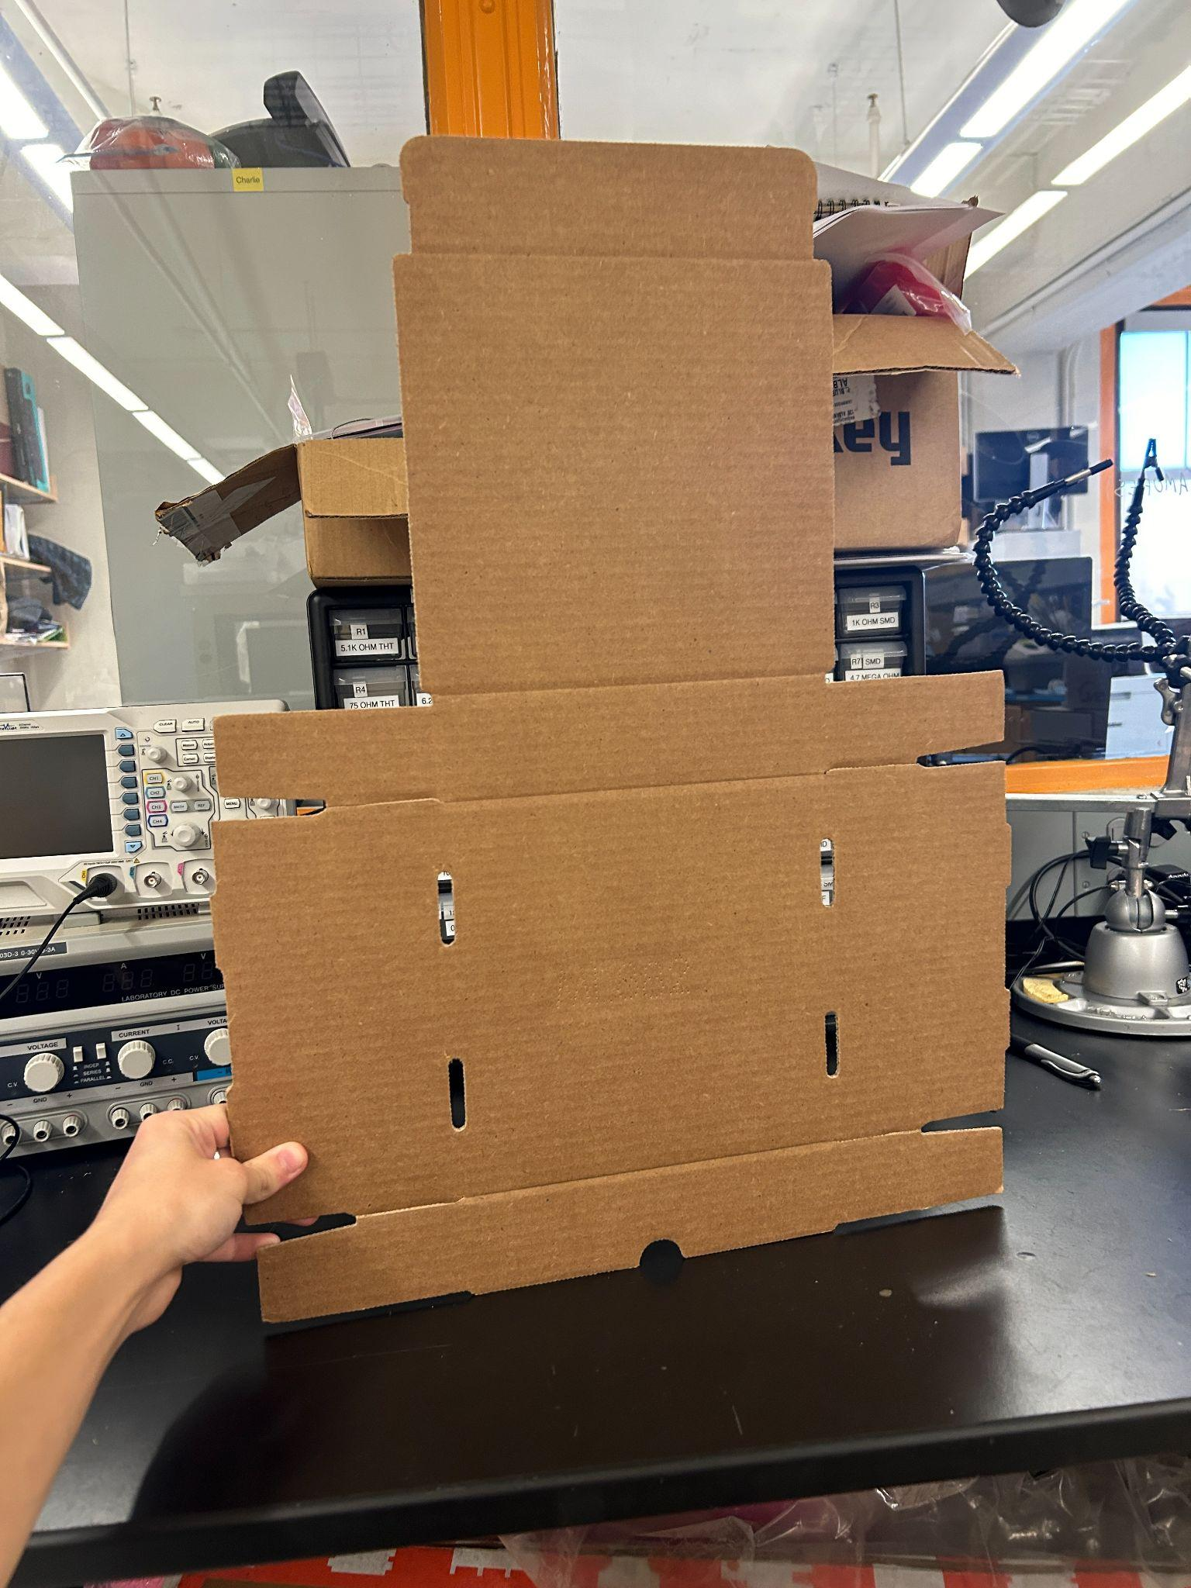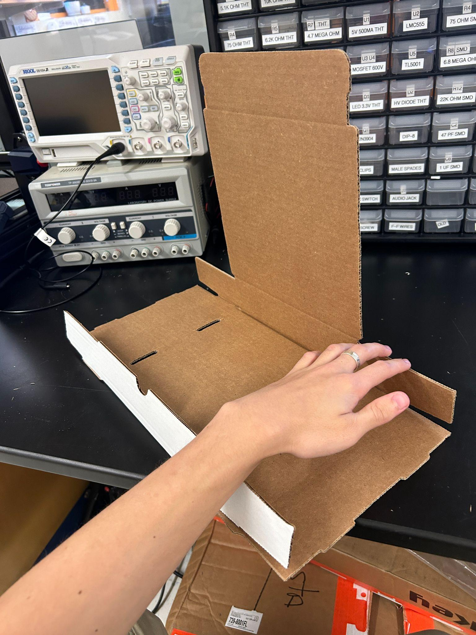

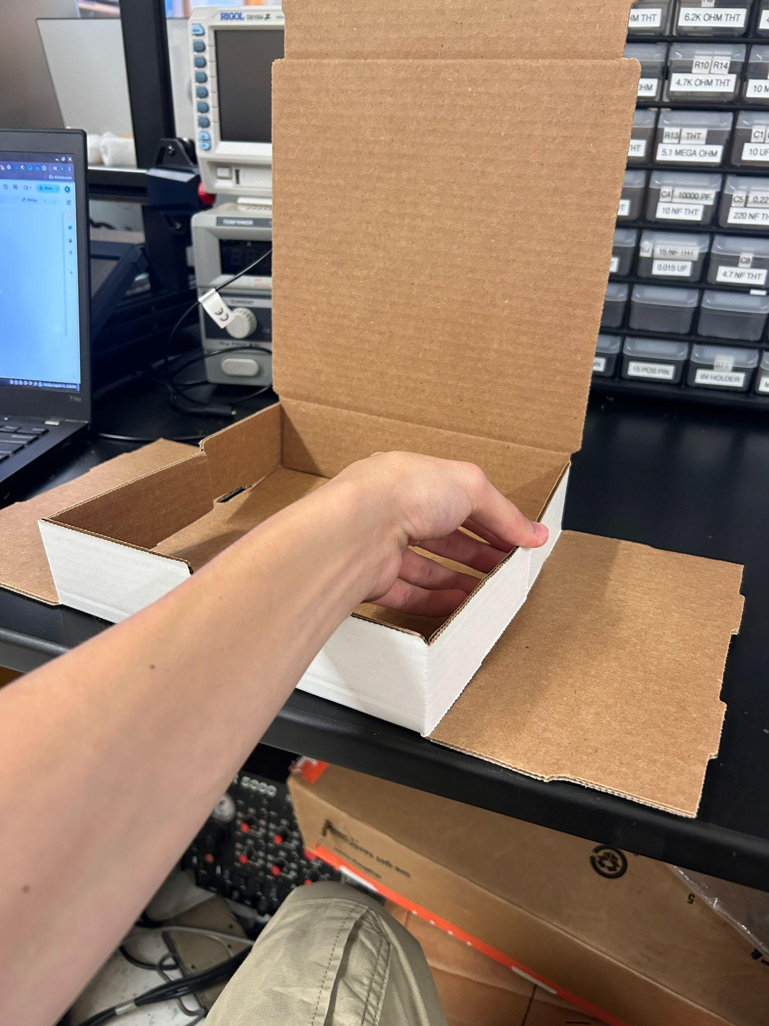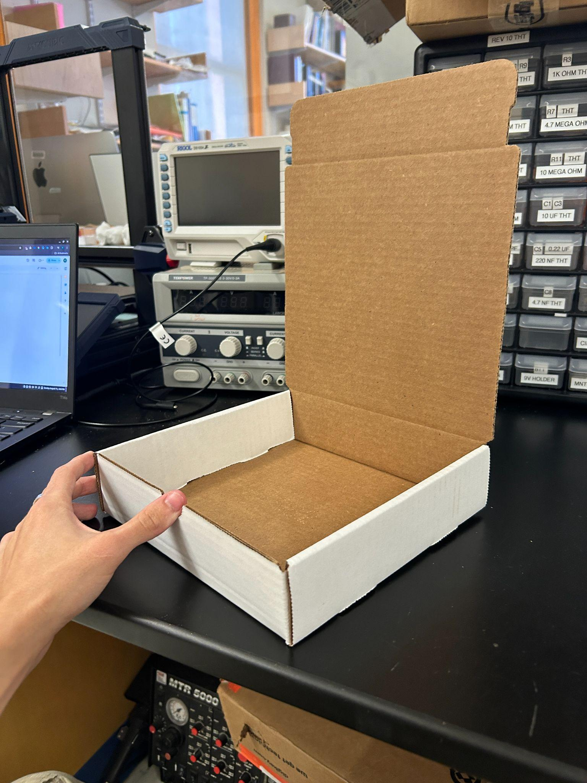

Fold the box

**Step 2:**

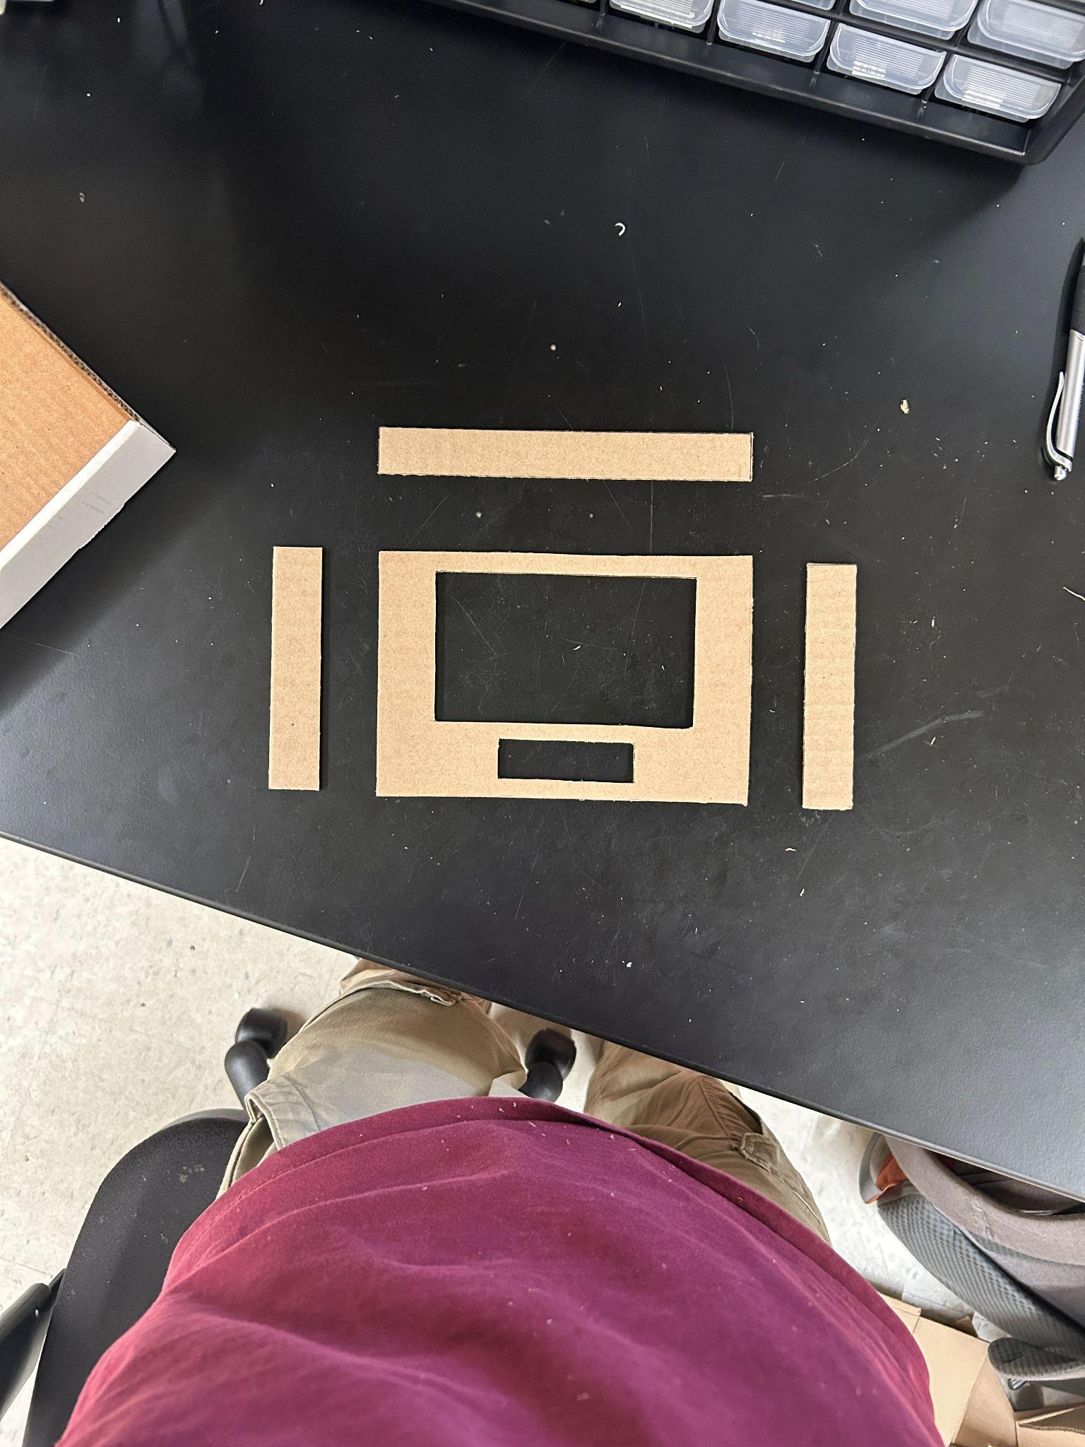

Laser cut the box insert, according to the DXF and/or engineering drawing / inkscape SVG of it.

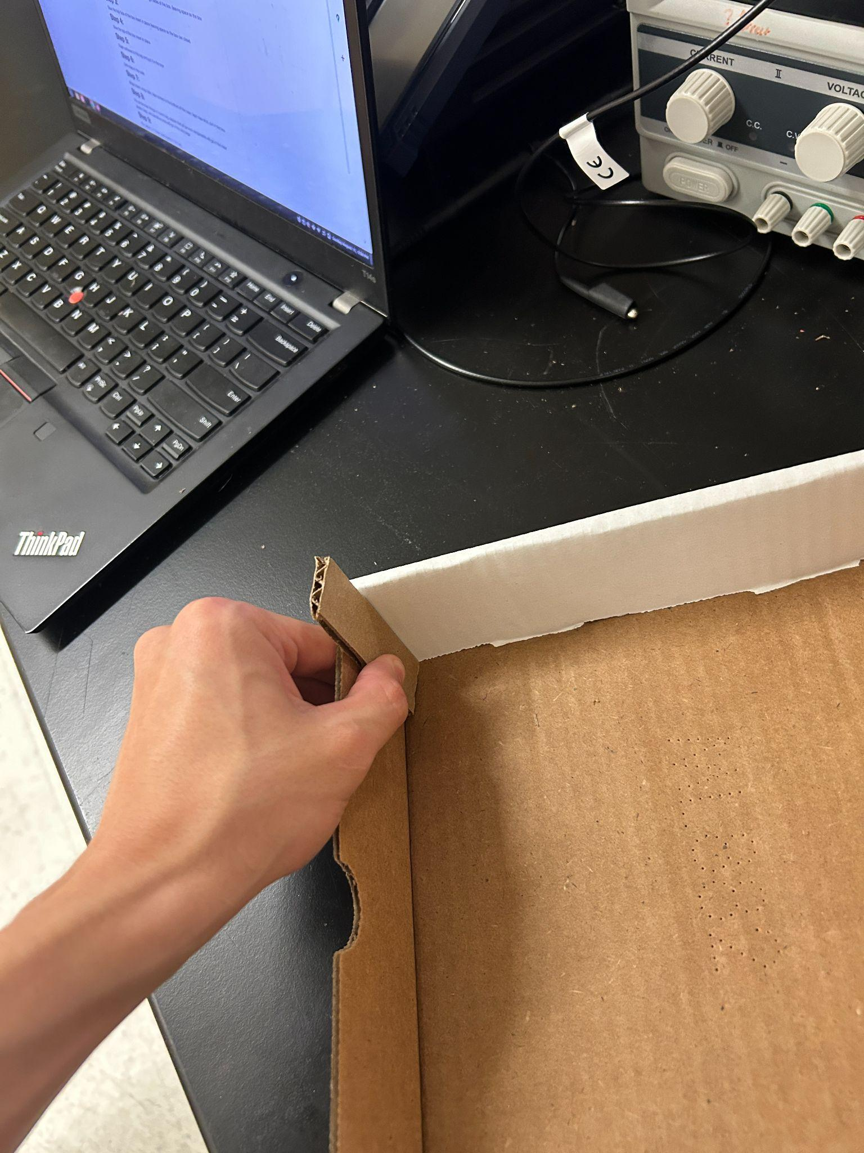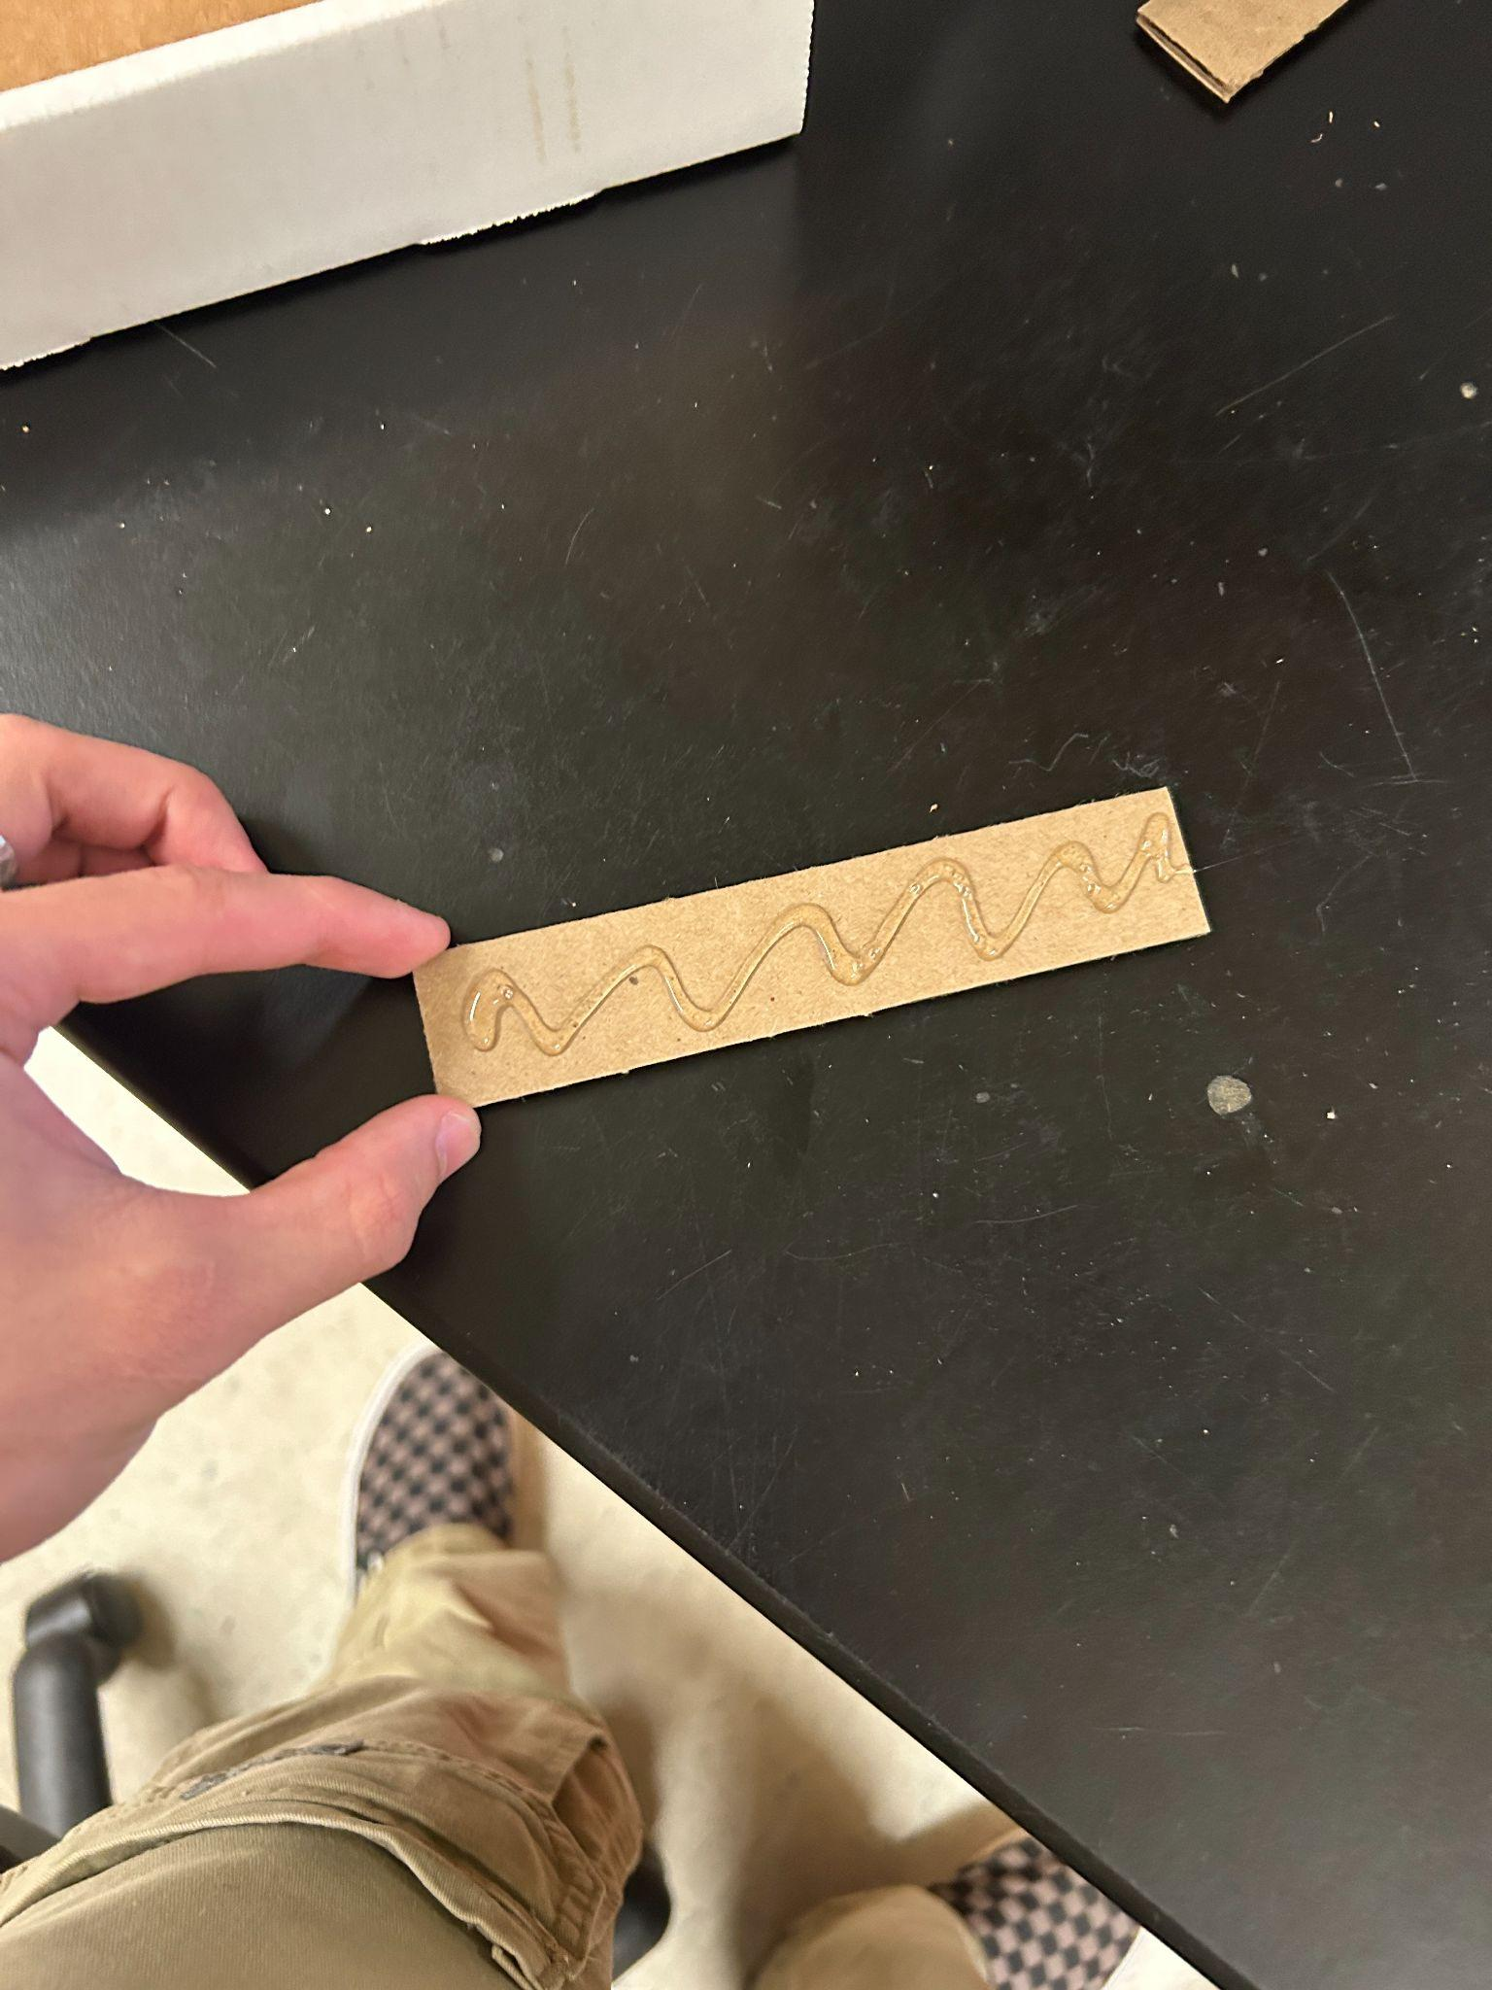

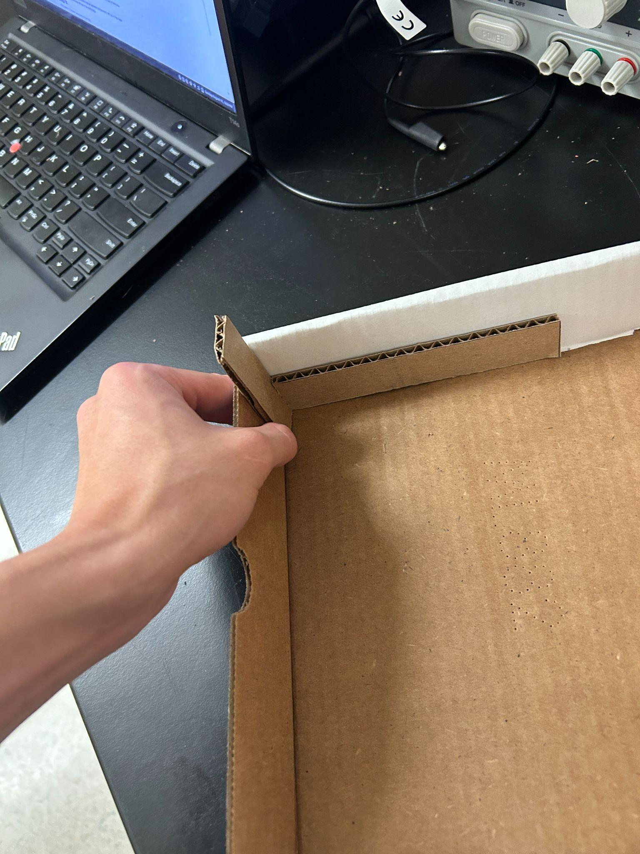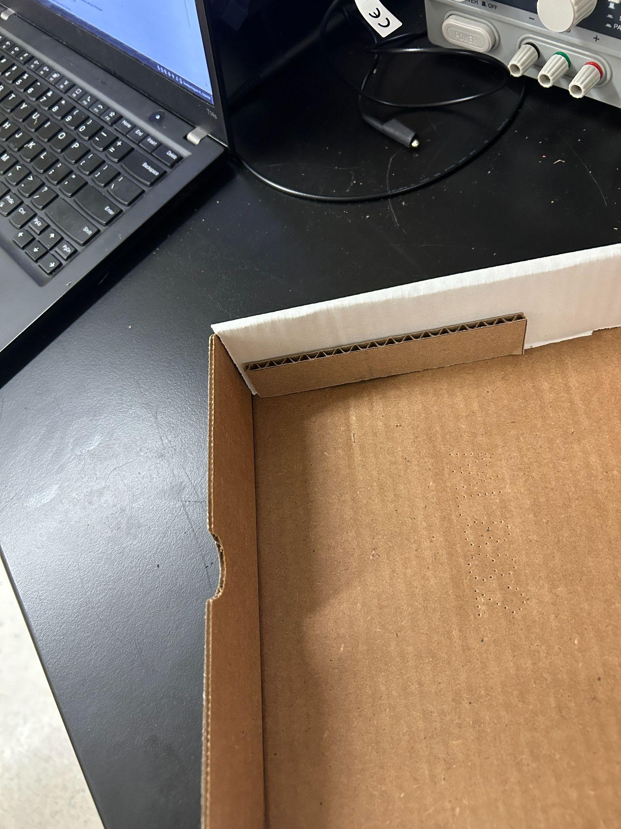

Place a temporary spacer in the box so when you glue the sides of the box insert, the top of the box can still close.

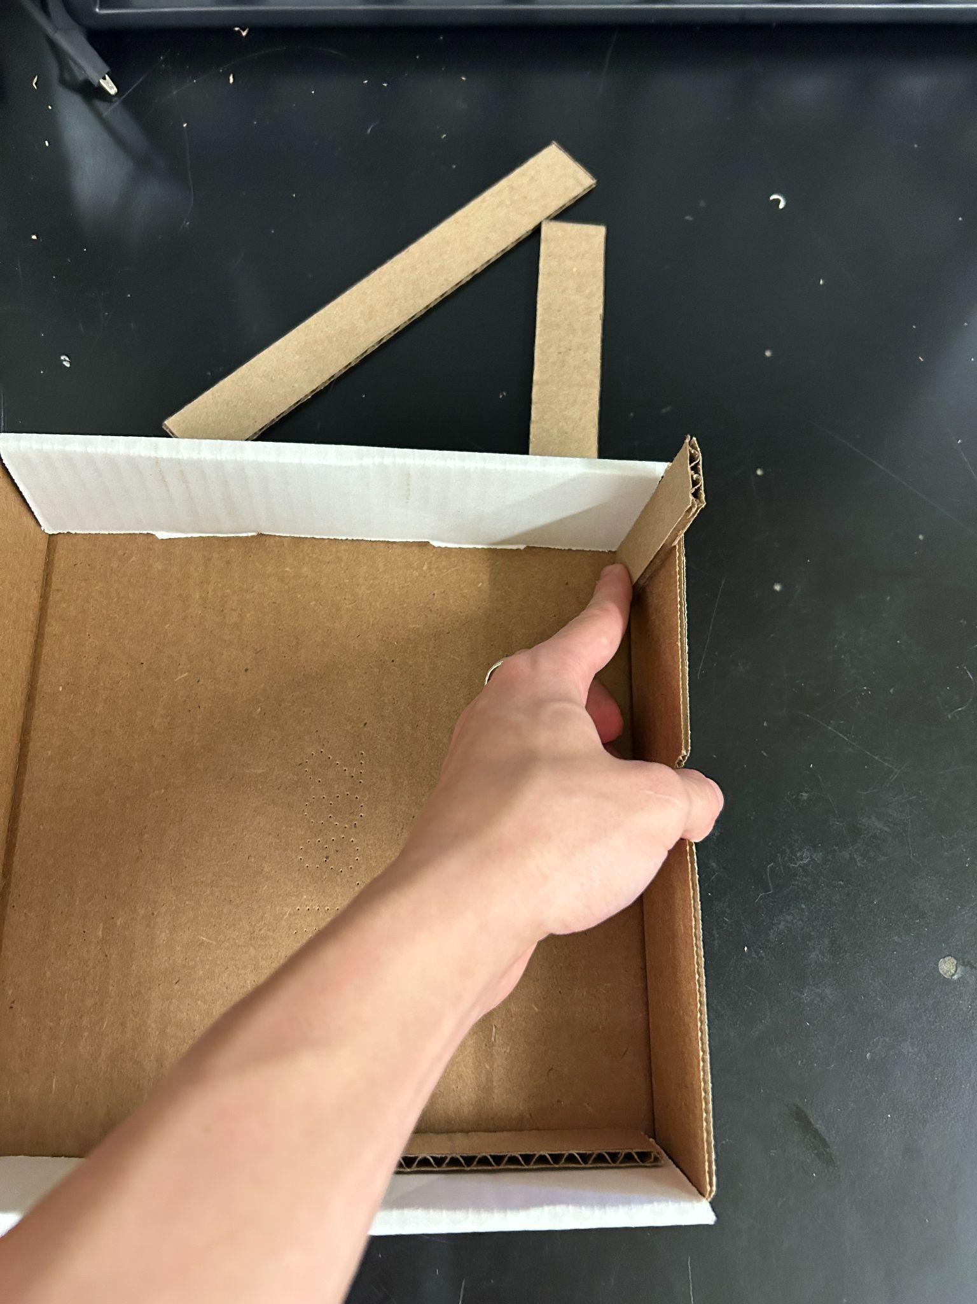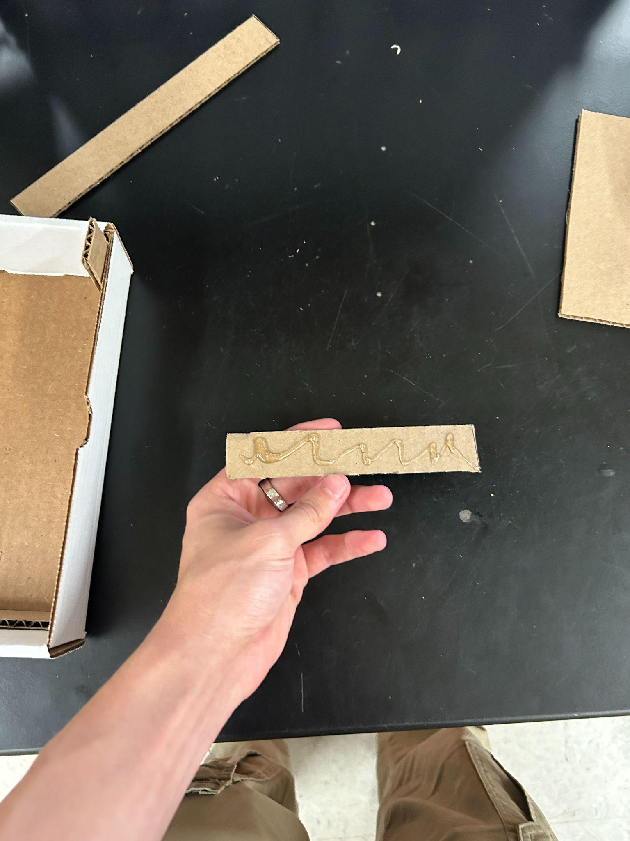

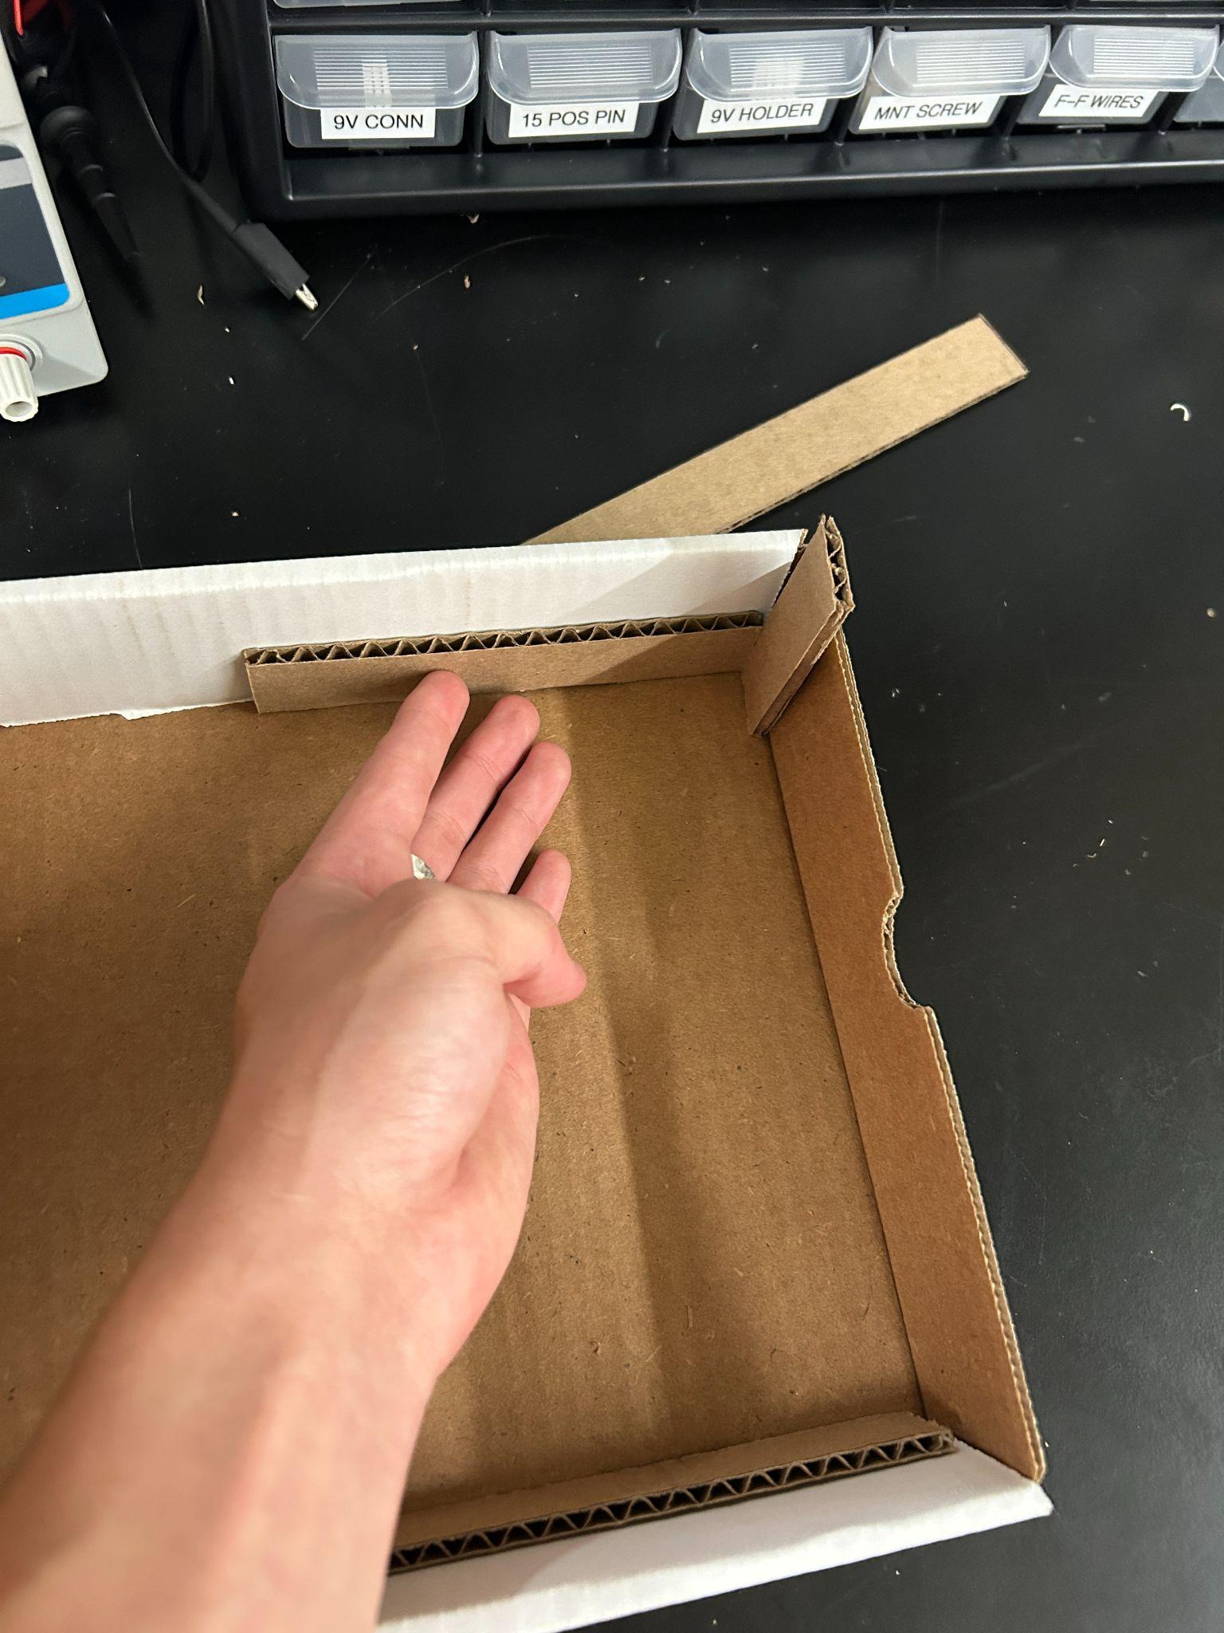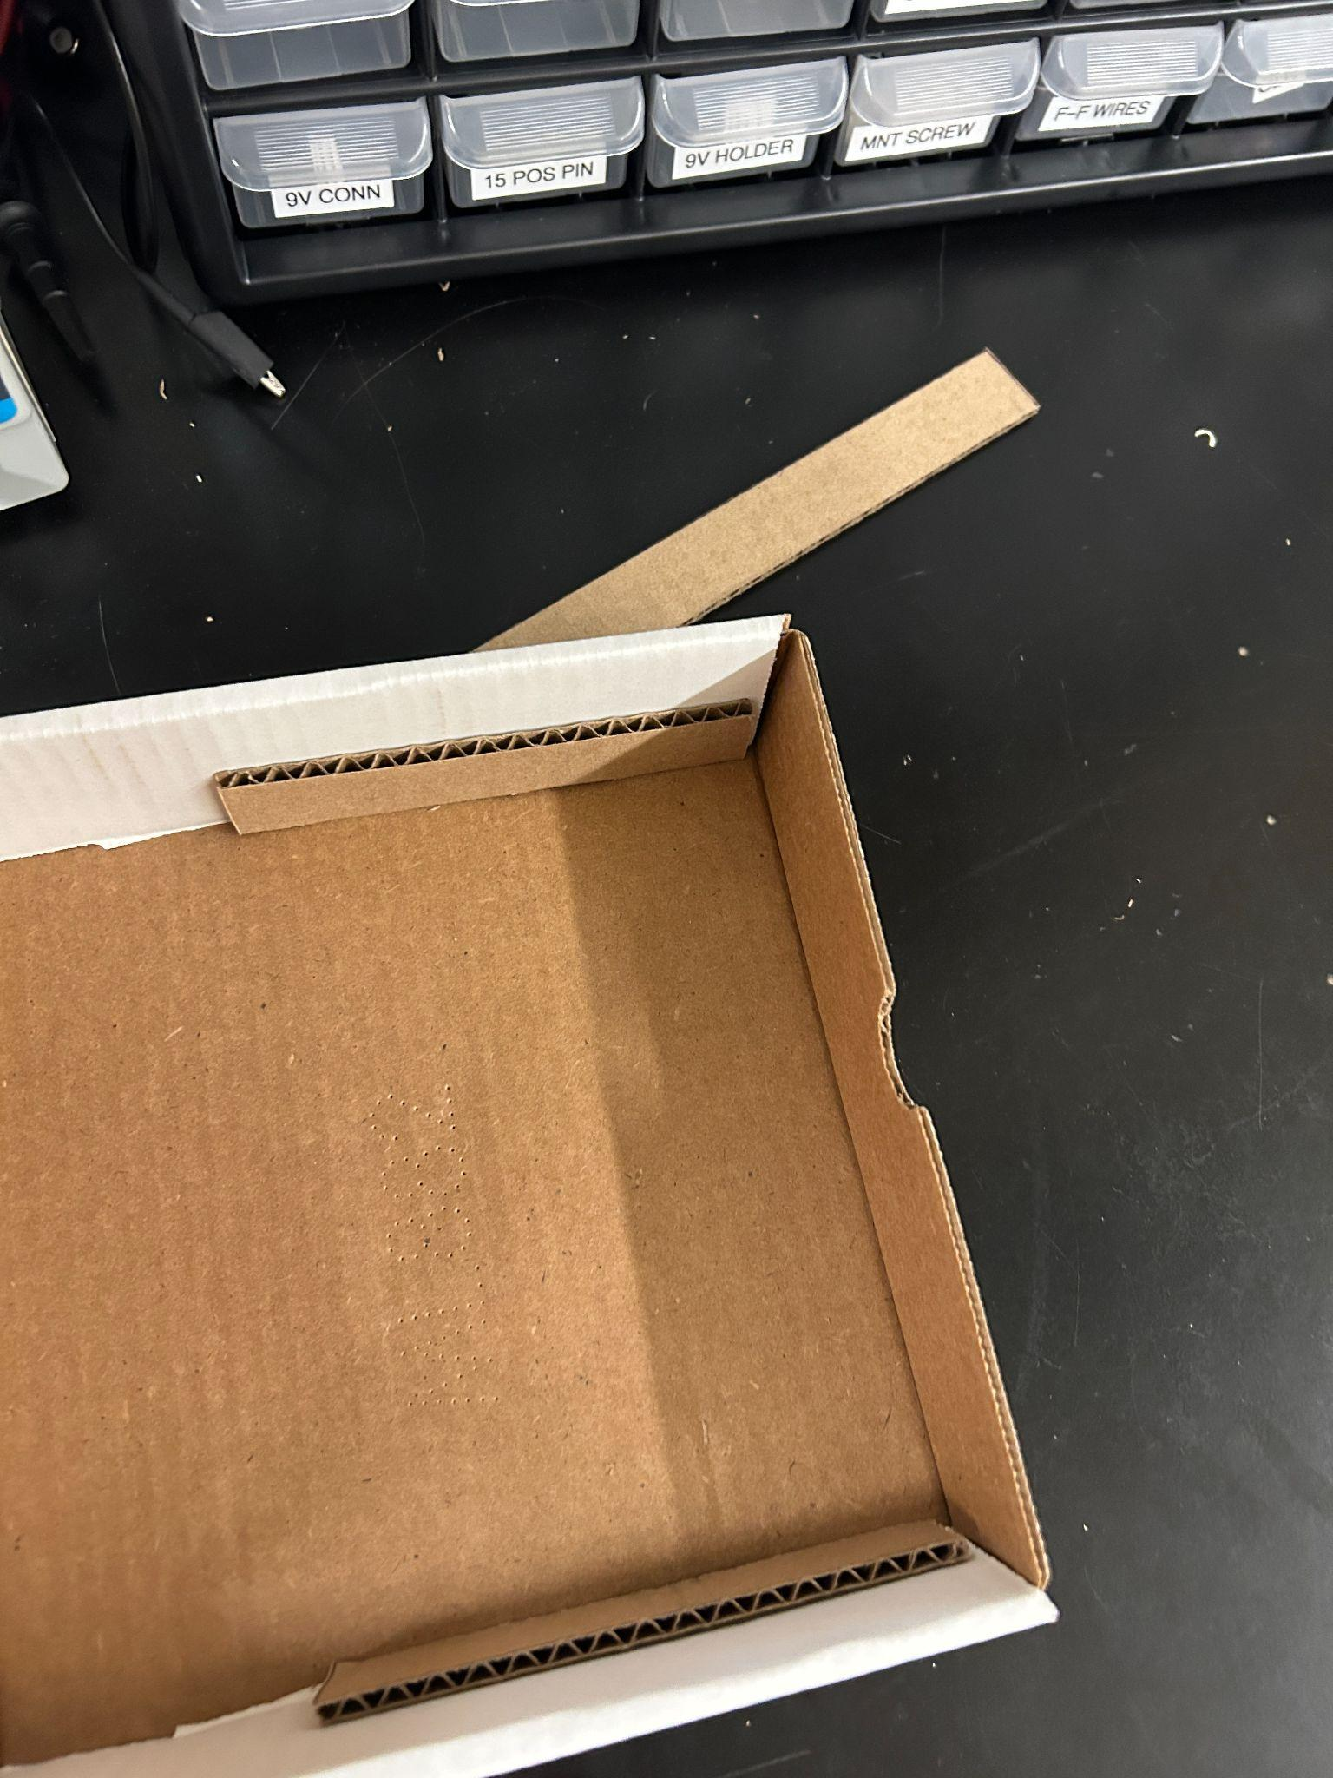

Repeat on the other side

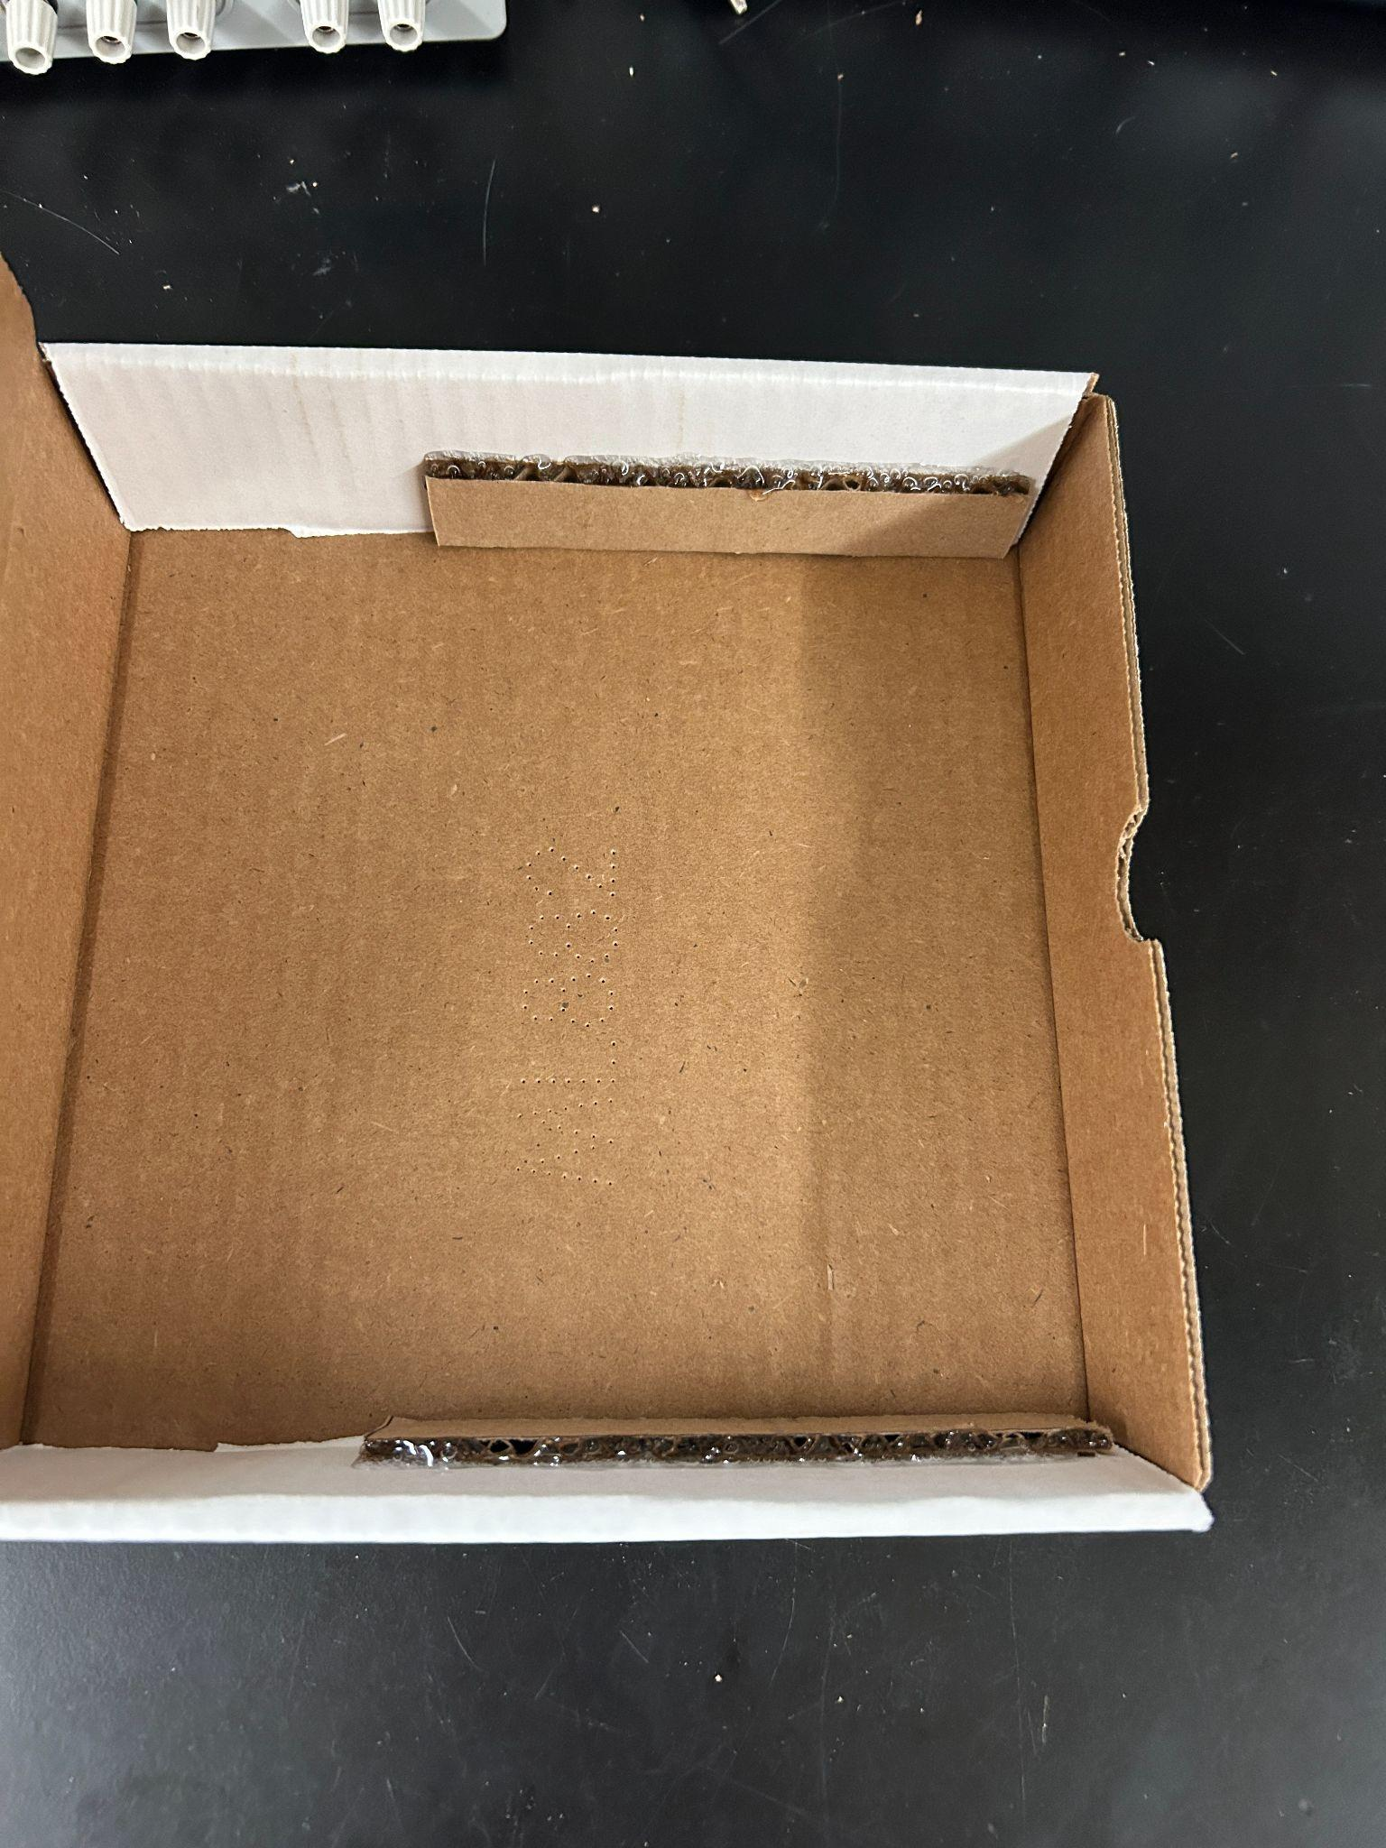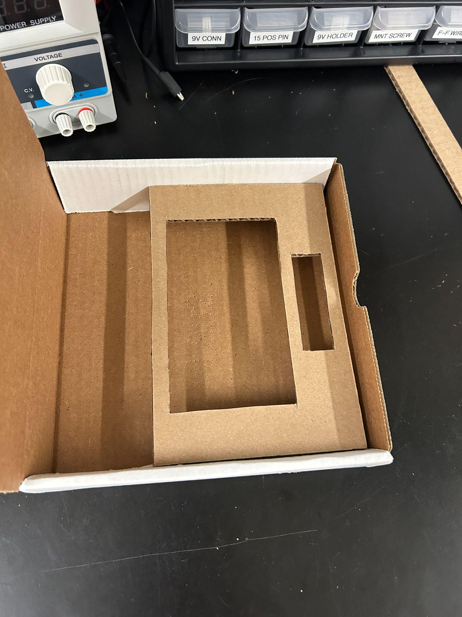

Put glue on the tops of the sides of the insert, and place the top of the insert over (still leaving space so the box can close)

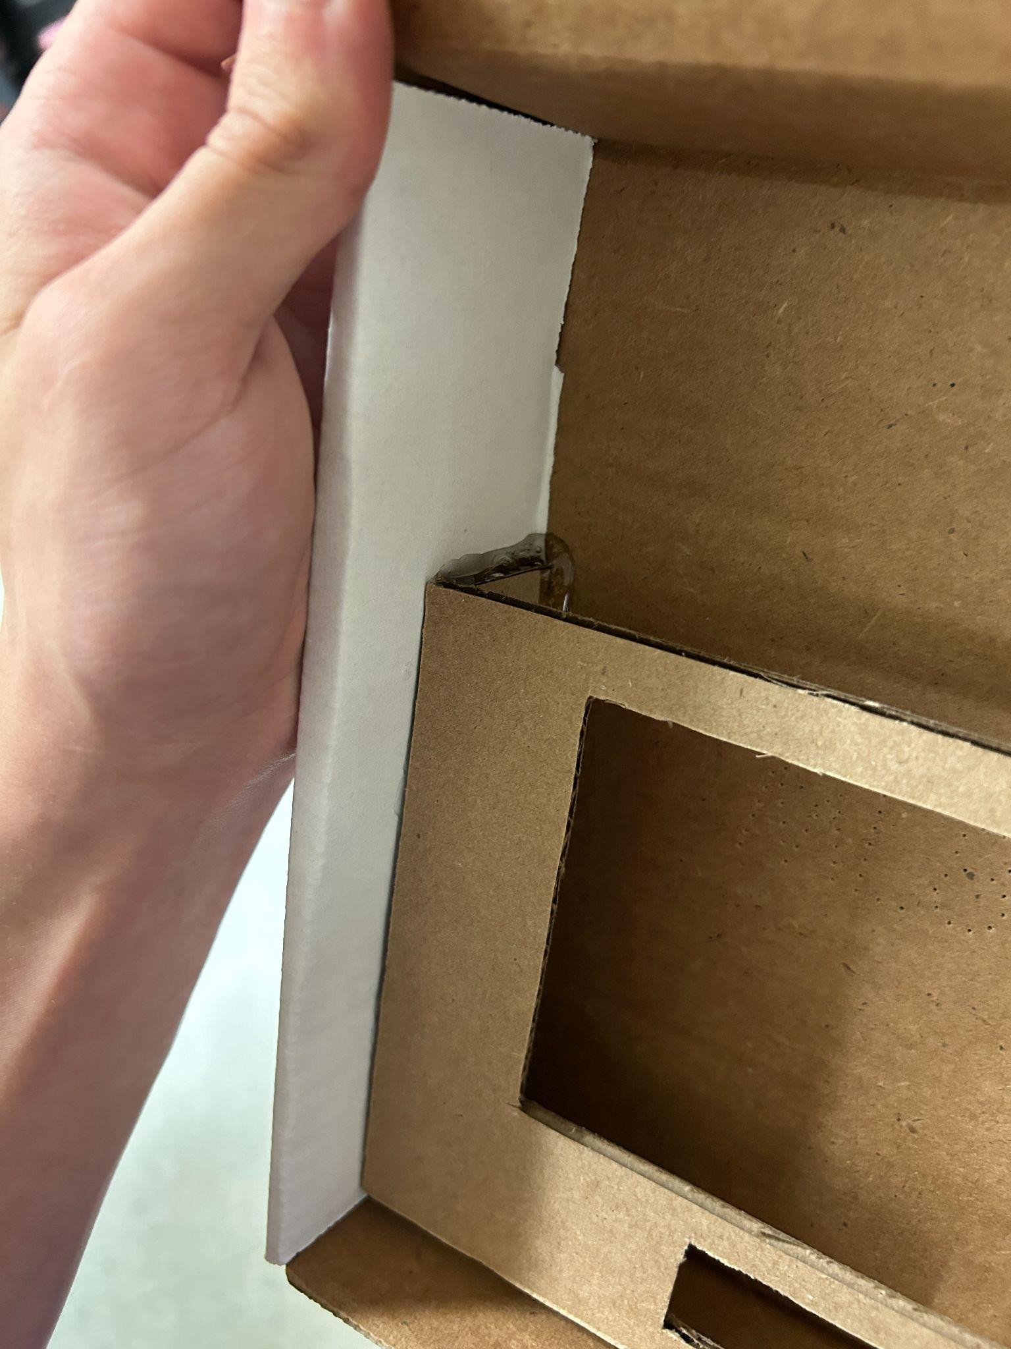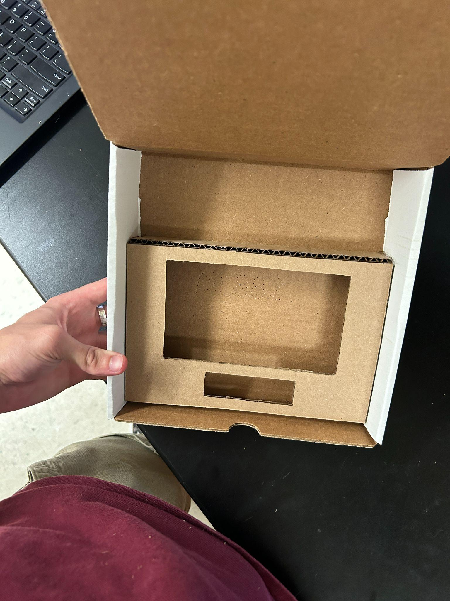

Apply glue like to on both sides and put the backstop of the insert in

**Step 3:**

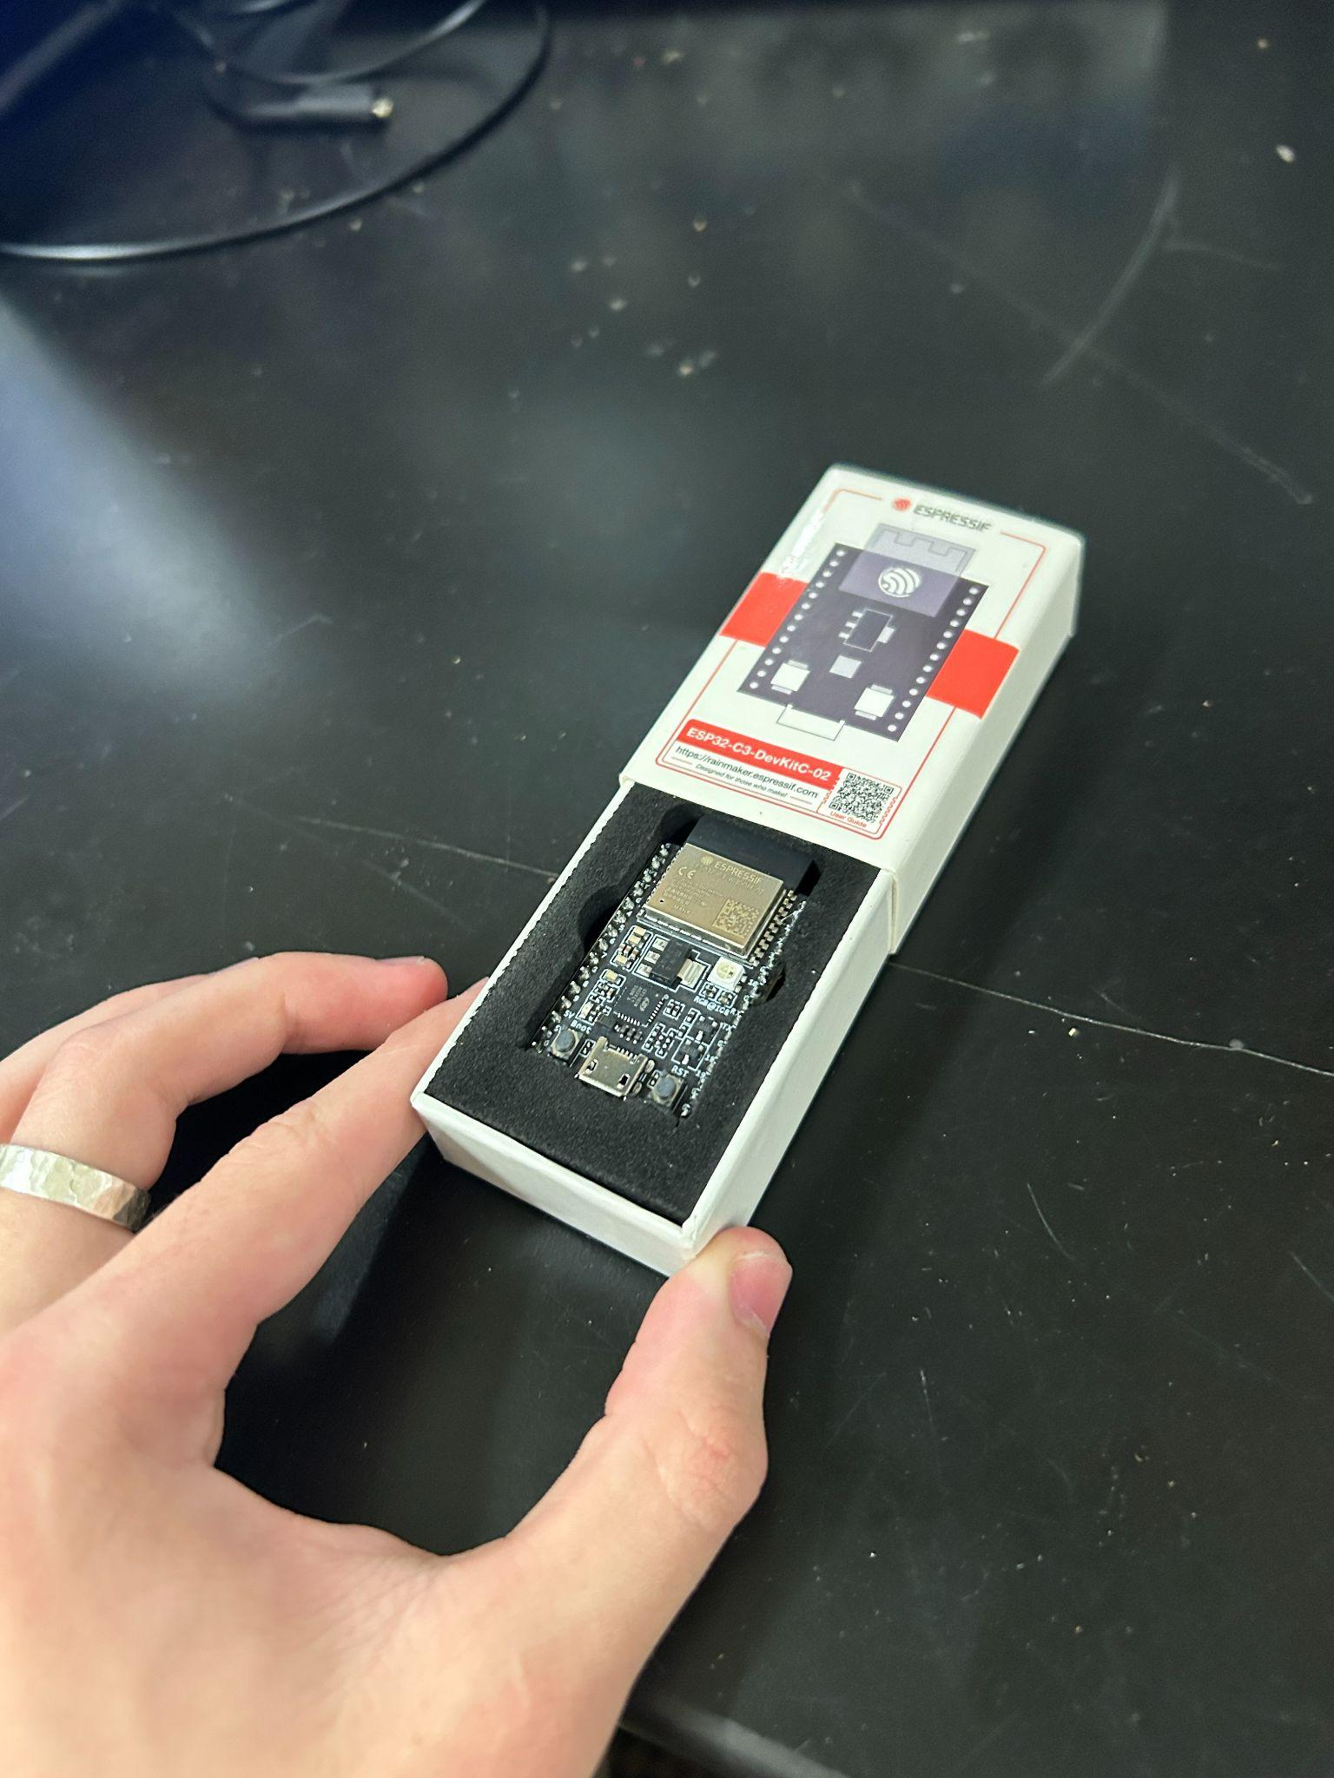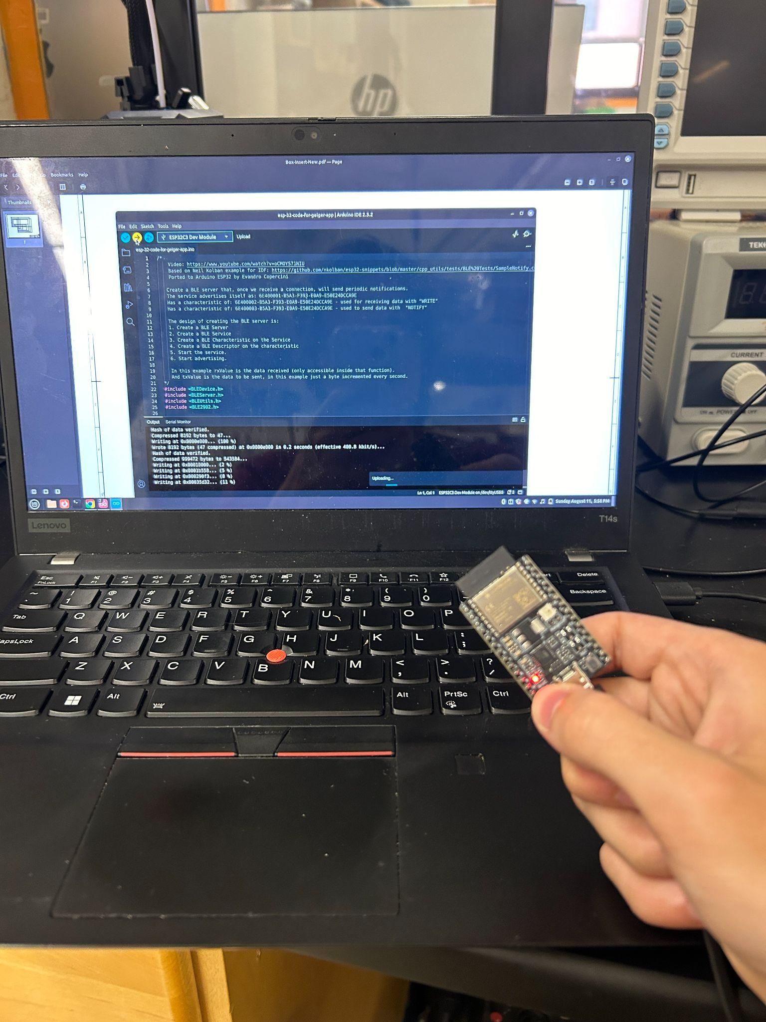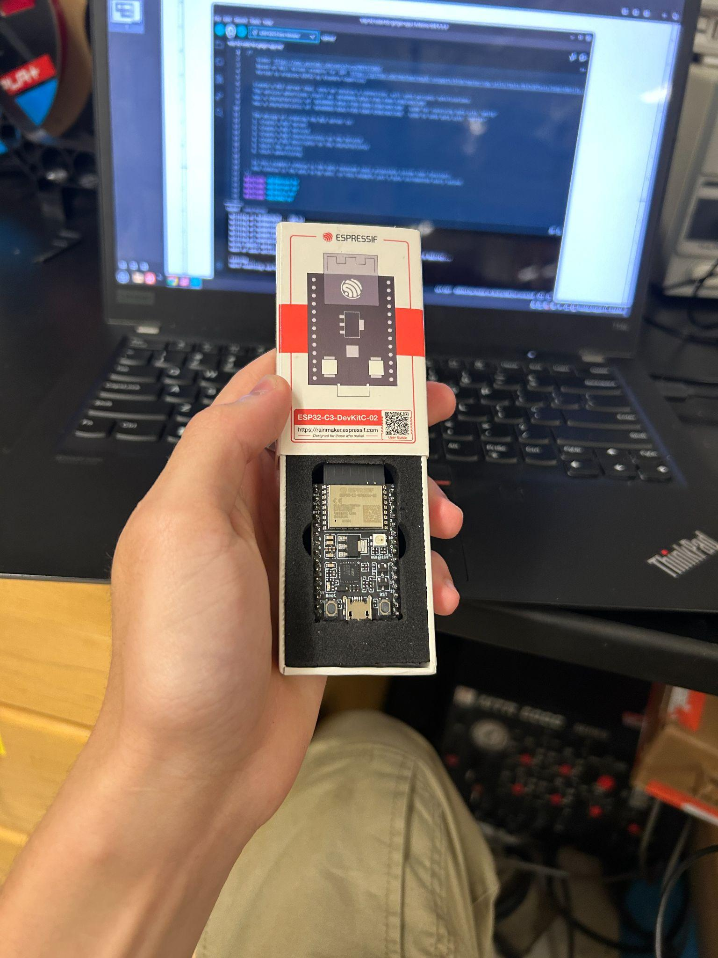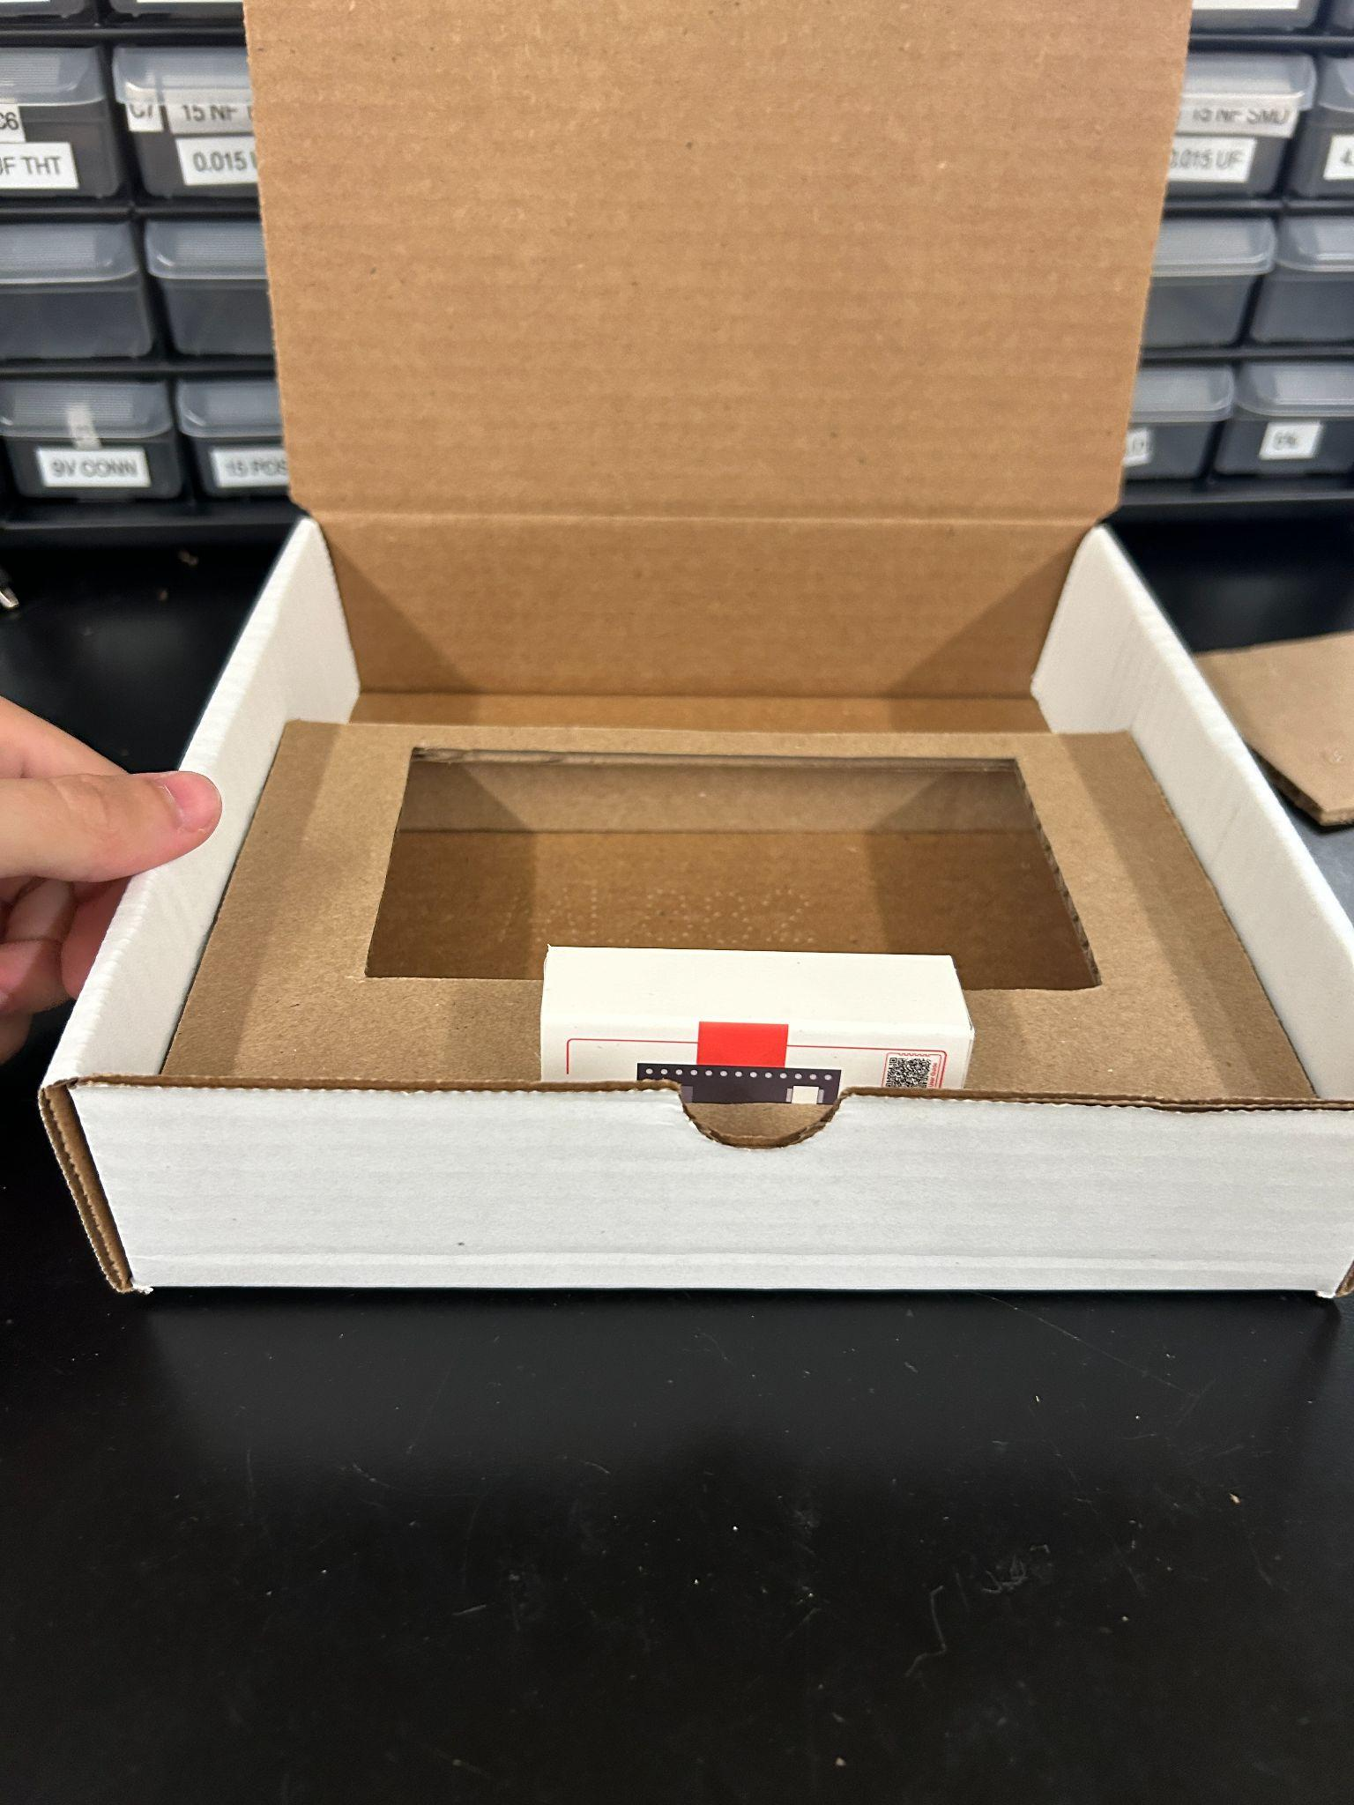

Flash software to the esp and put it in the box (might have to hold down “boot” button while uploading, check guides on how to upload to the ESP-32 if you have problems)

**Step 4:**

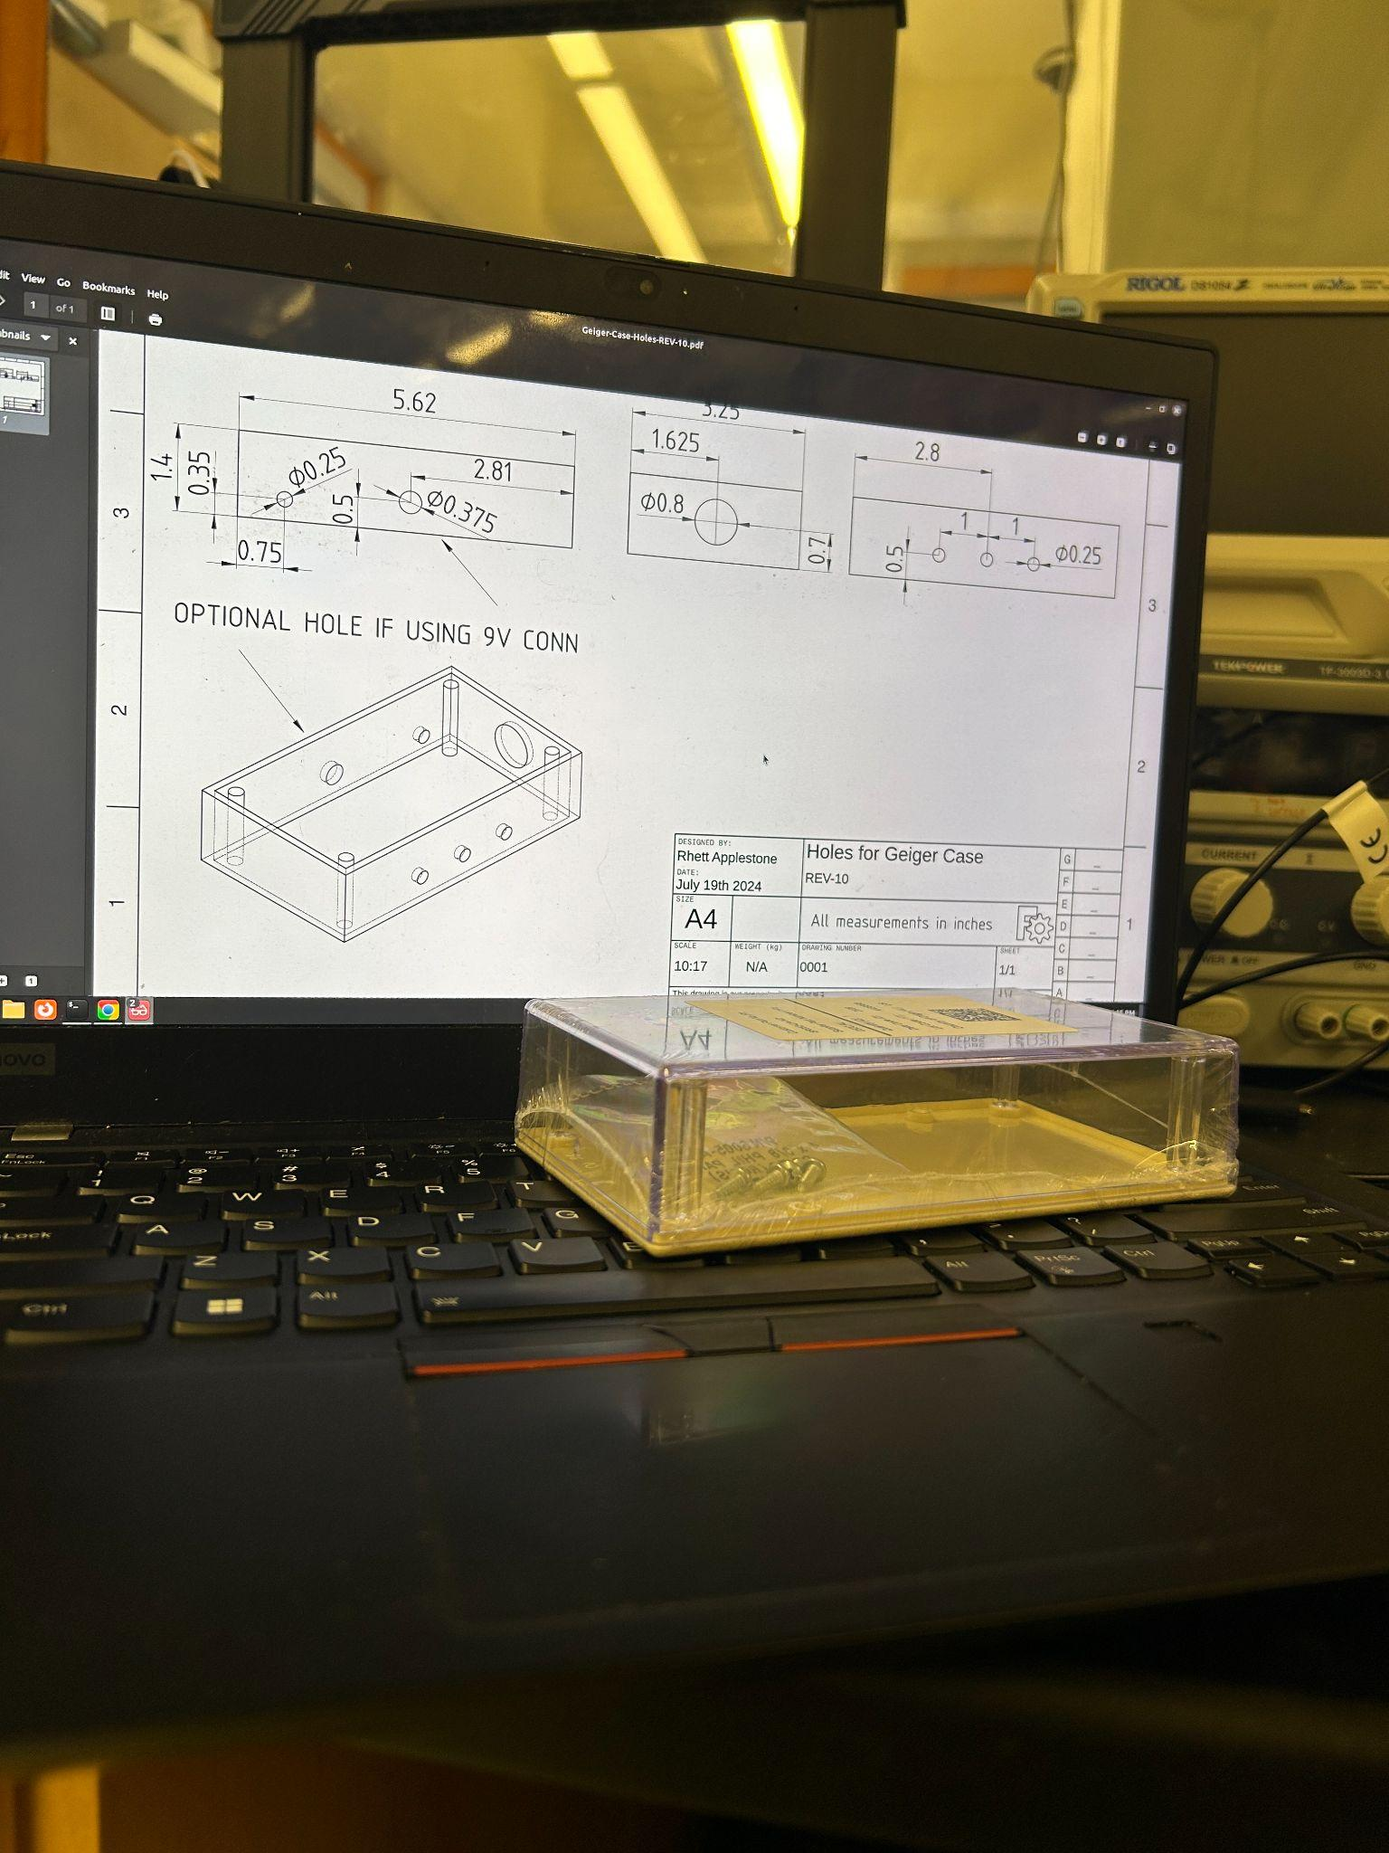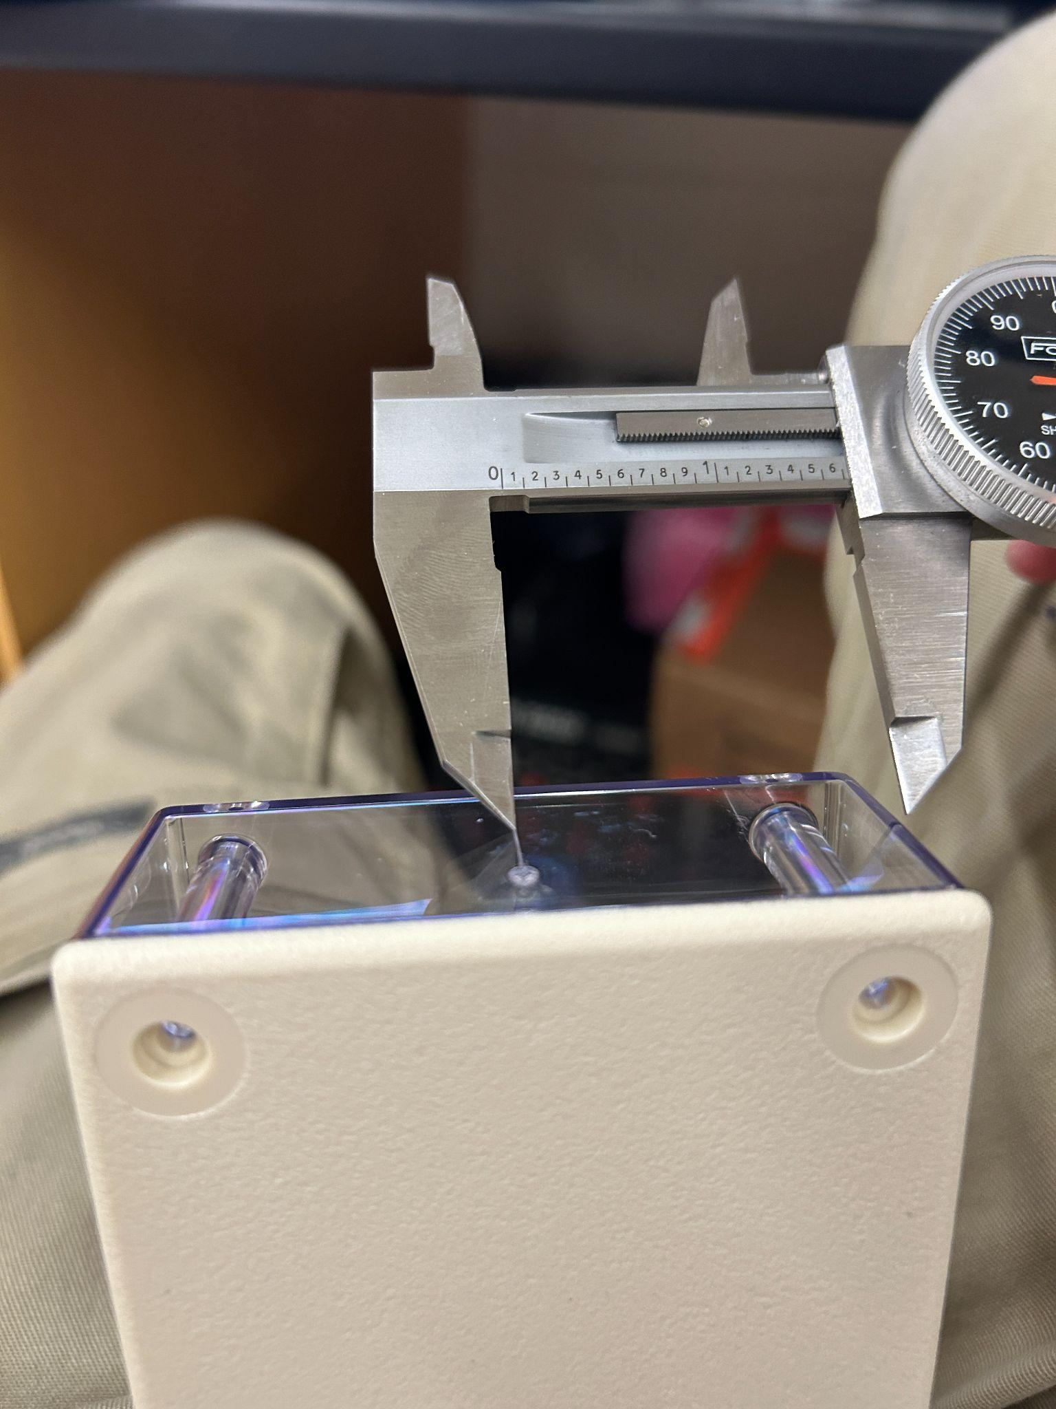

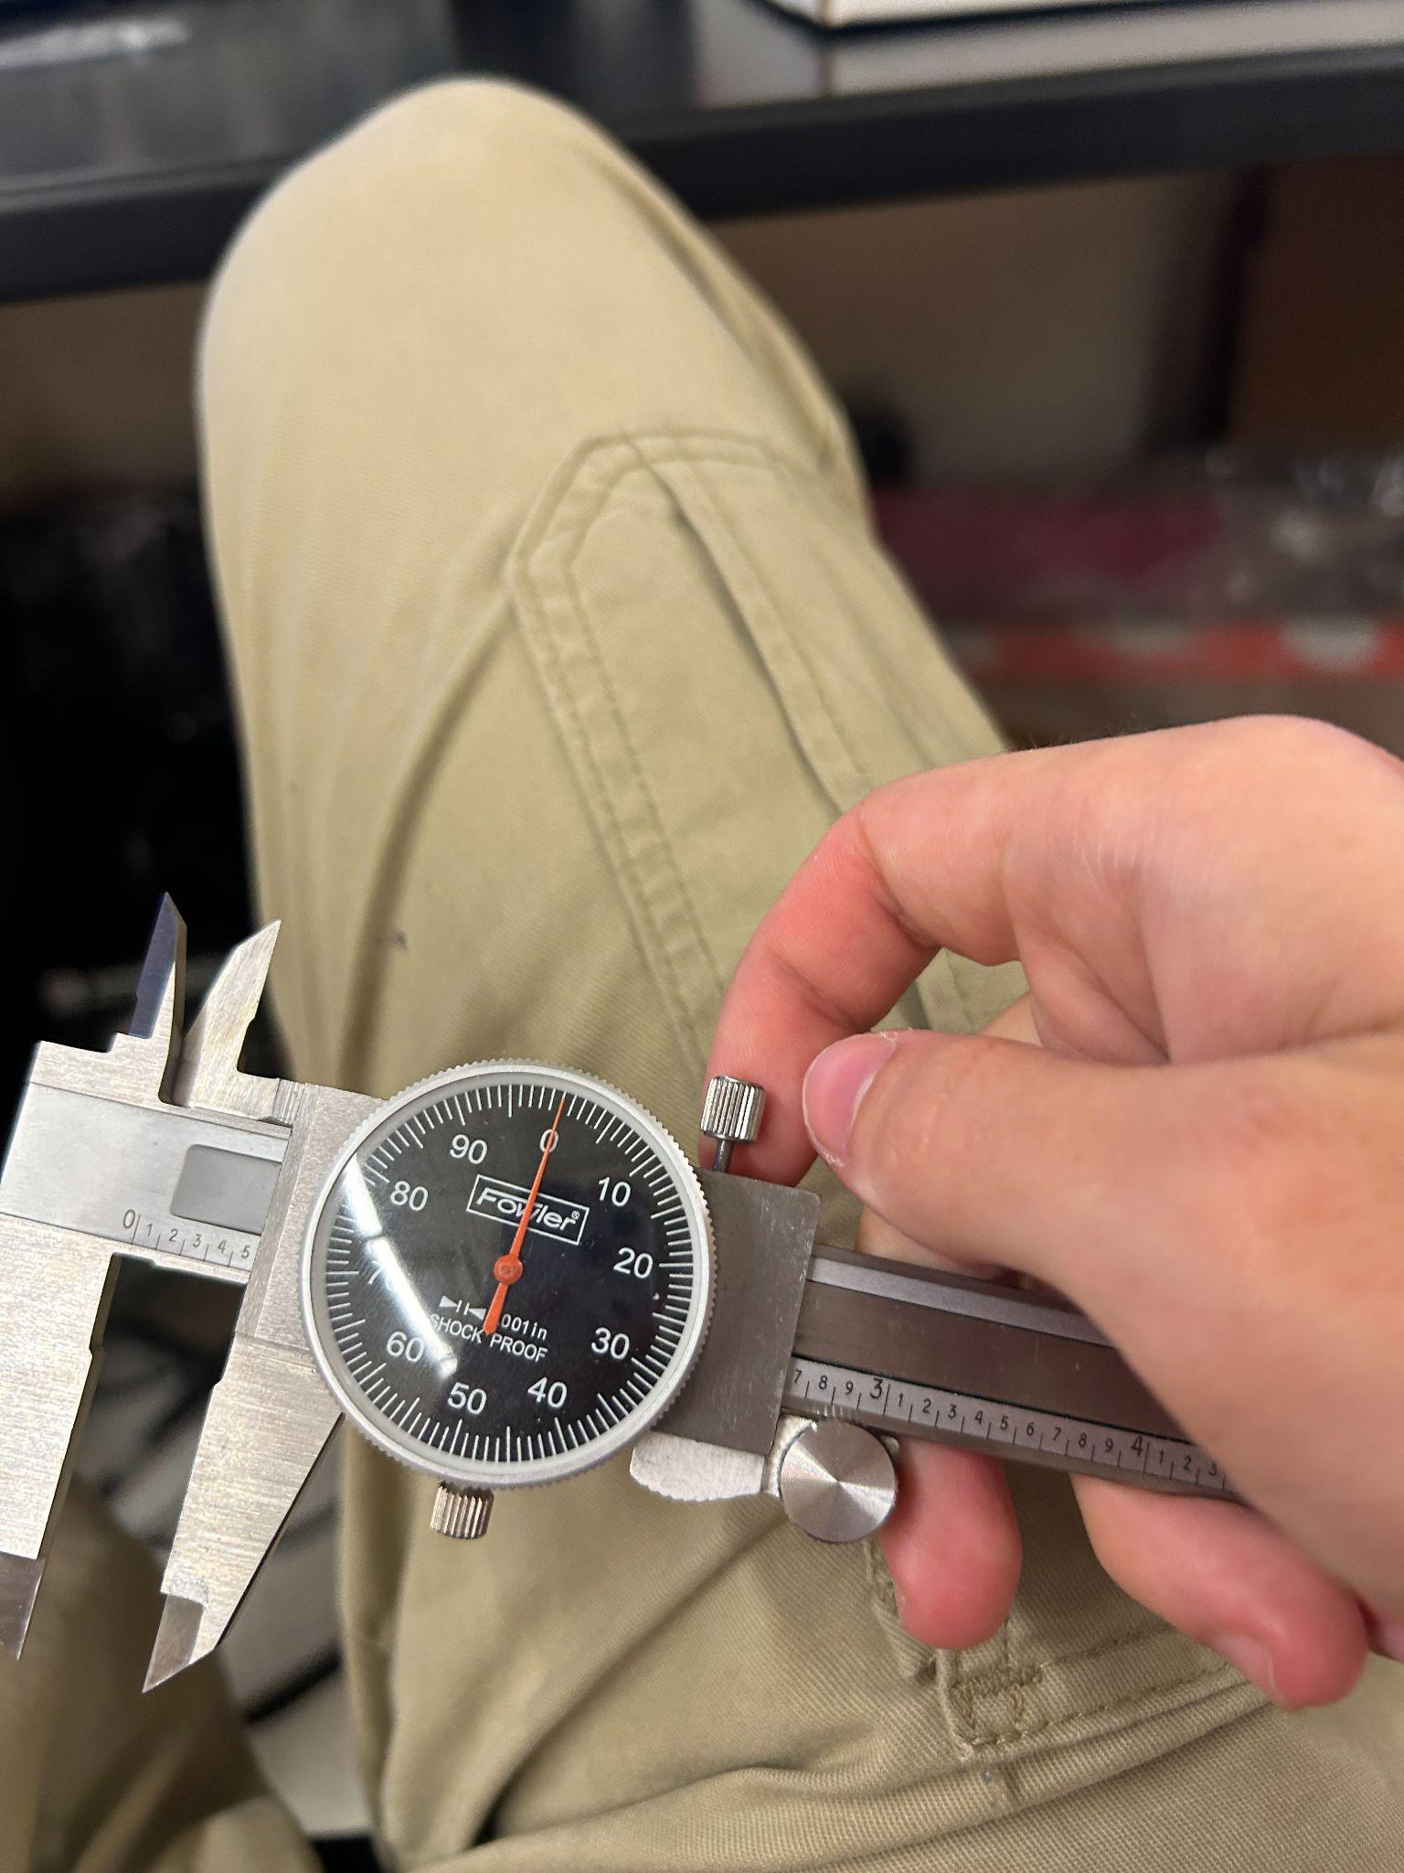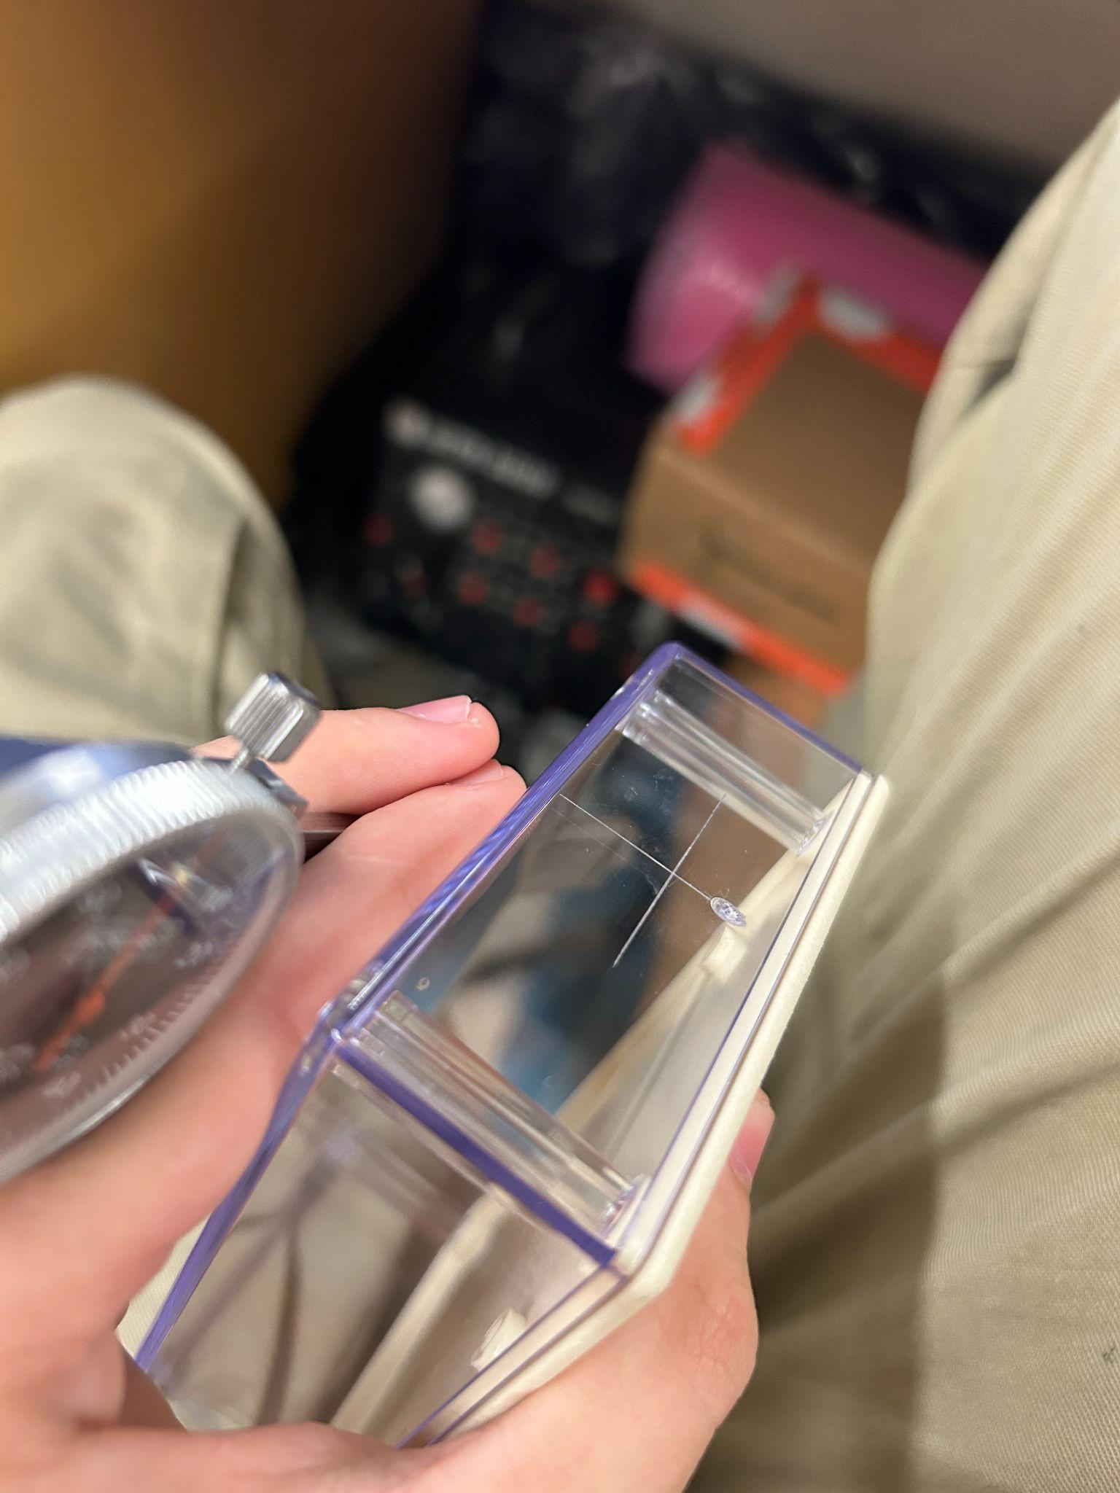

Scribe places to drill holes in the case (tip, use the knob on the calipers to lock them at a certain length) Do so for all needed holes

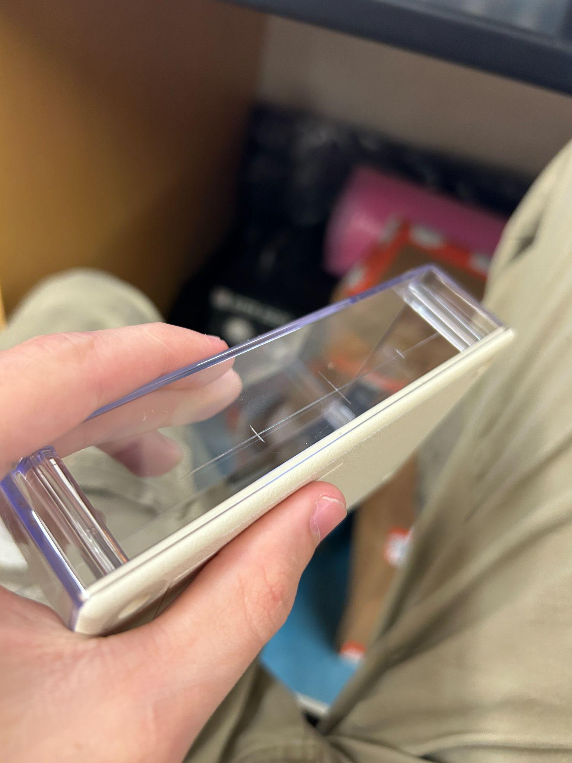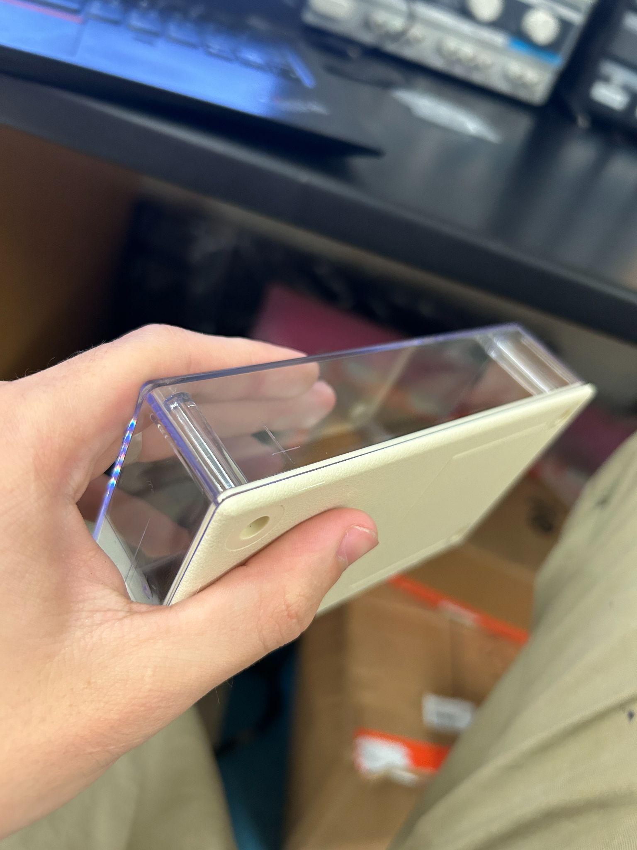

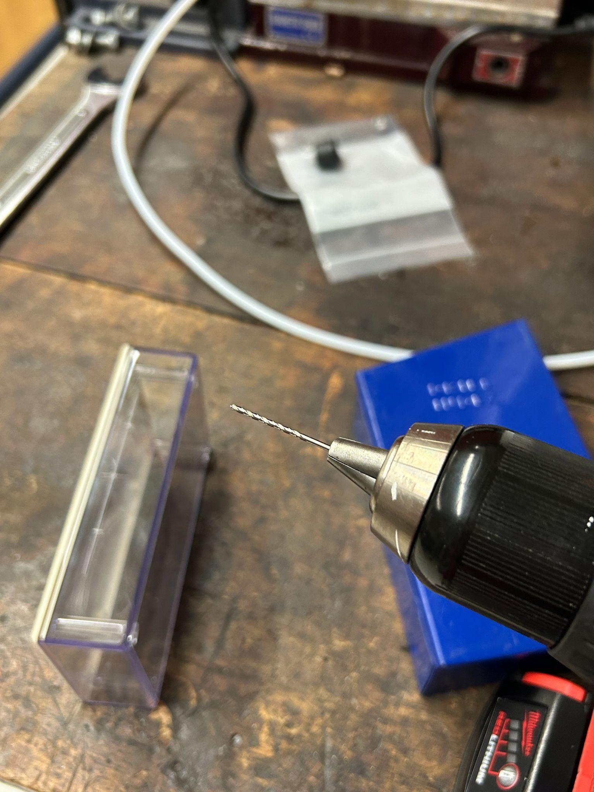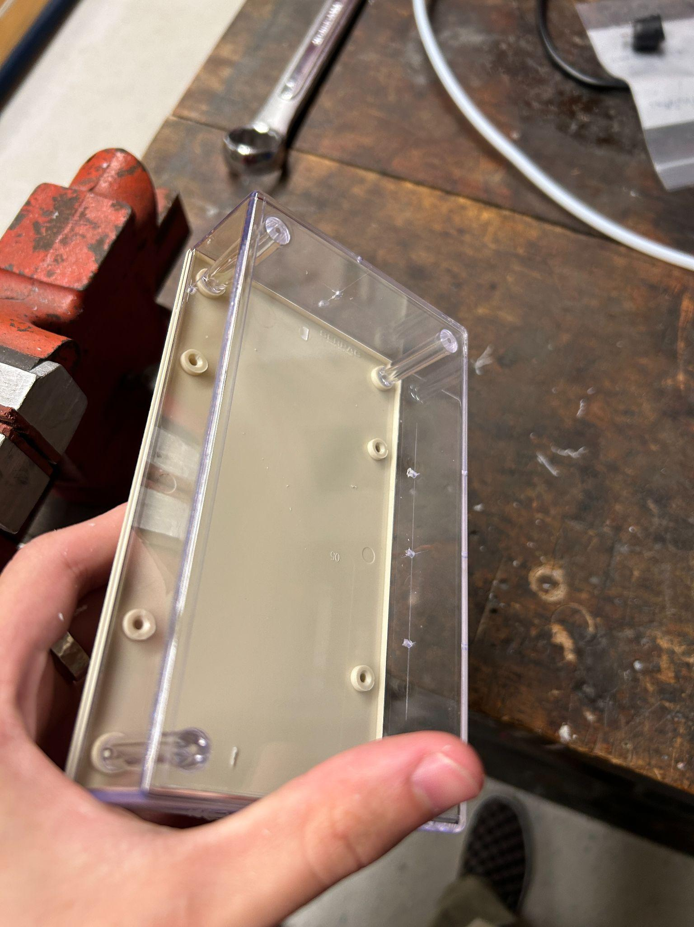

Drill all holes with the smallest bit you have

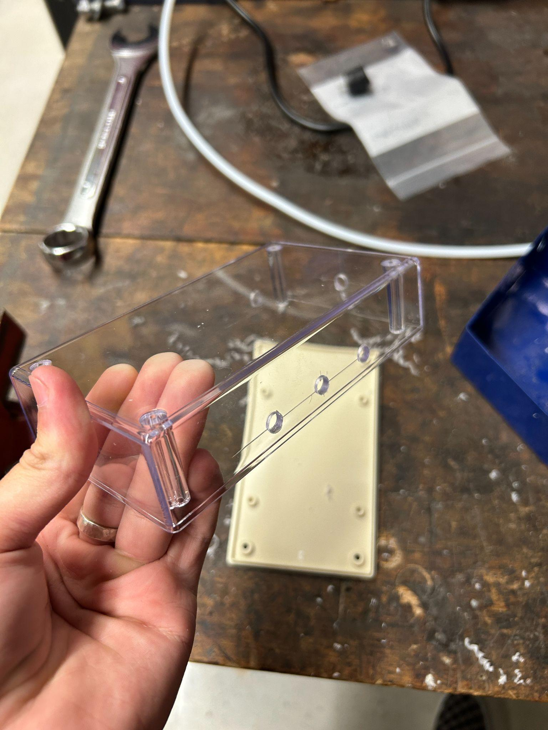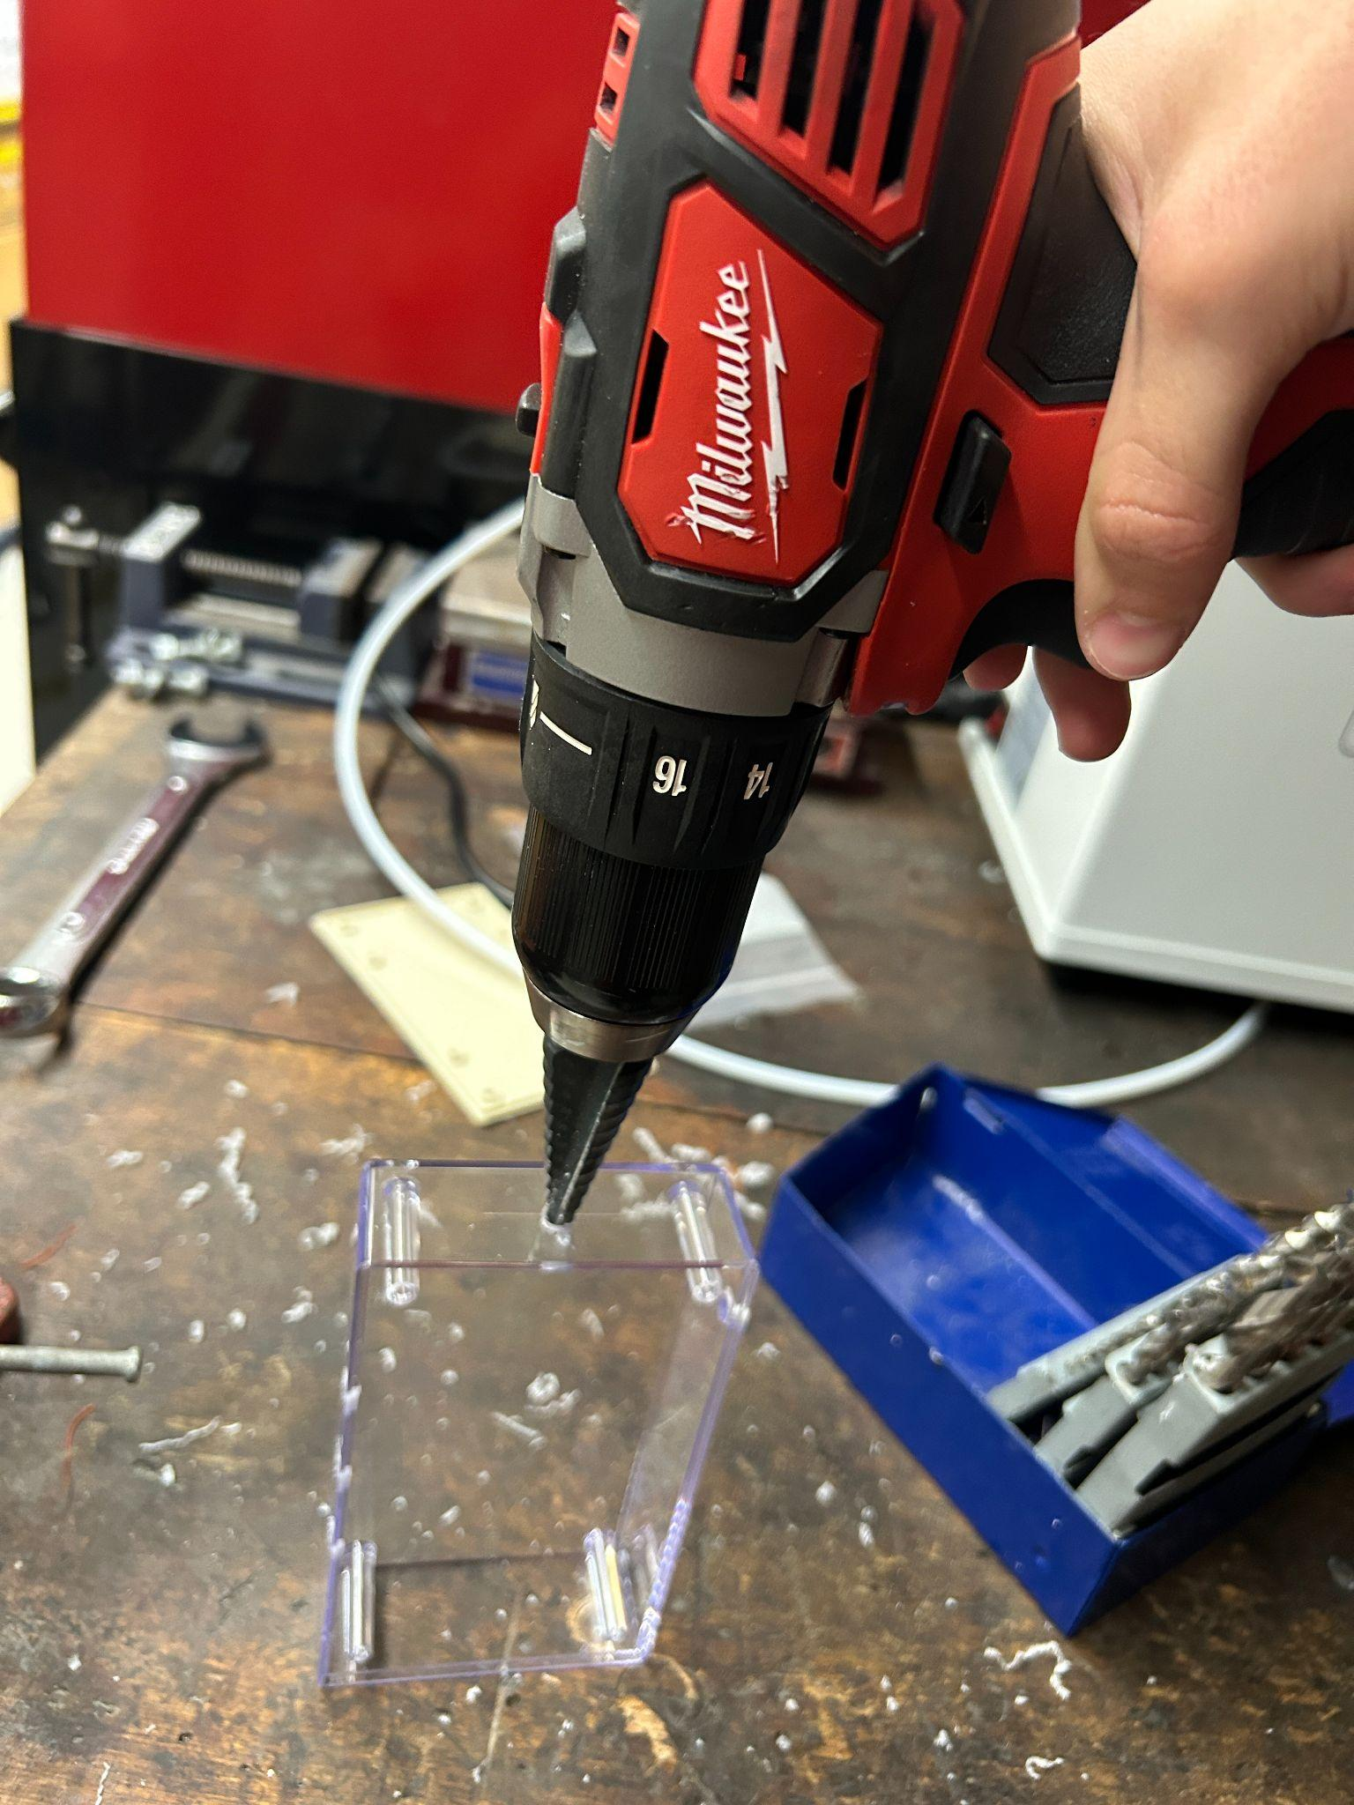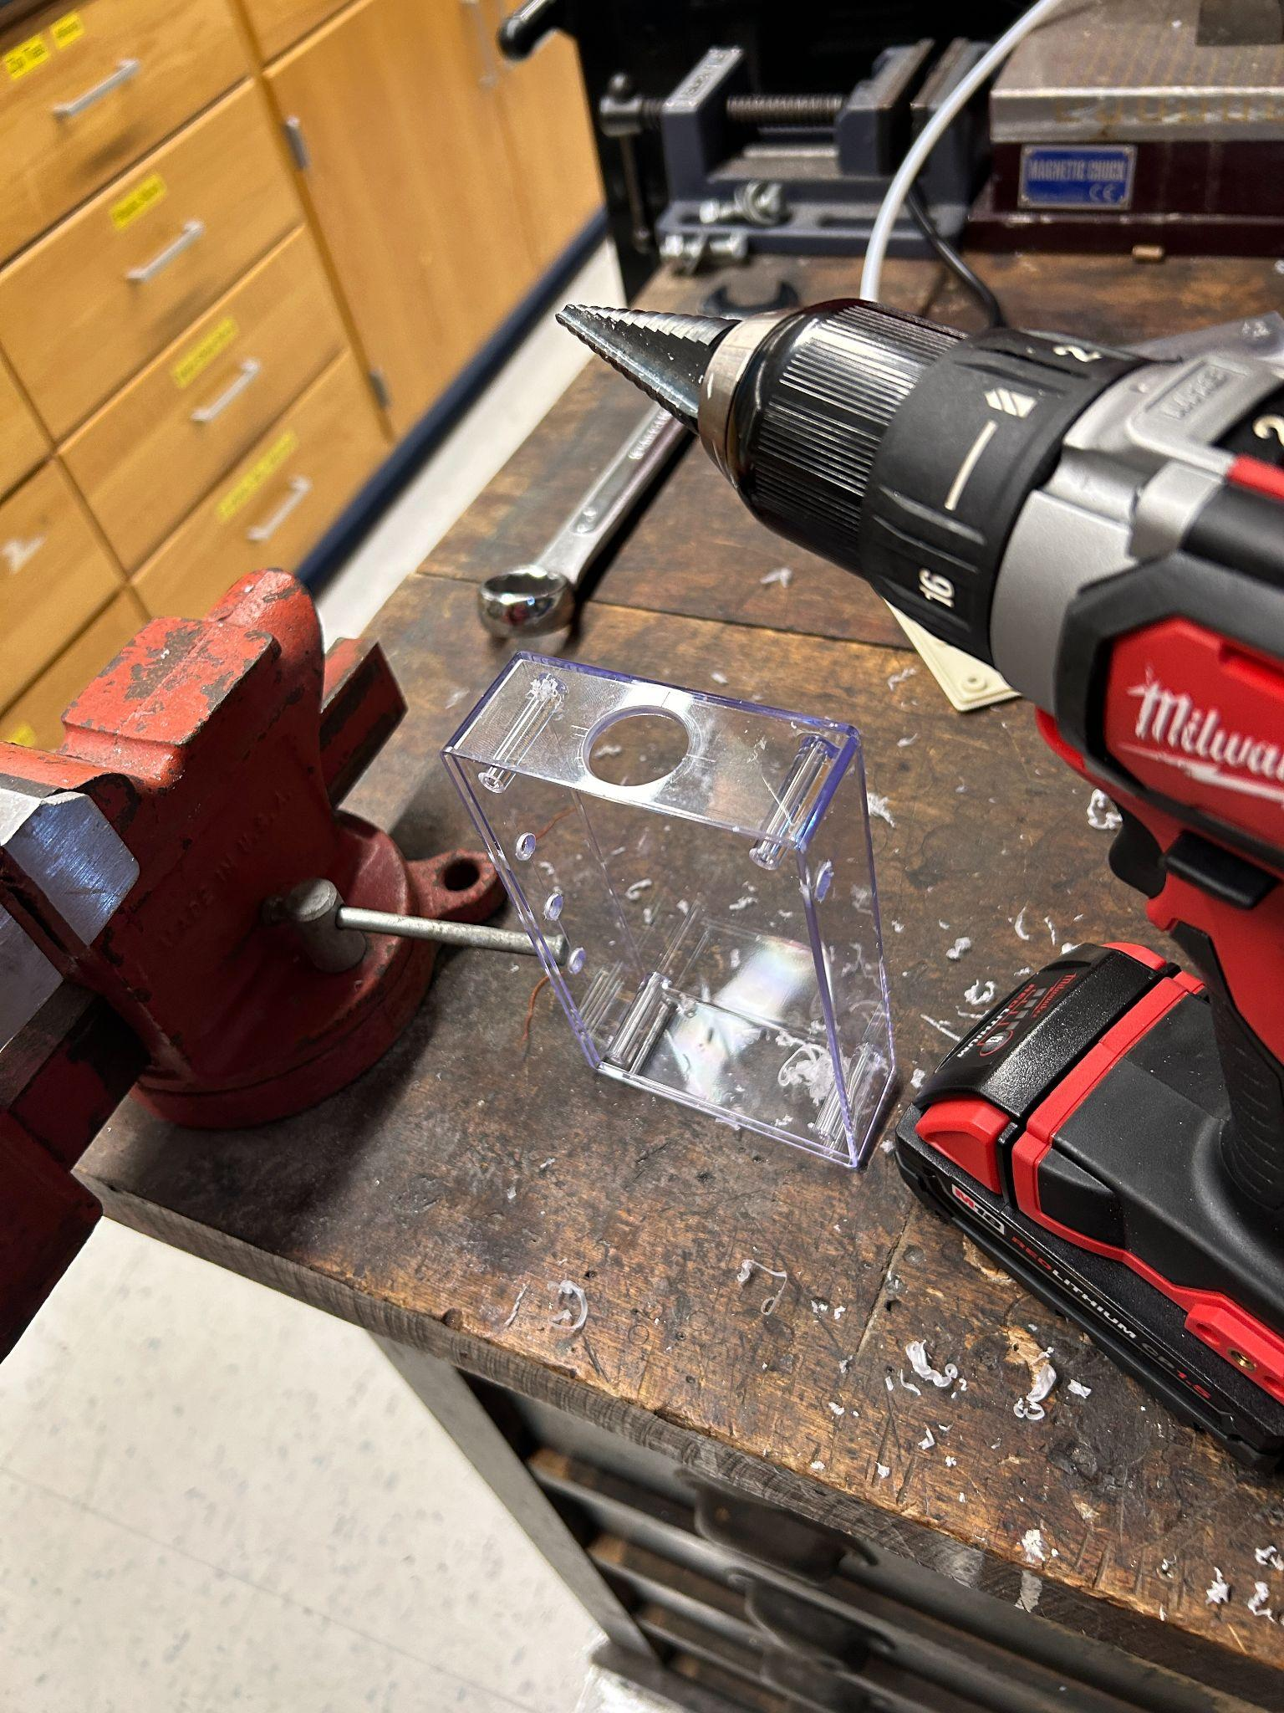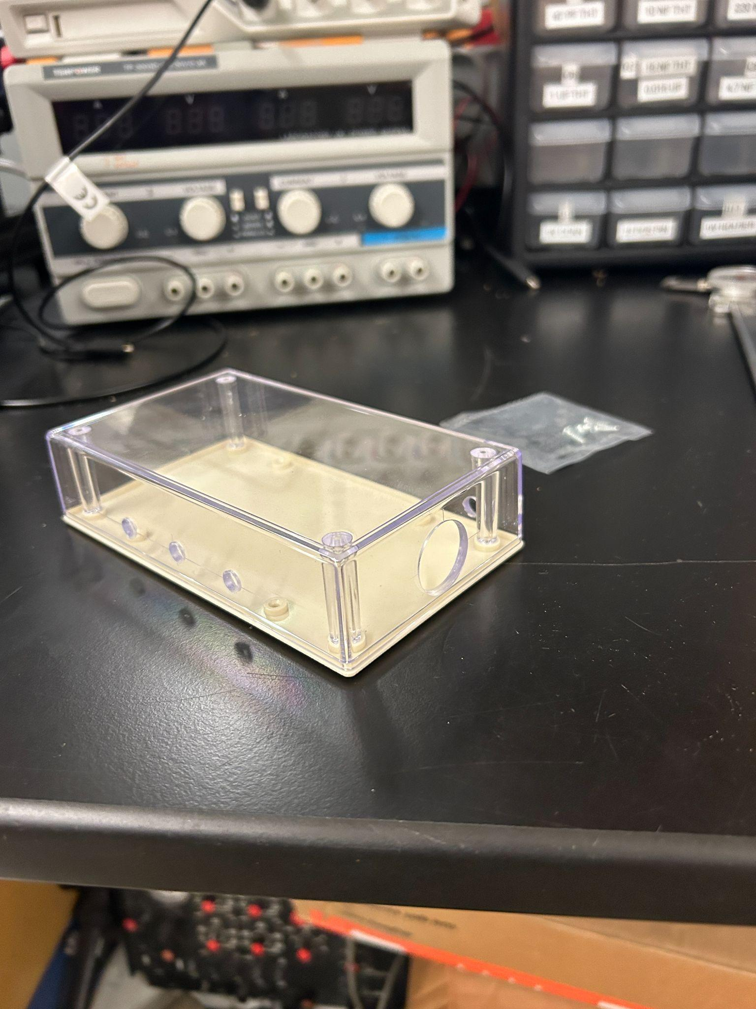

Drill all holes in the case with a ¼ inch bit then go back for the switch hole and drill it to around 0.8 inches (drill the 9V conn hole only if you need to, else don't)

**Step 5:**

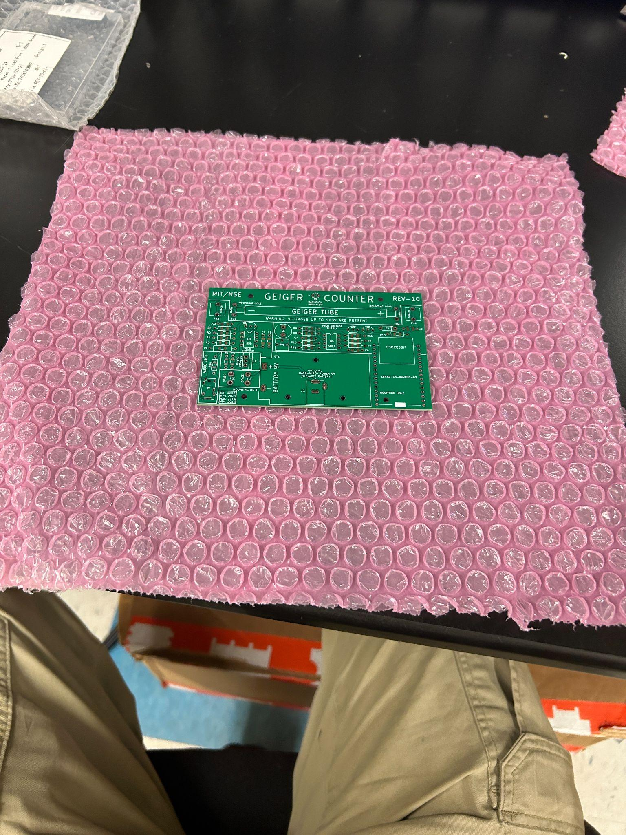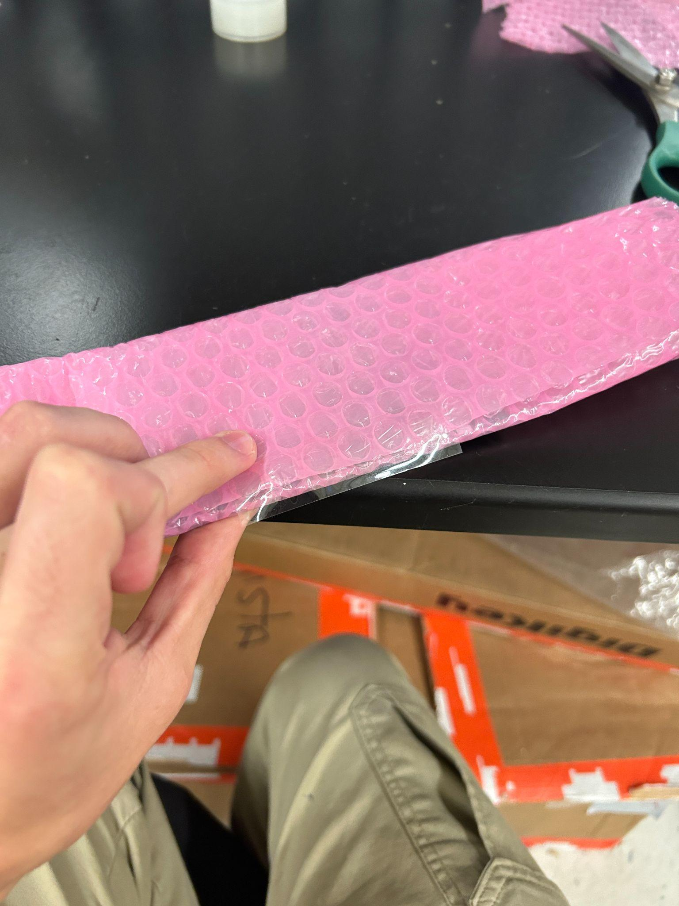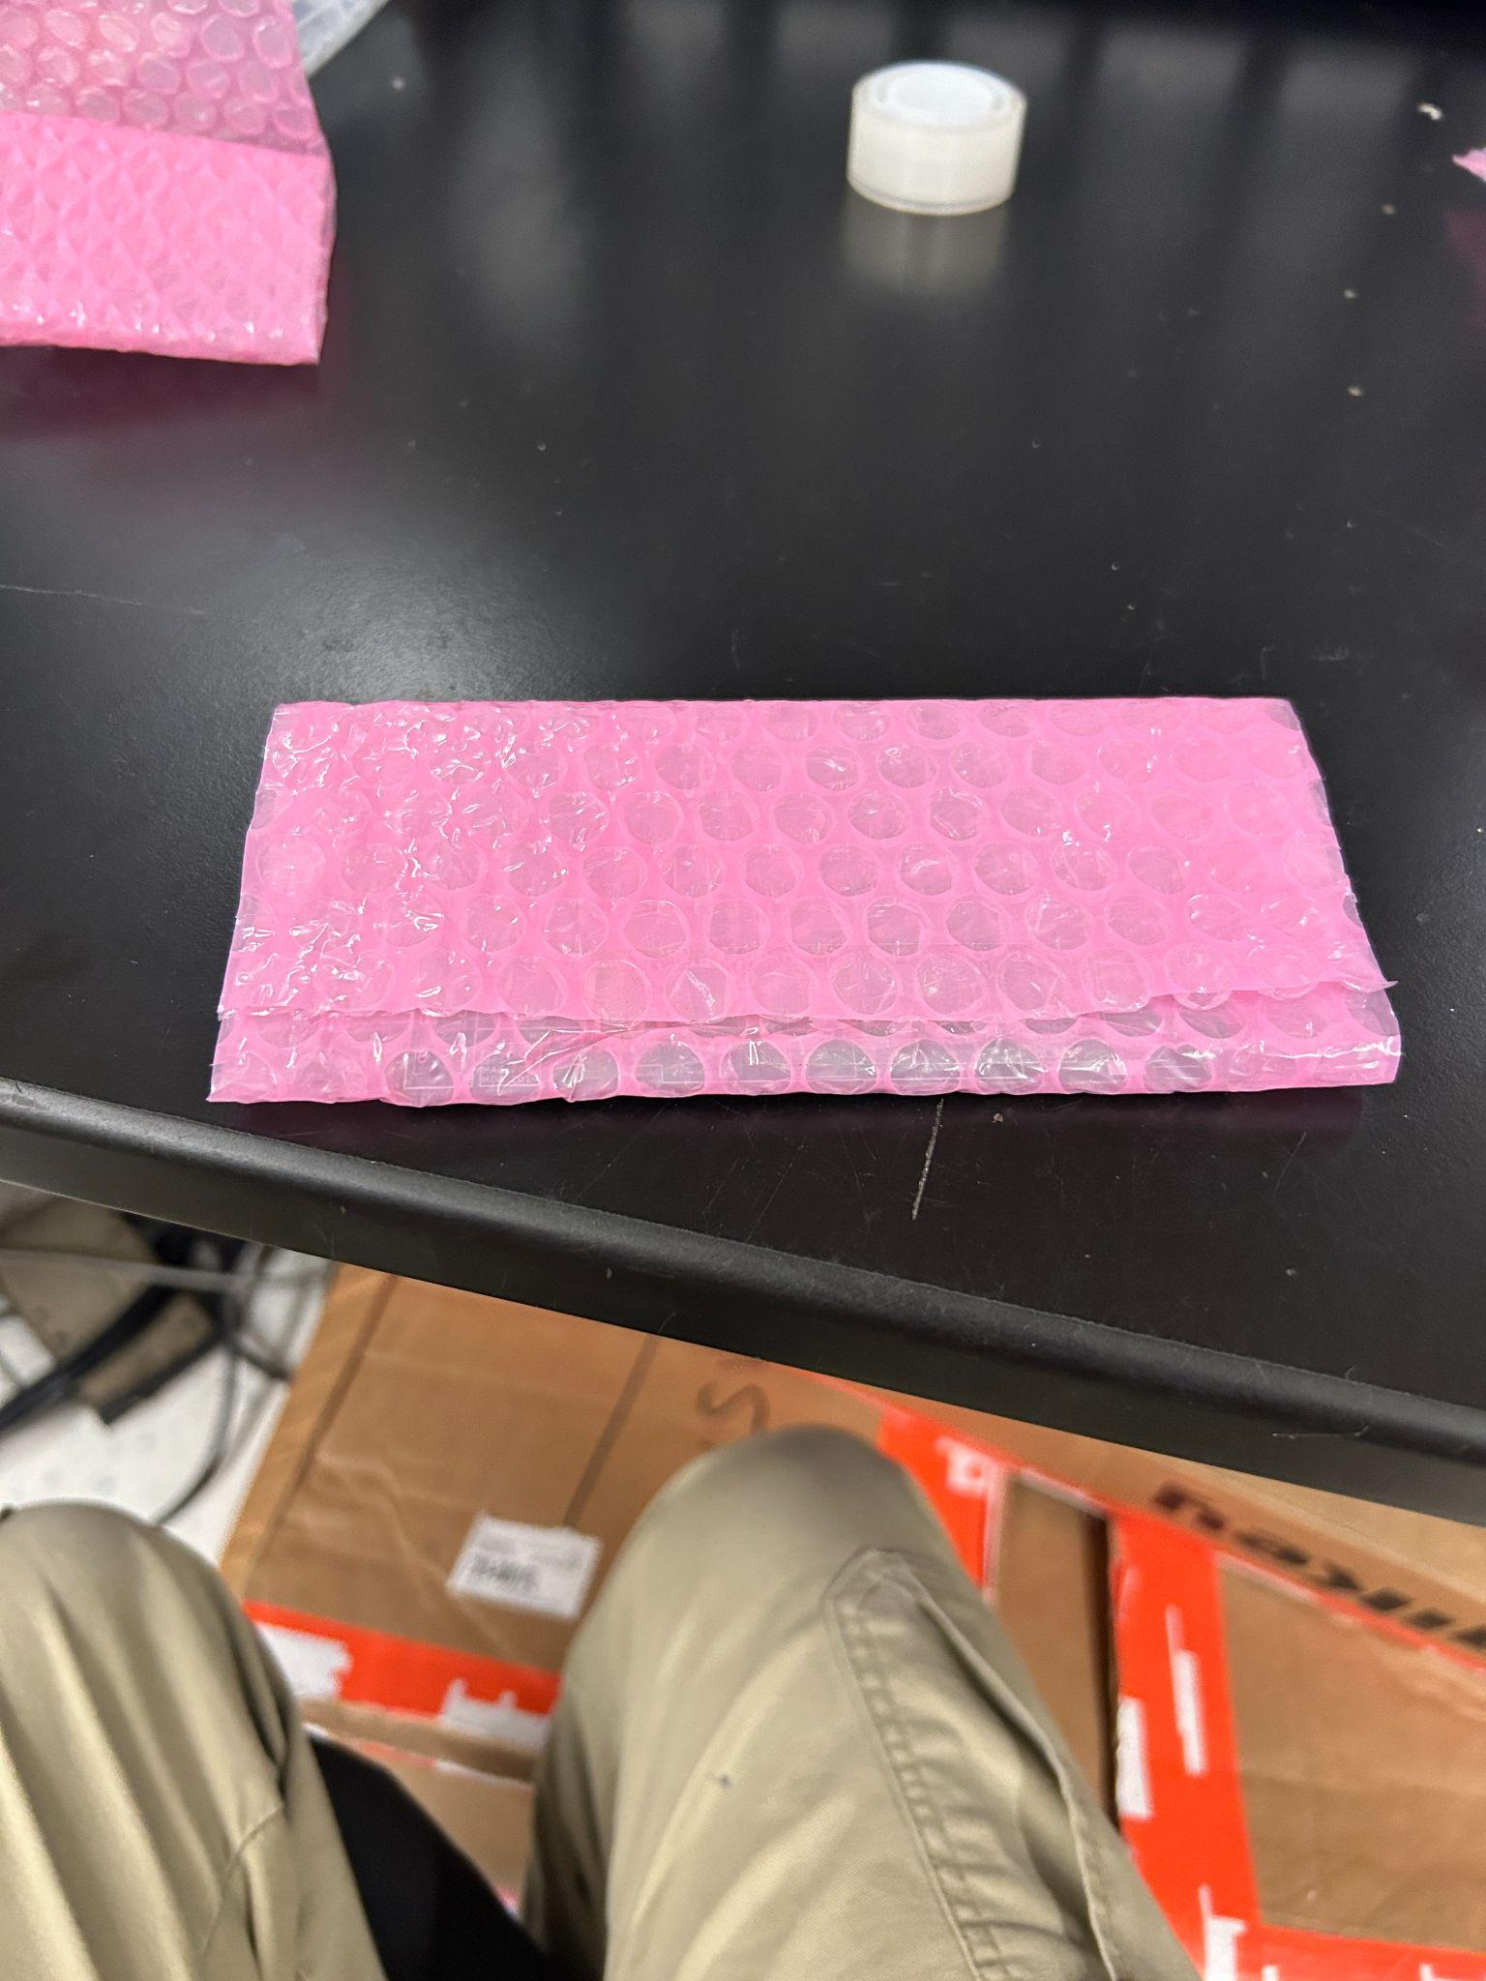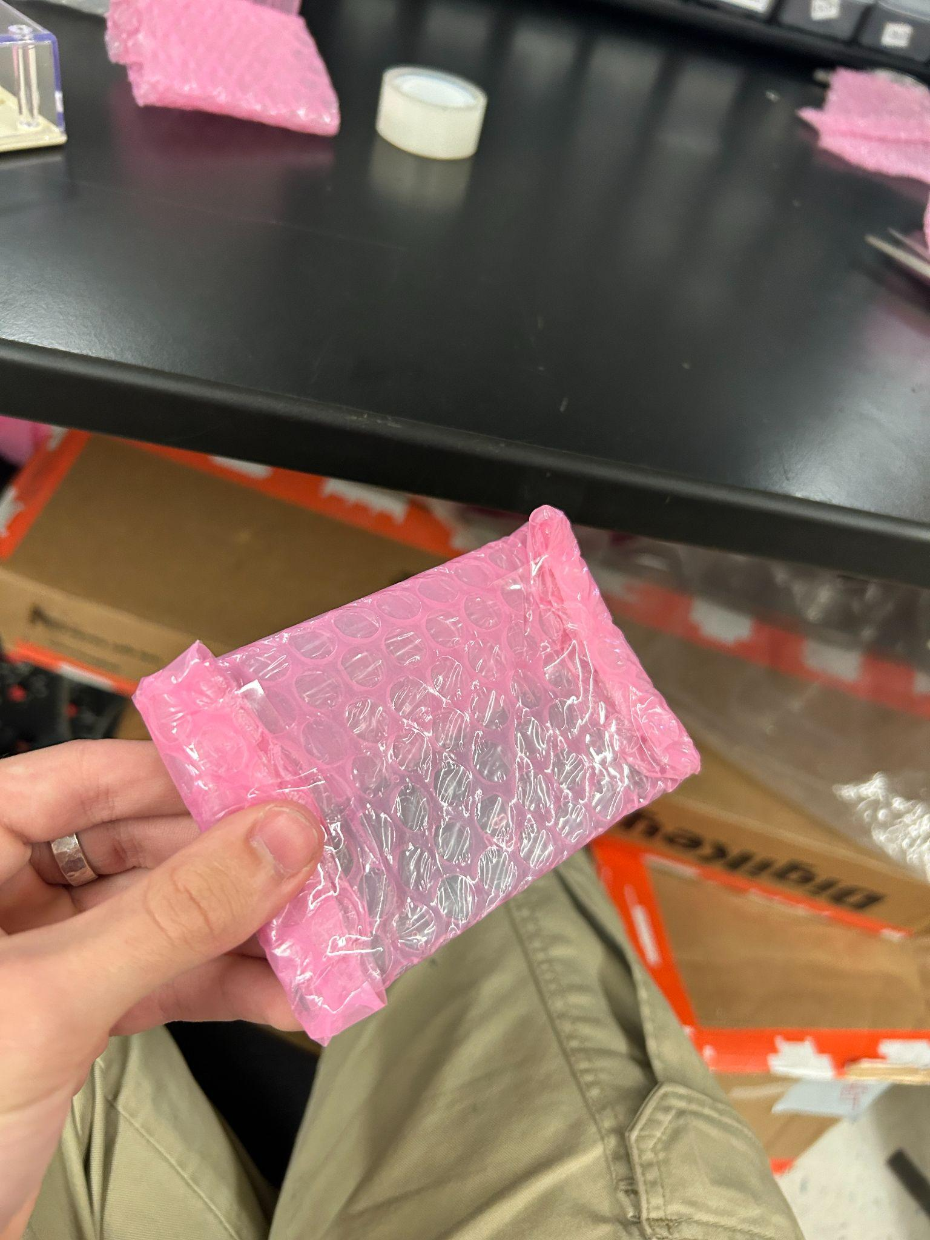

Wrap board like so and put it in the top of the case

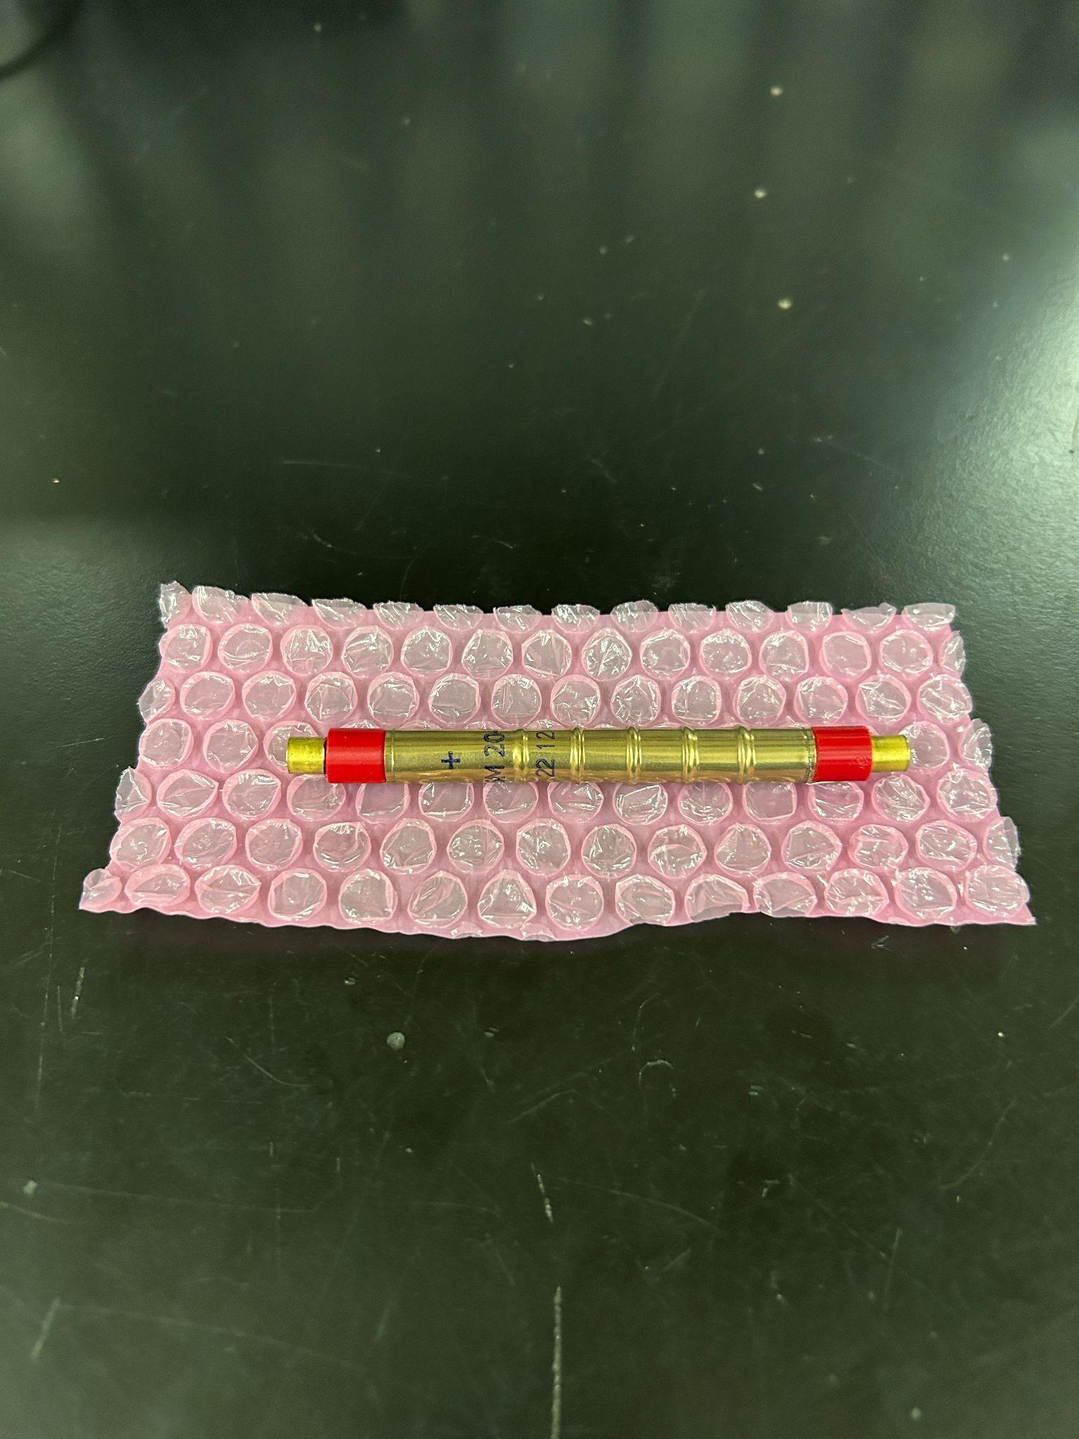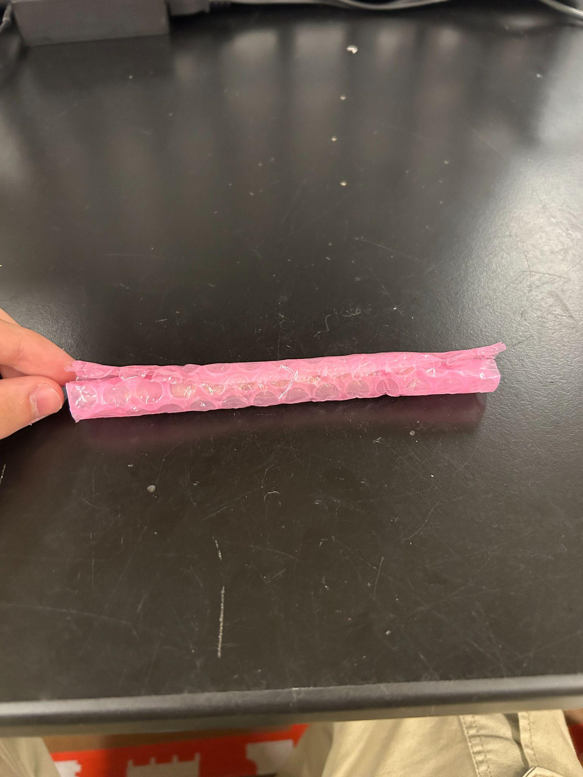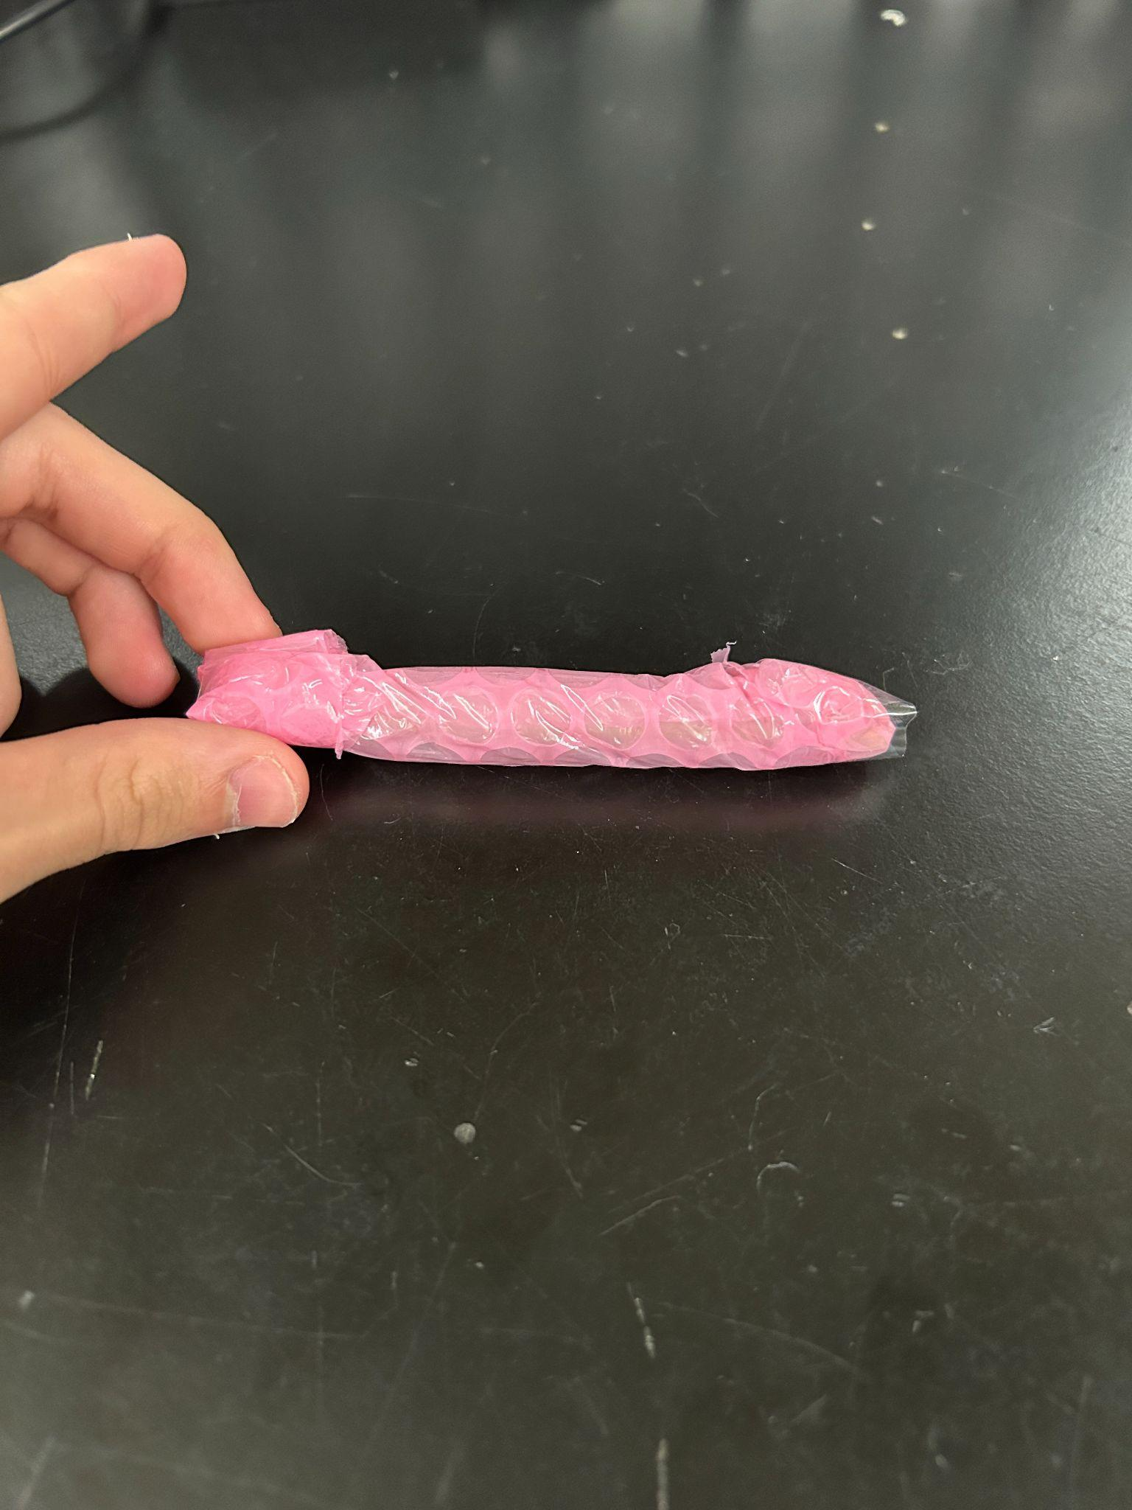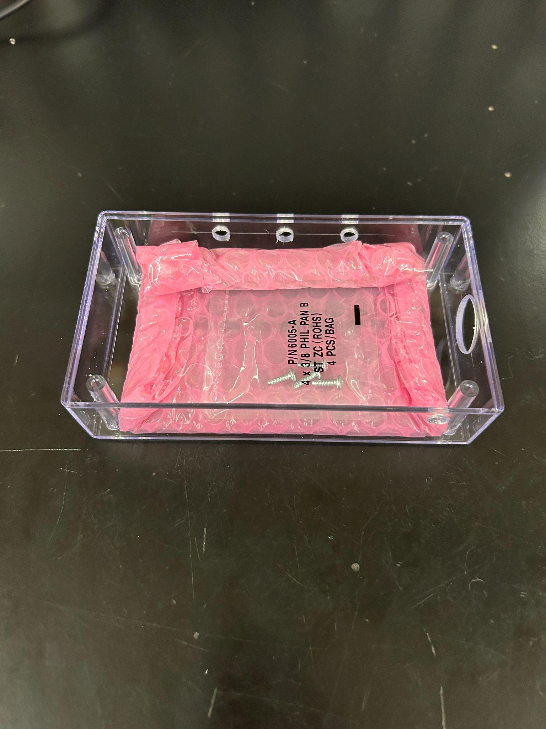

Wrap the tube like so, and also put it in the case (along with the four case screws, do not forget the four case screws, (SCREW 1 on the BOM))

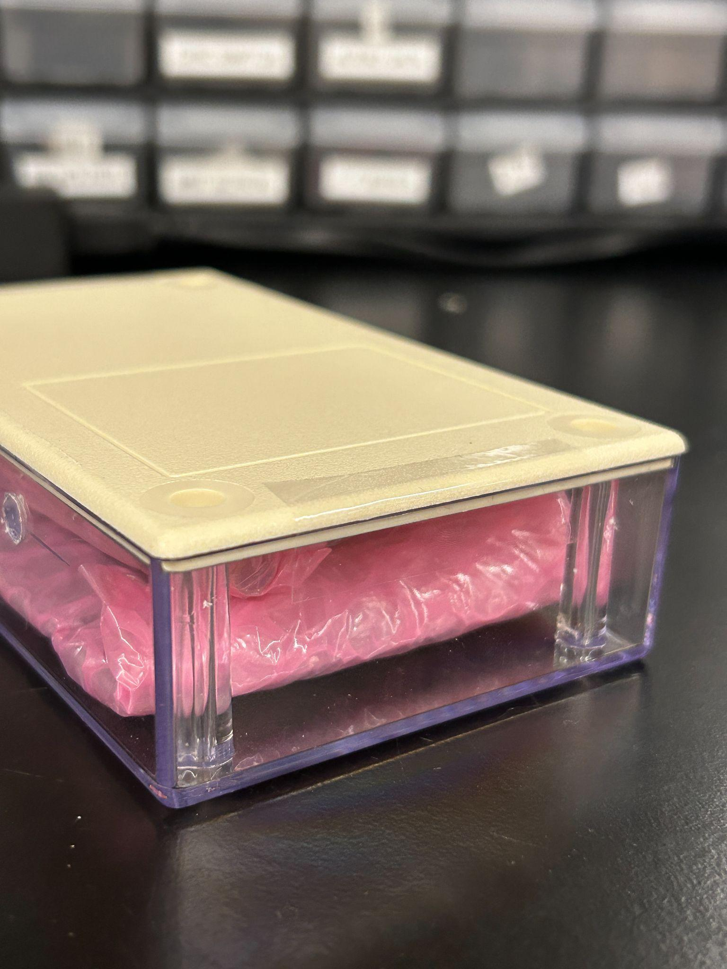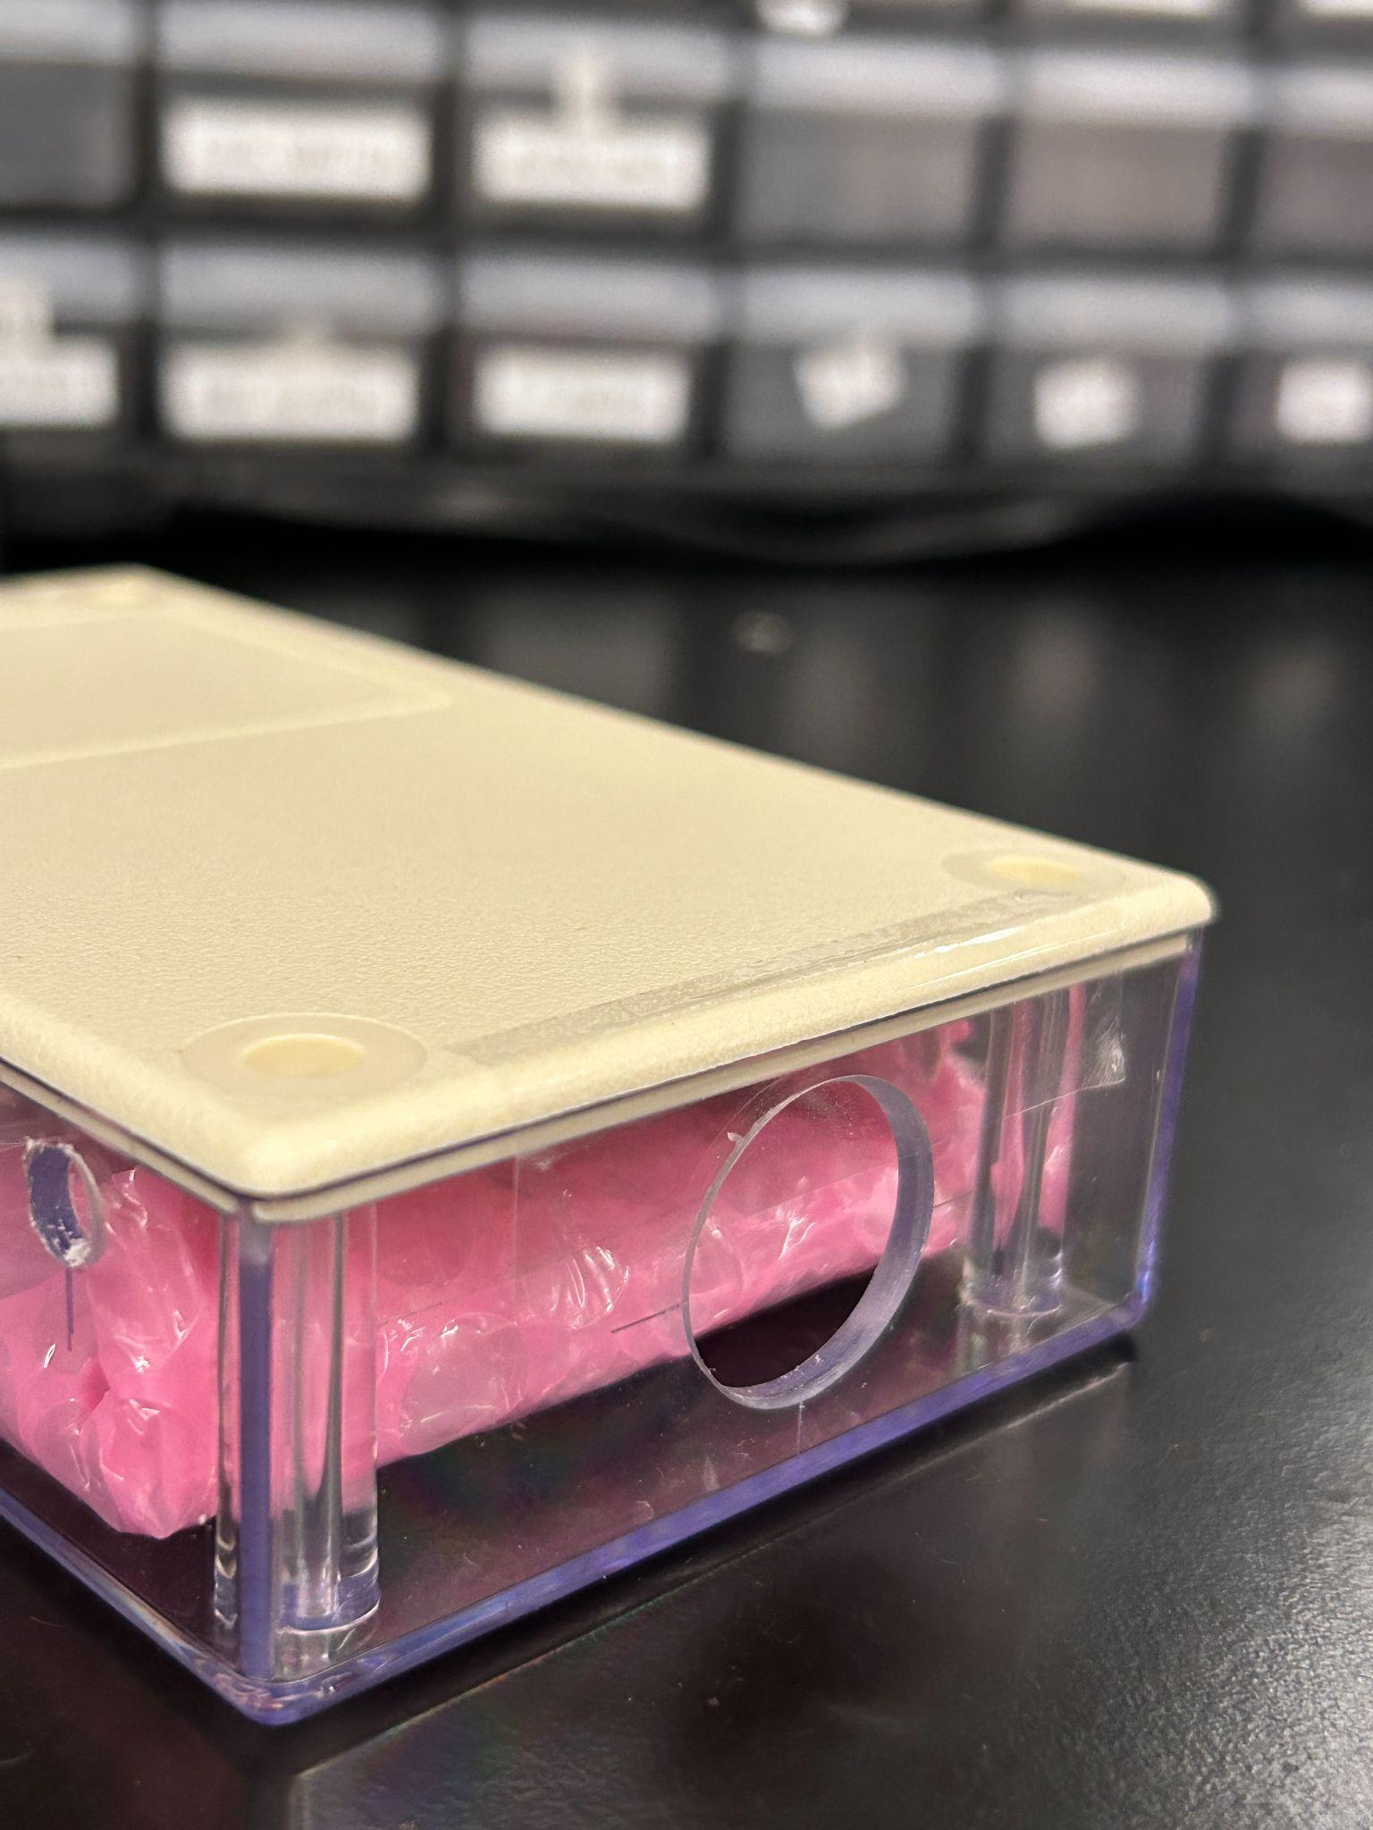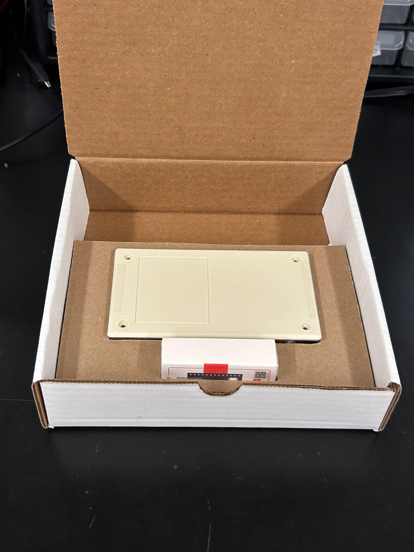

Put tape on both ends of the case, and put it top down in the box

**Step 6:**

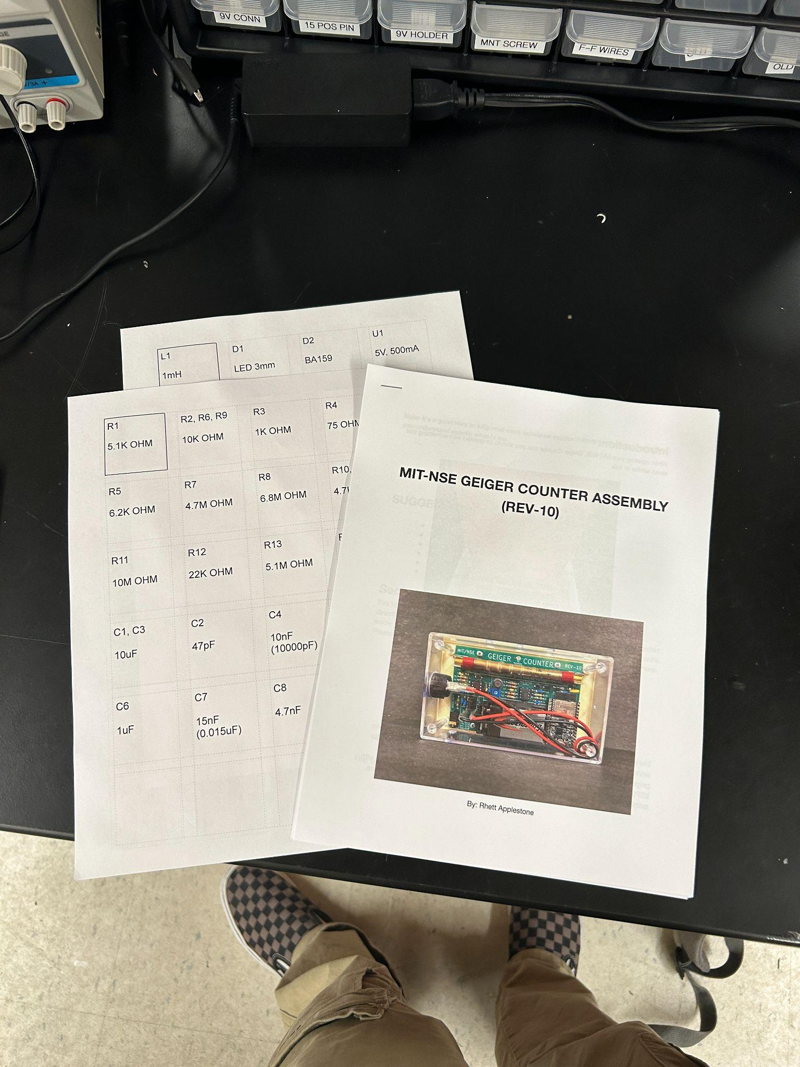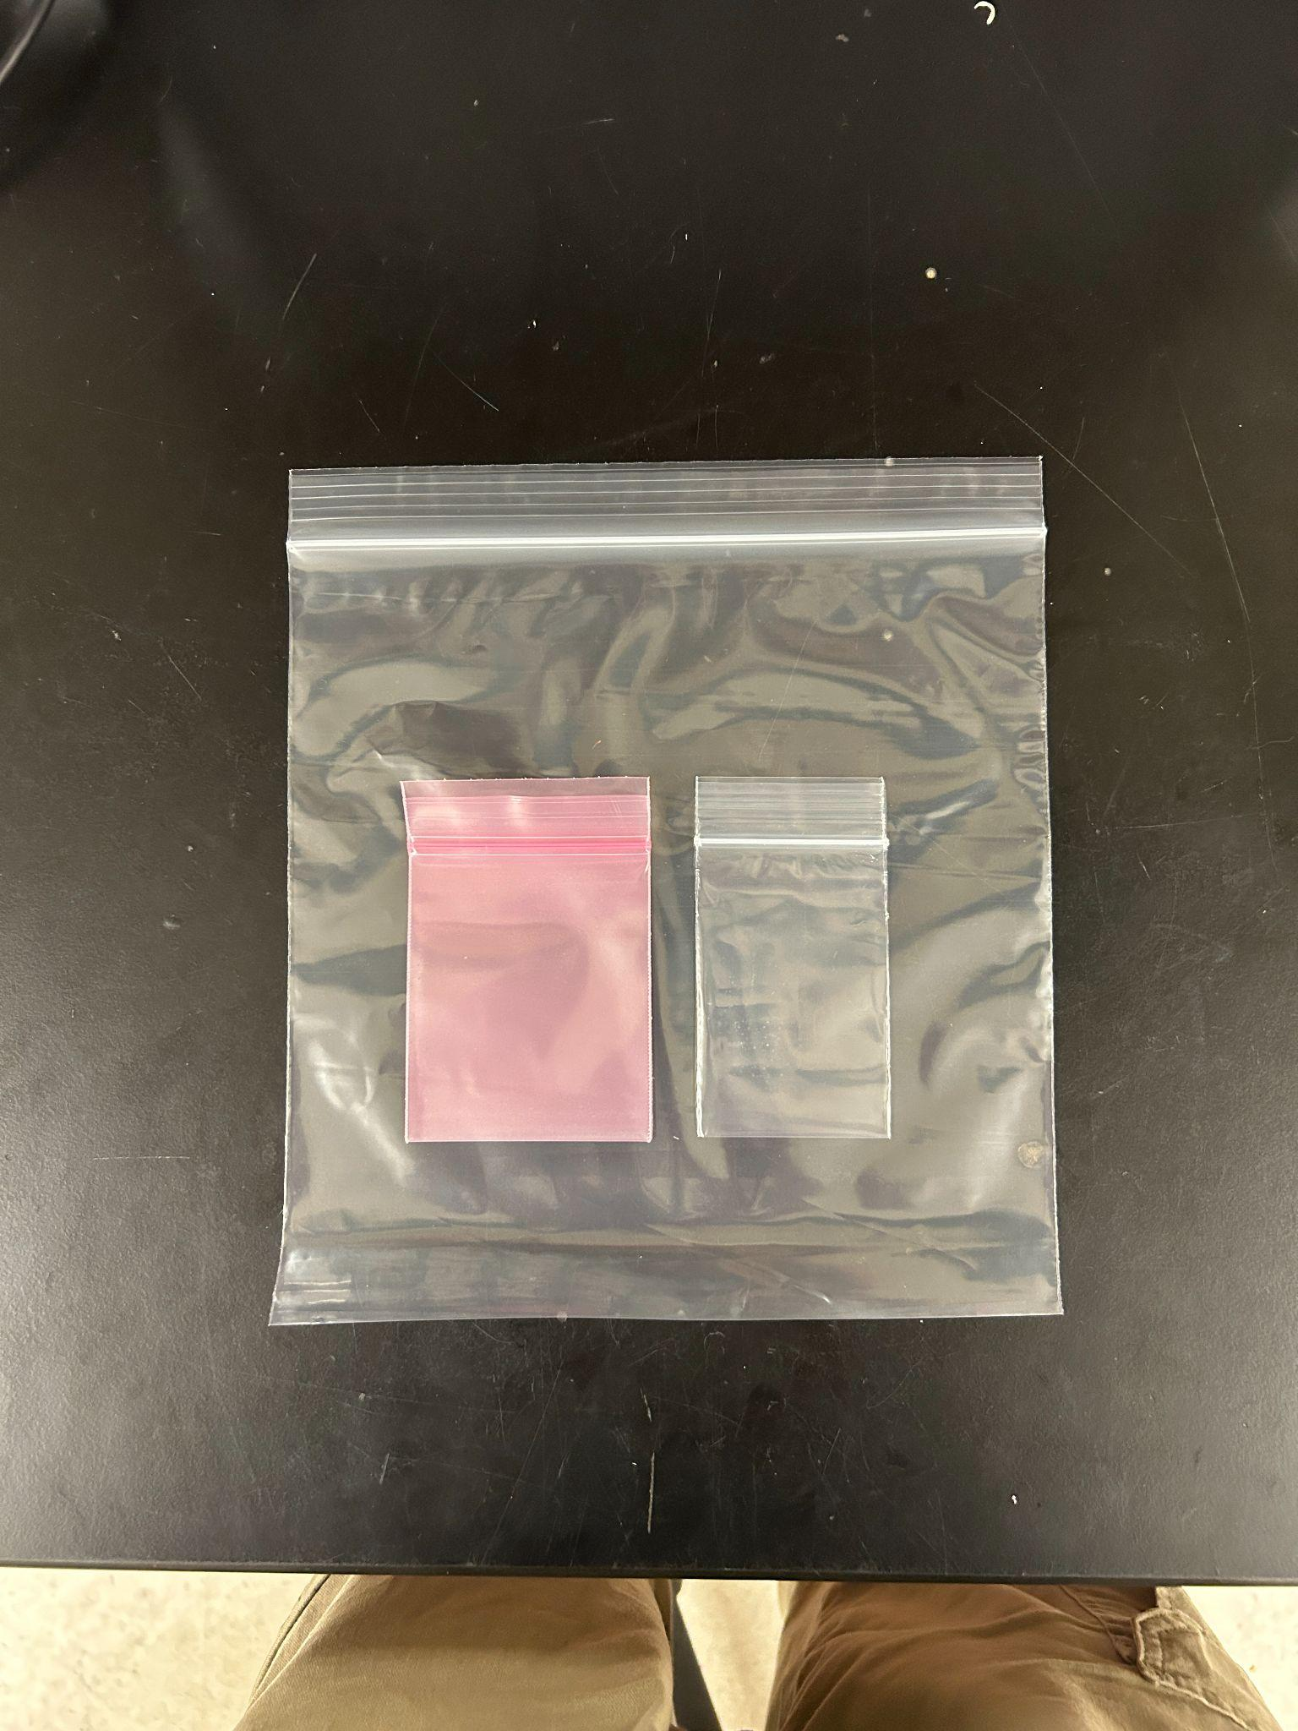

Print out labels (on label sheets) and your instruction manual (staple it). There are three types of bags we use. The large clear bag will contain all electronic components, the pink pag is for sensitive components, and the small clear bag is for non sensitive components.

All resistors and capacitors are non sensitive components

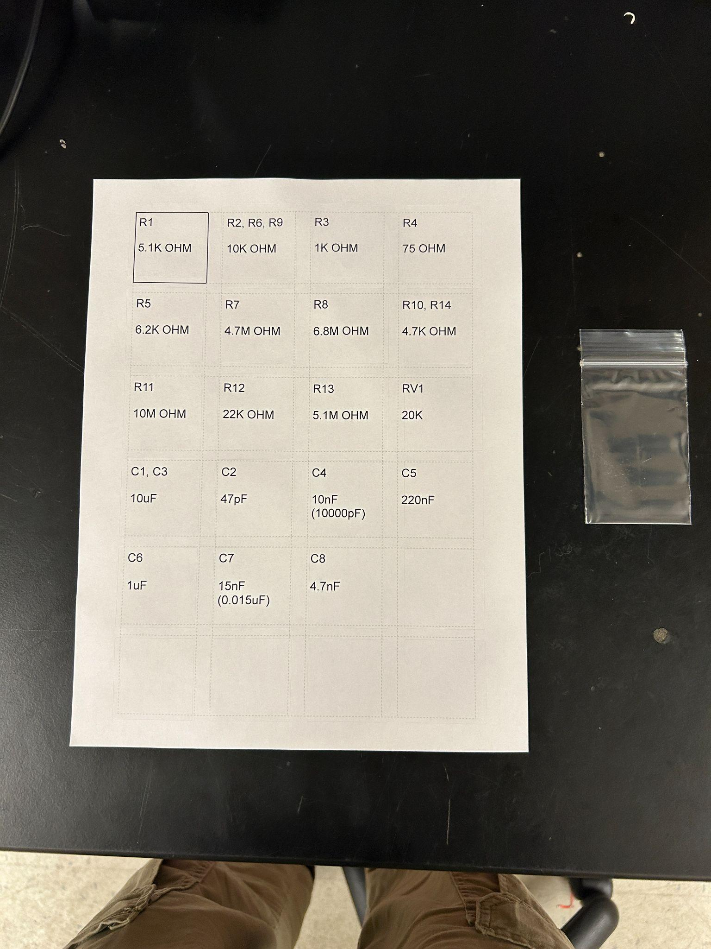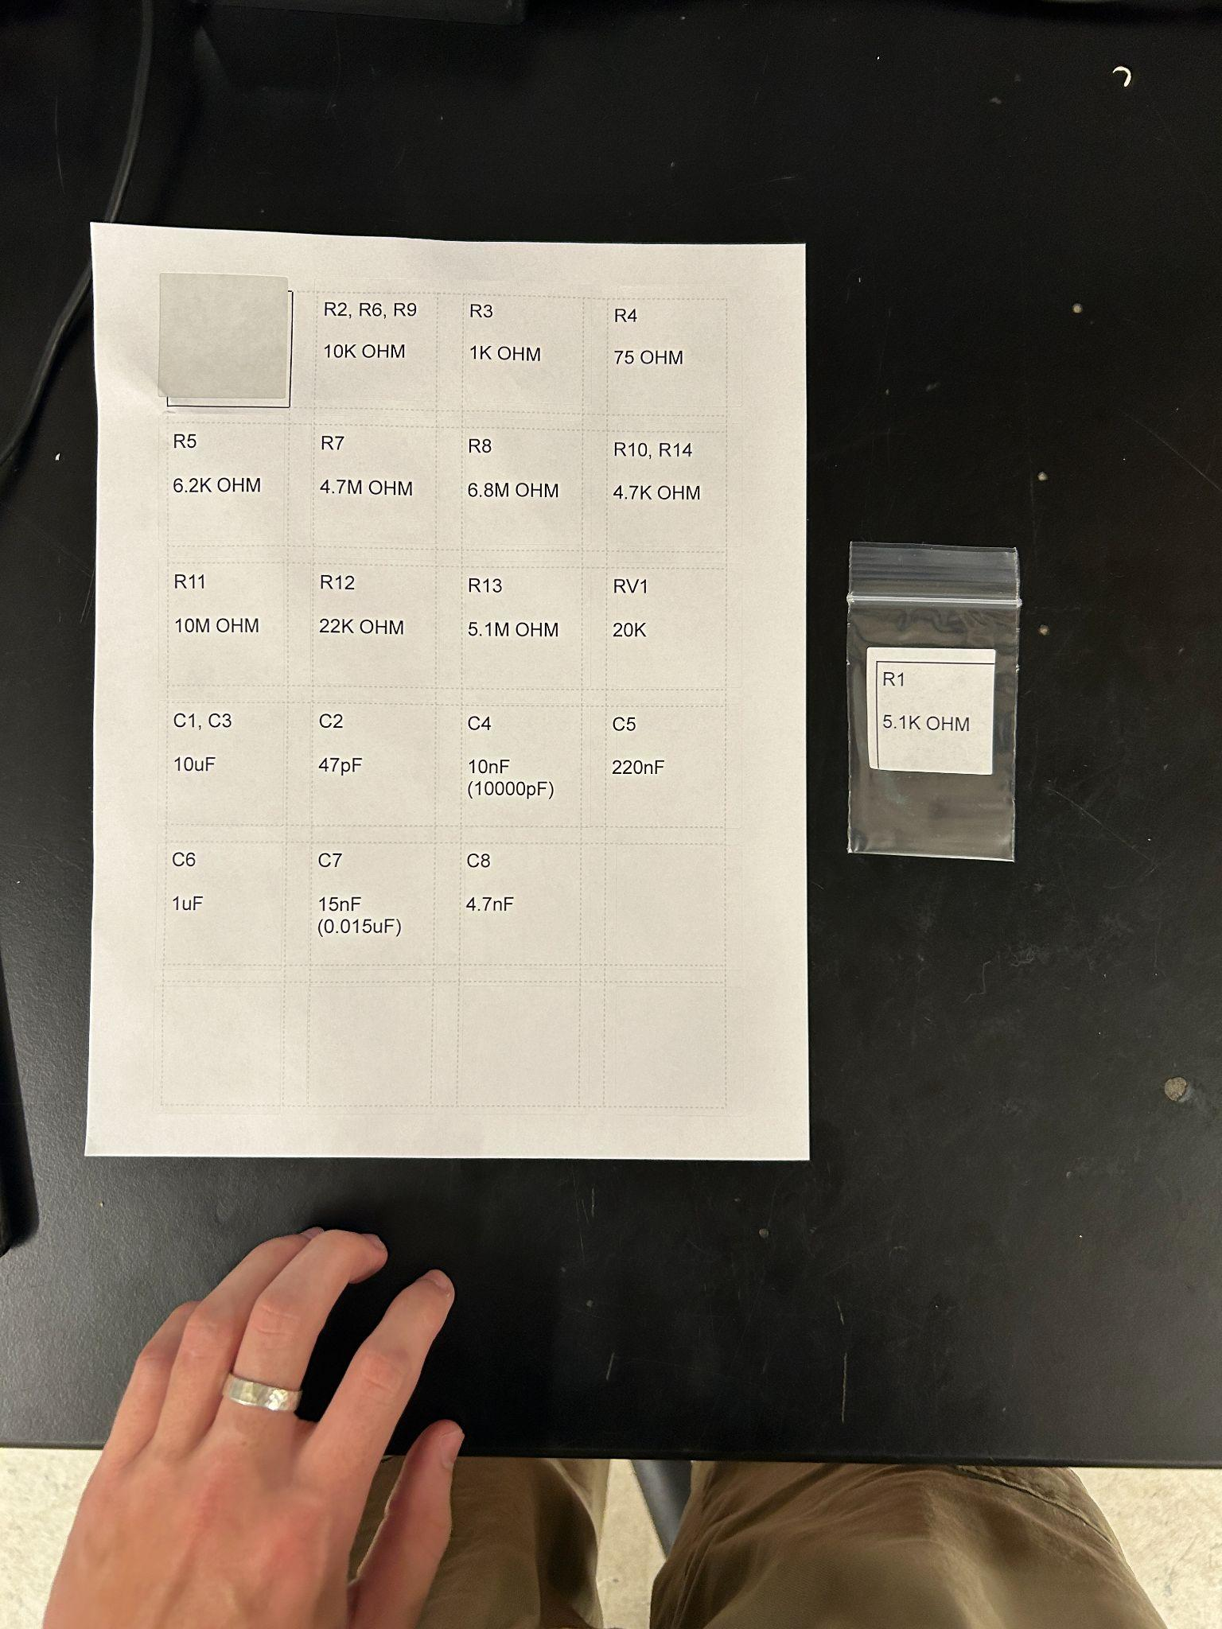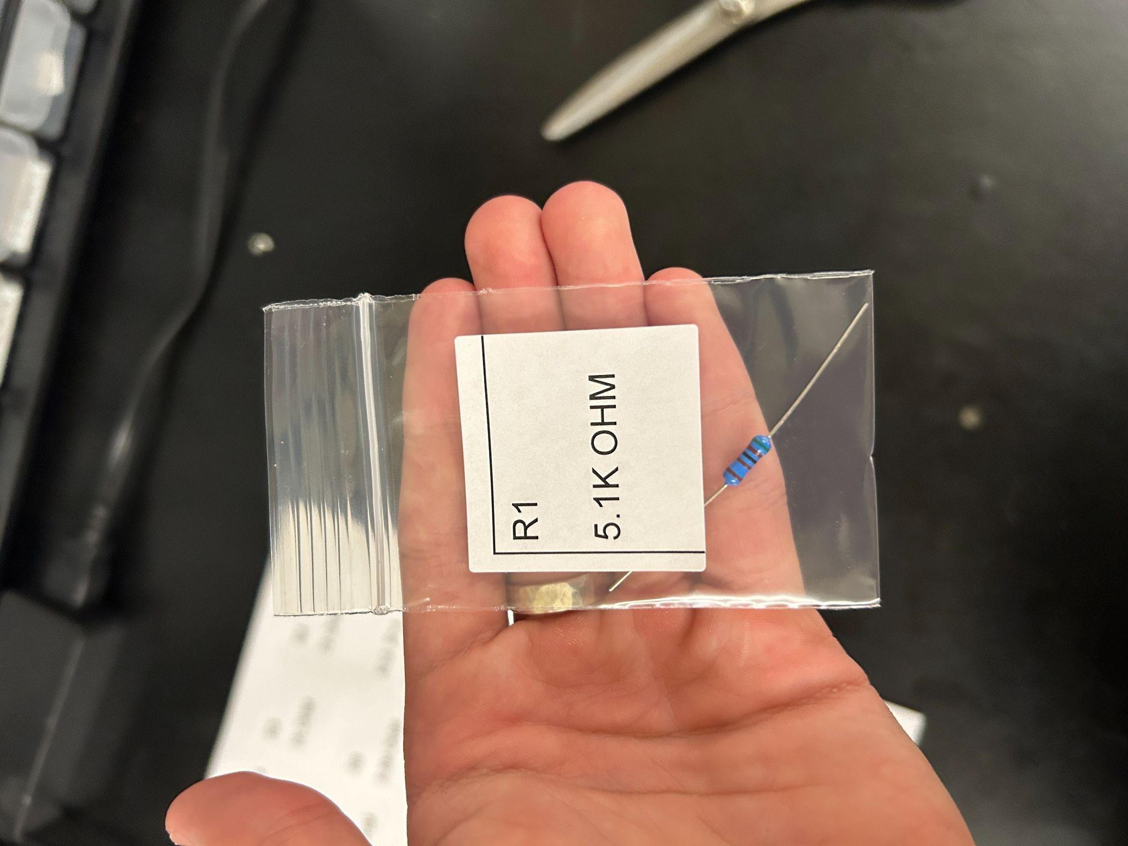

Non sensitive components also include L1 and RV1. Pretty simple, just put the label on the bag, then the component in the bag. Do this for all resistors and capacitors, L1 and RV1.

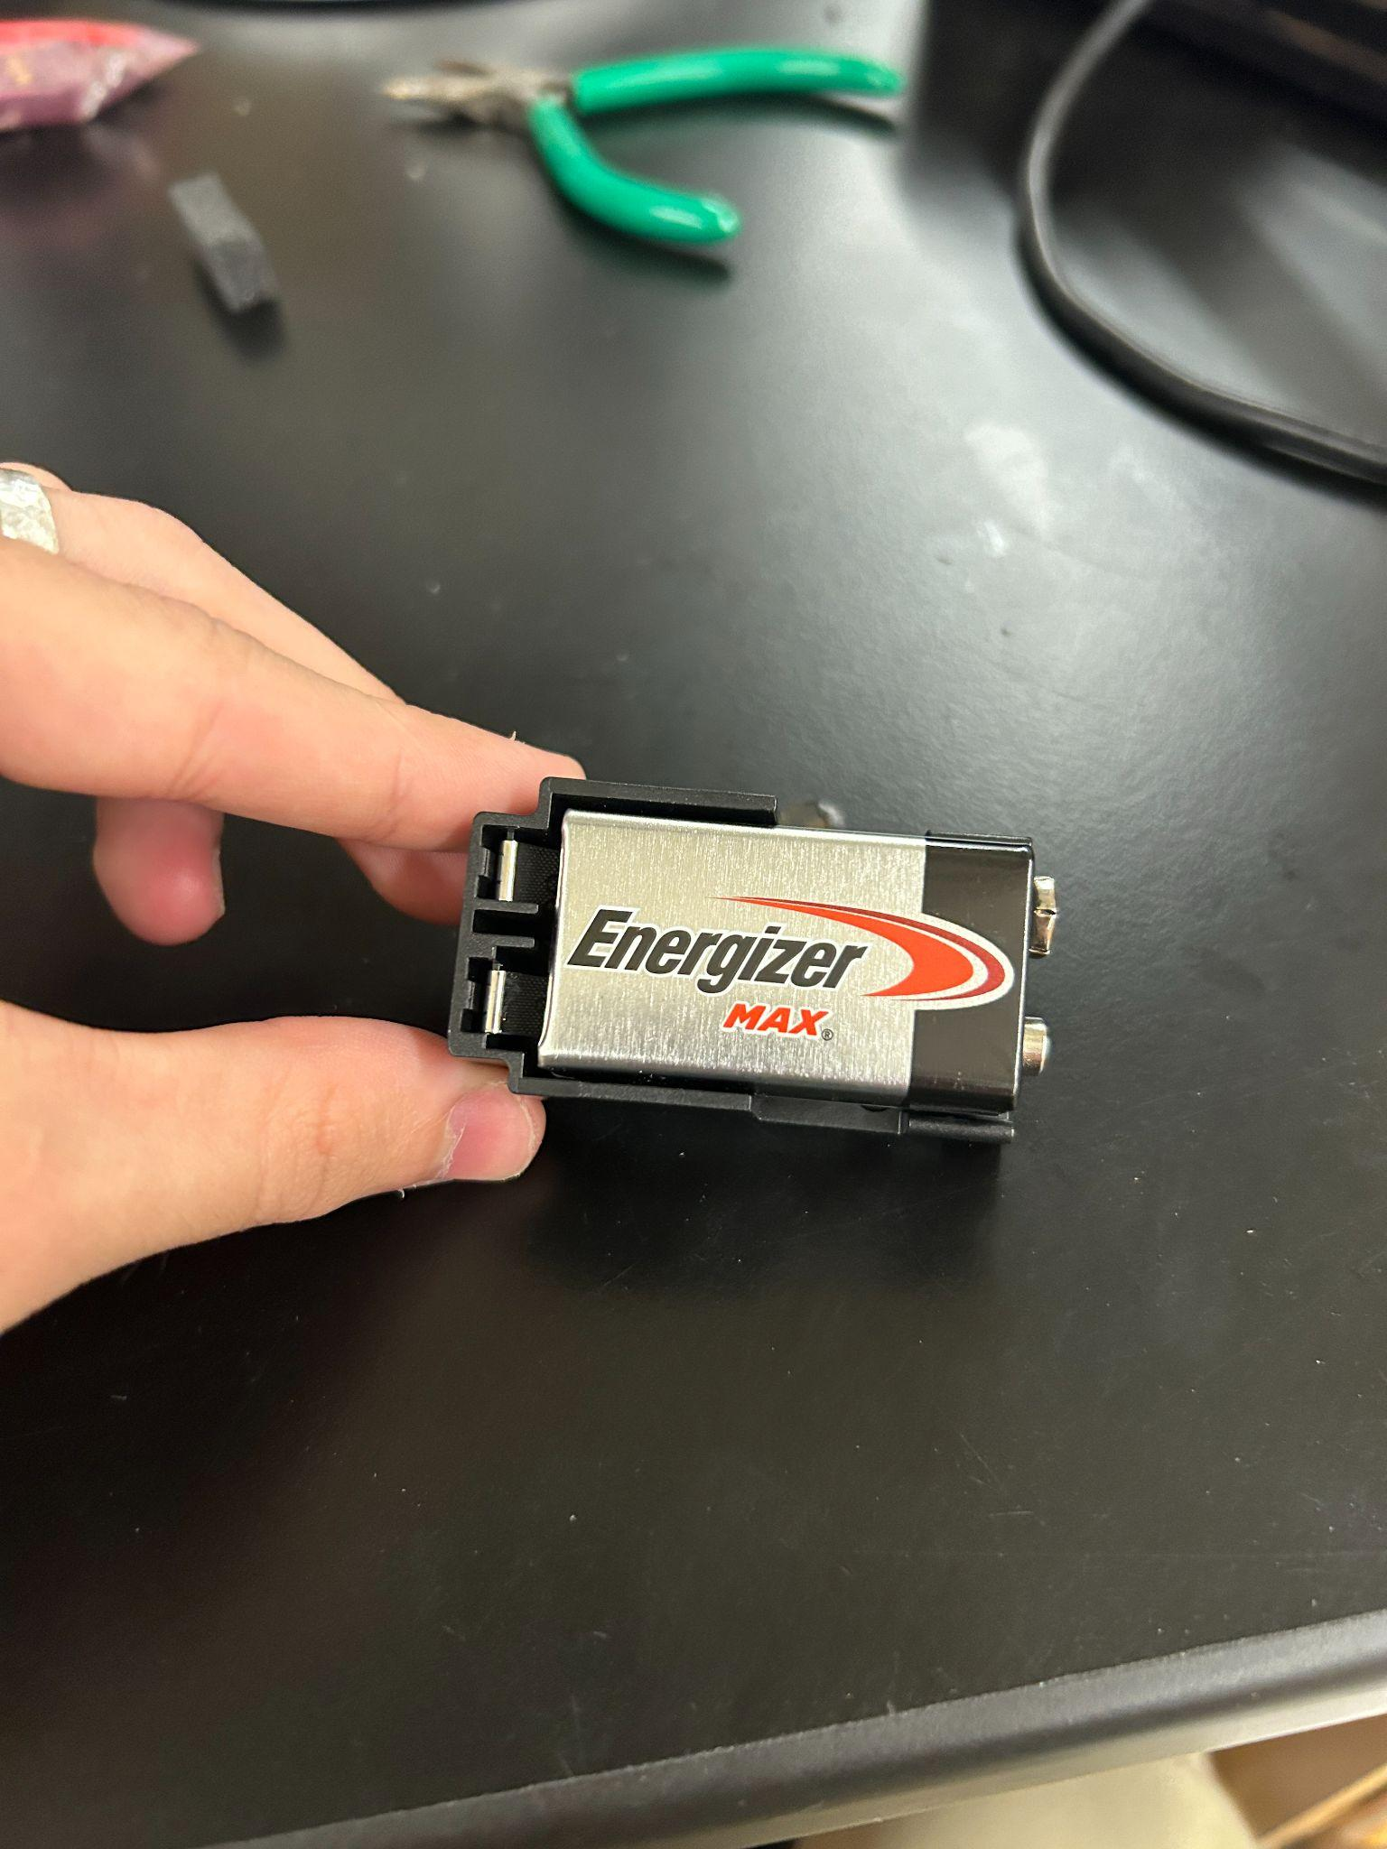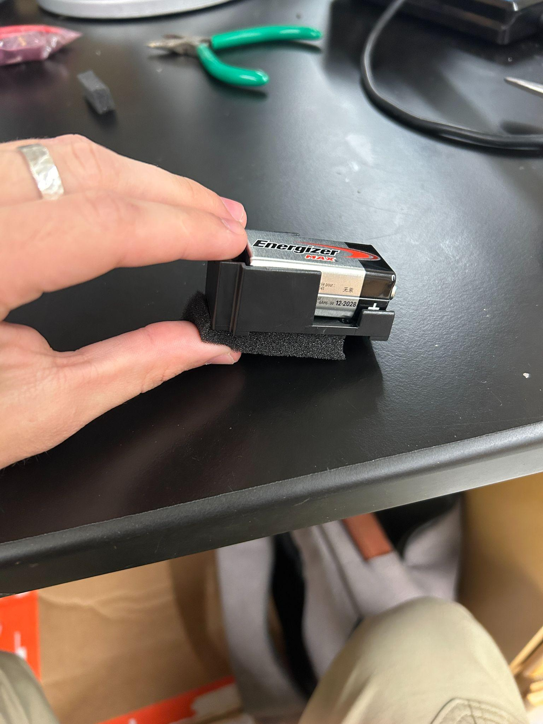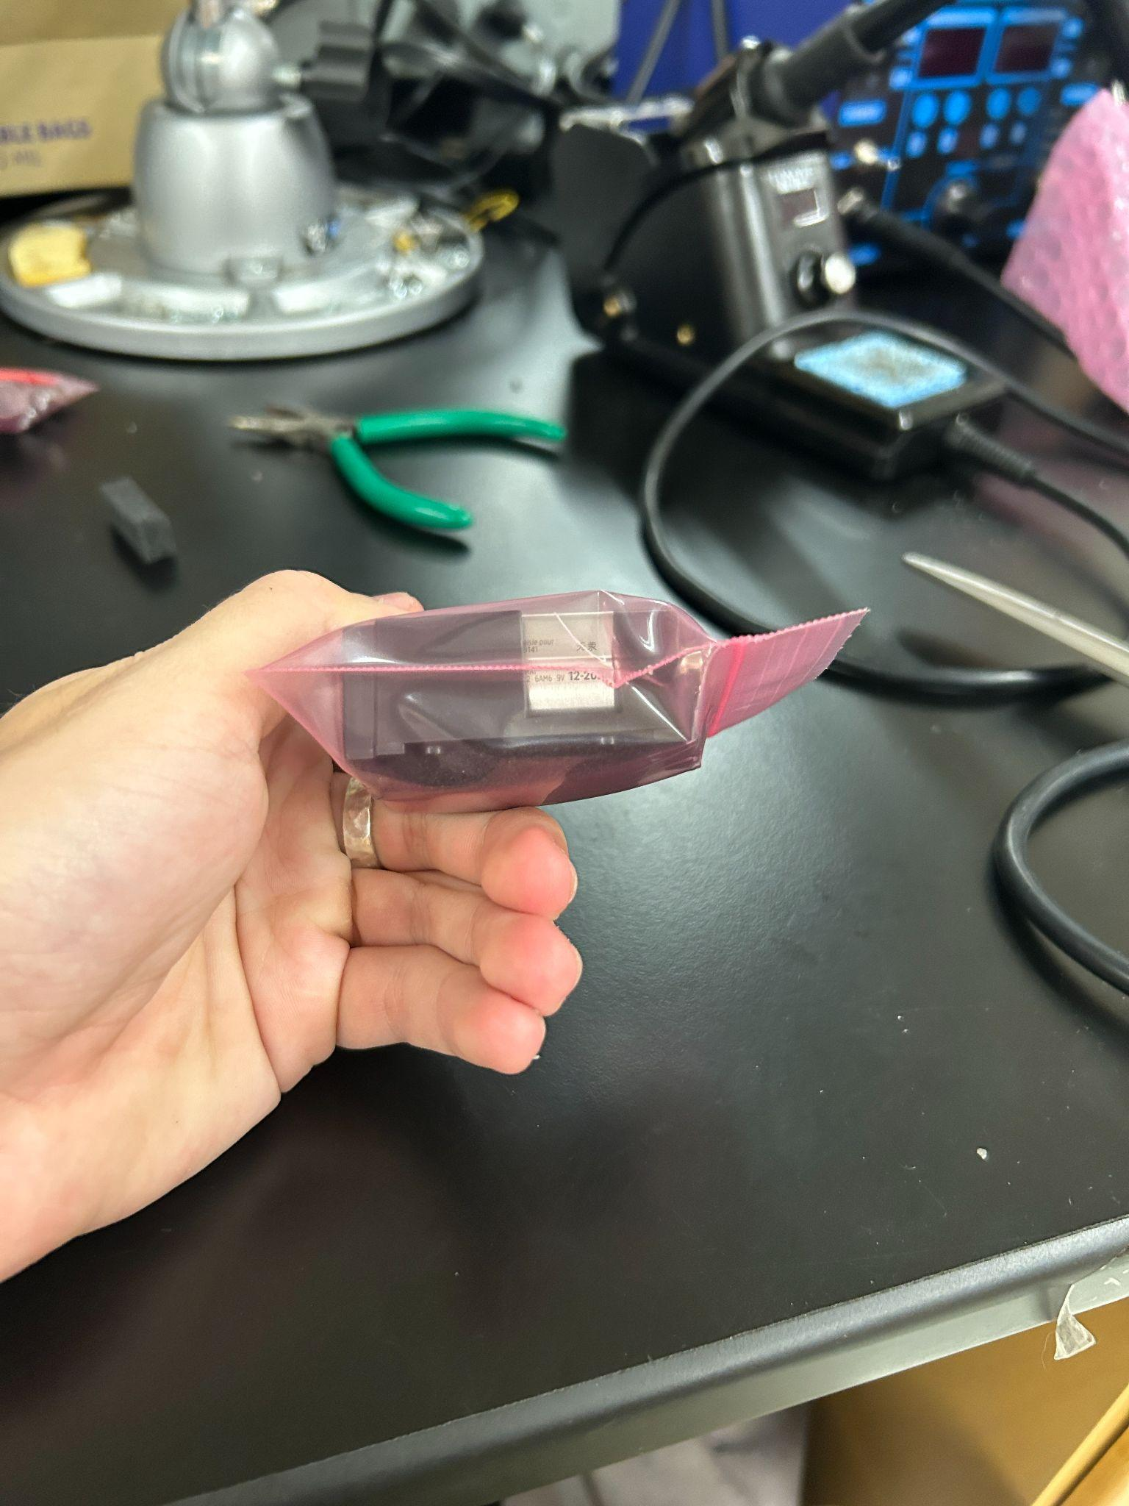

Put the battery in the holder backwards, put a bit of foam on the bottom, and put it in one of the pink bags. It’ll be tight but you can make the bag close if you try

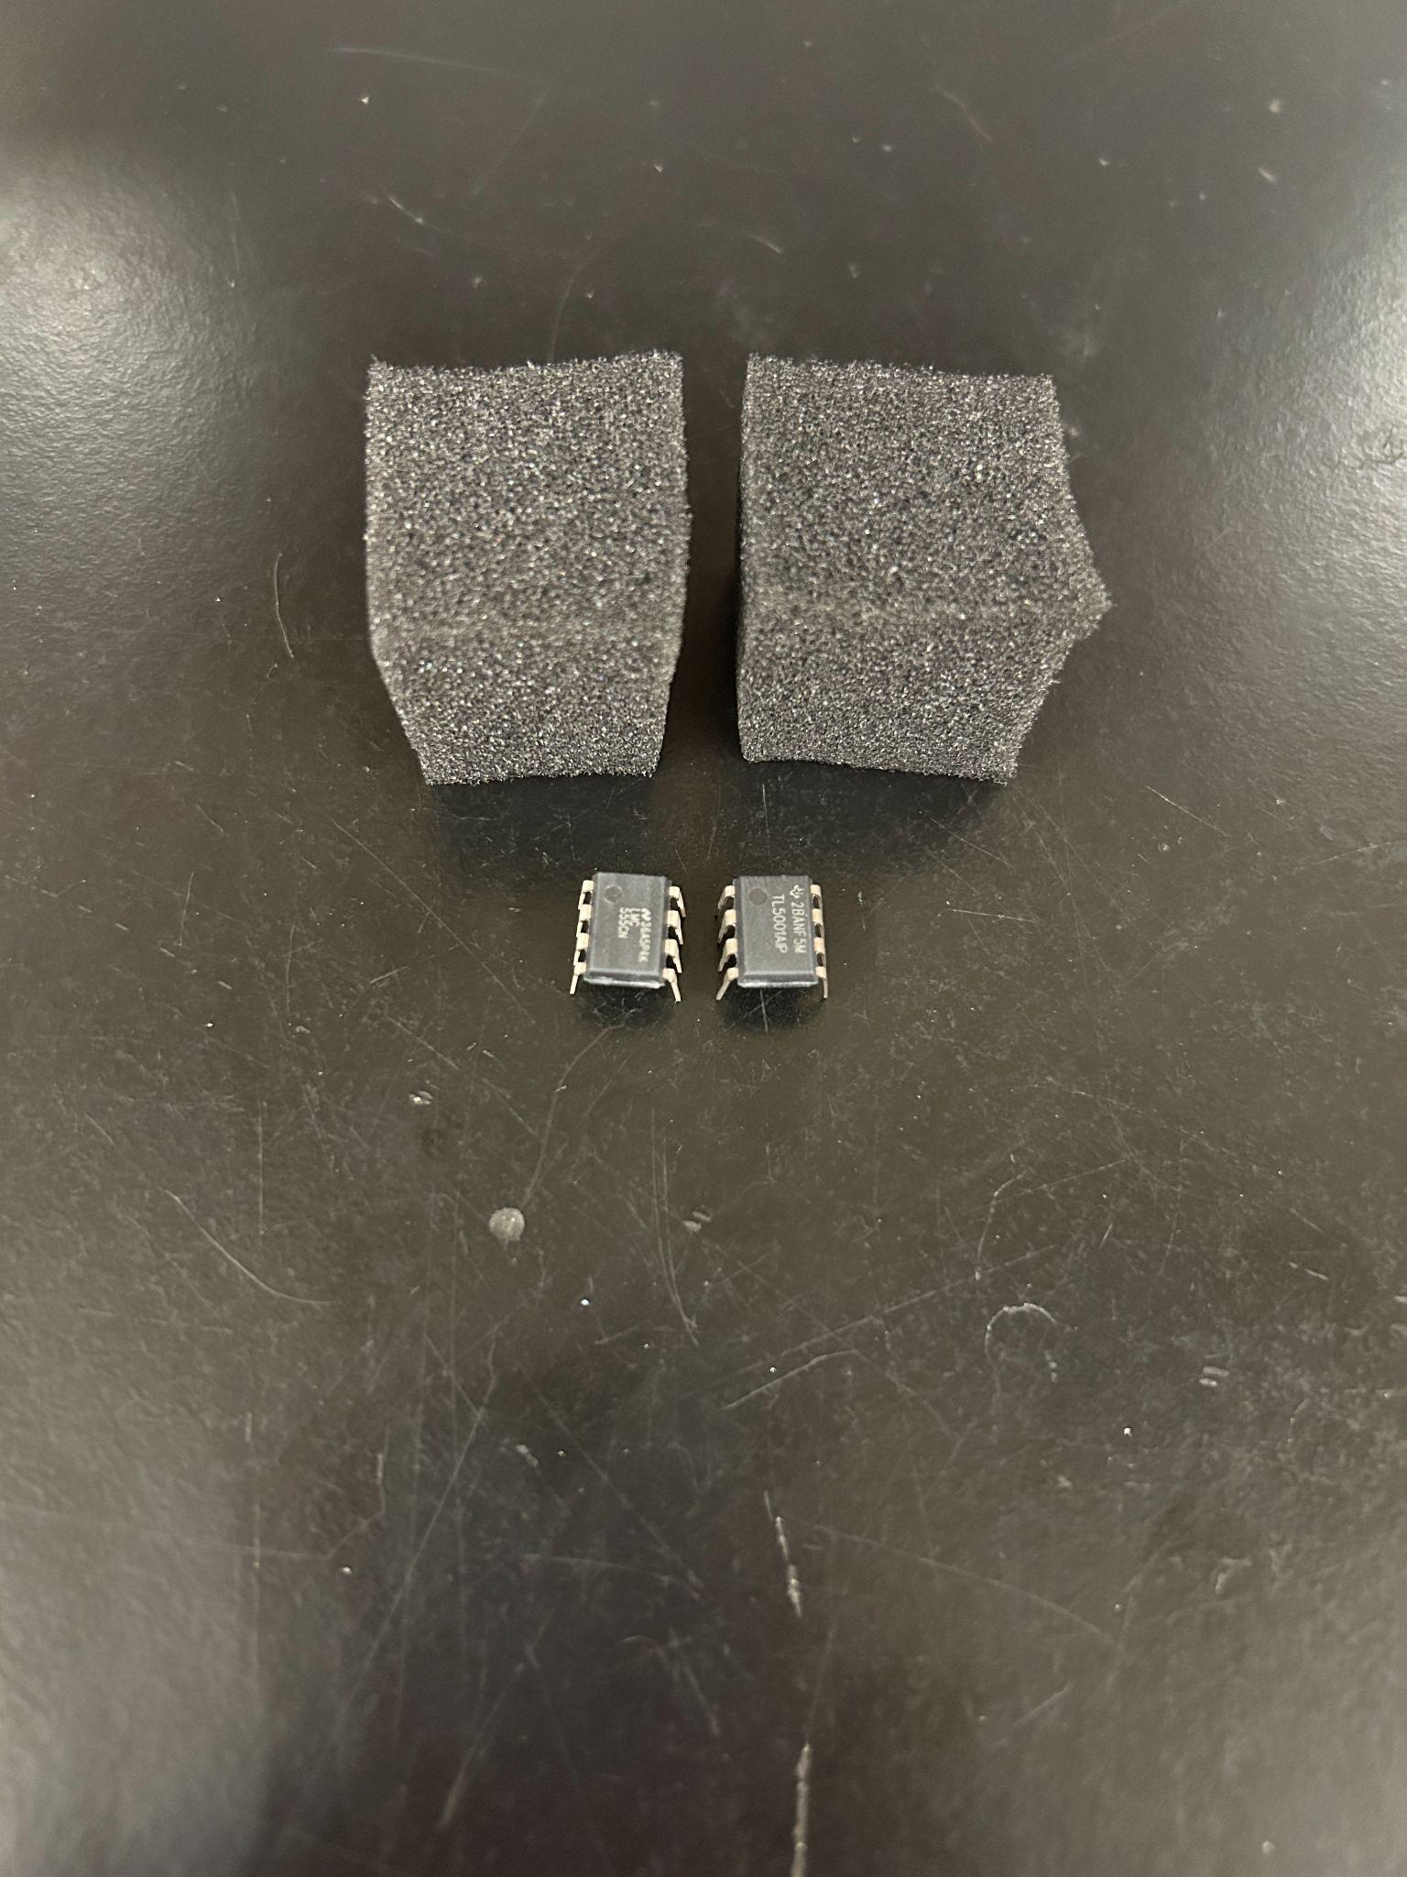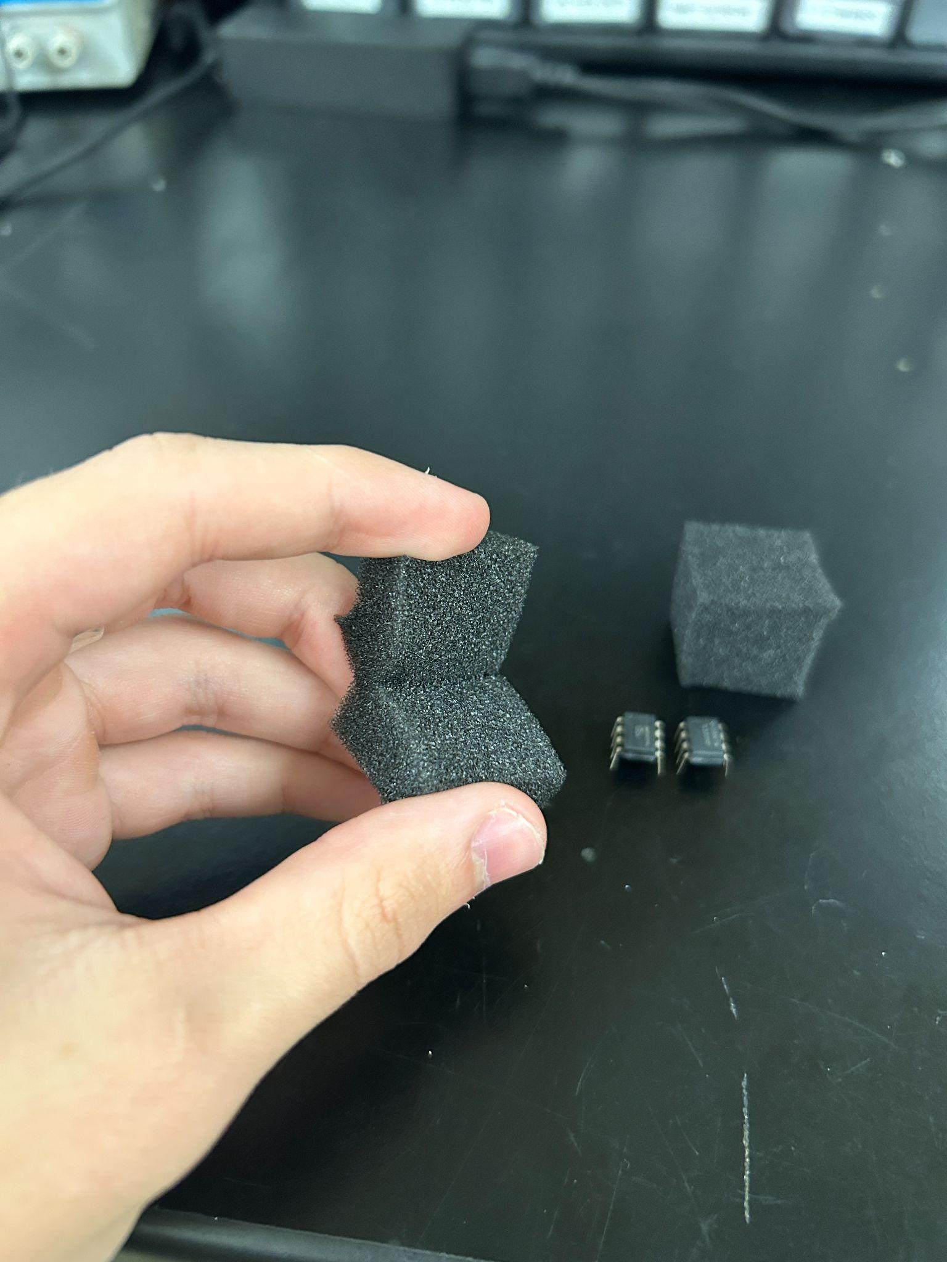

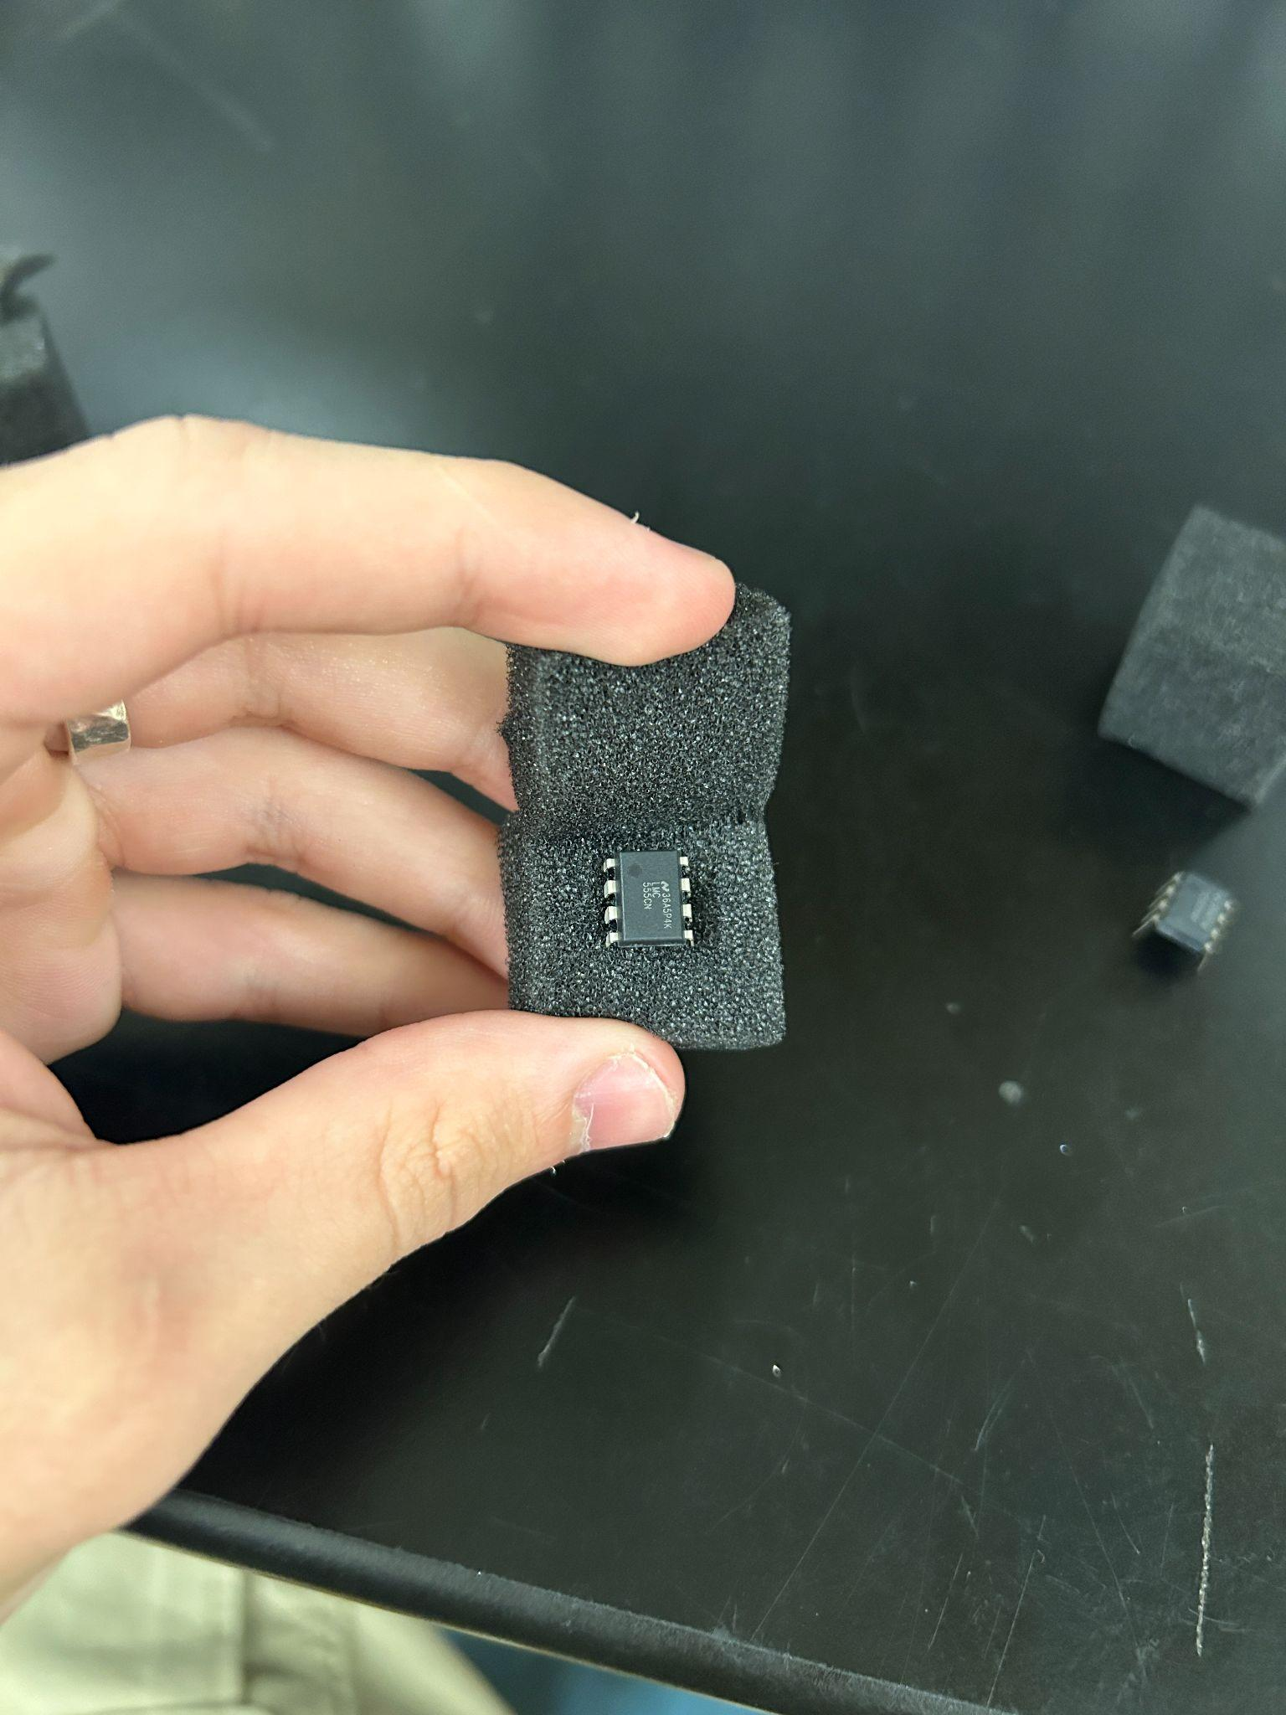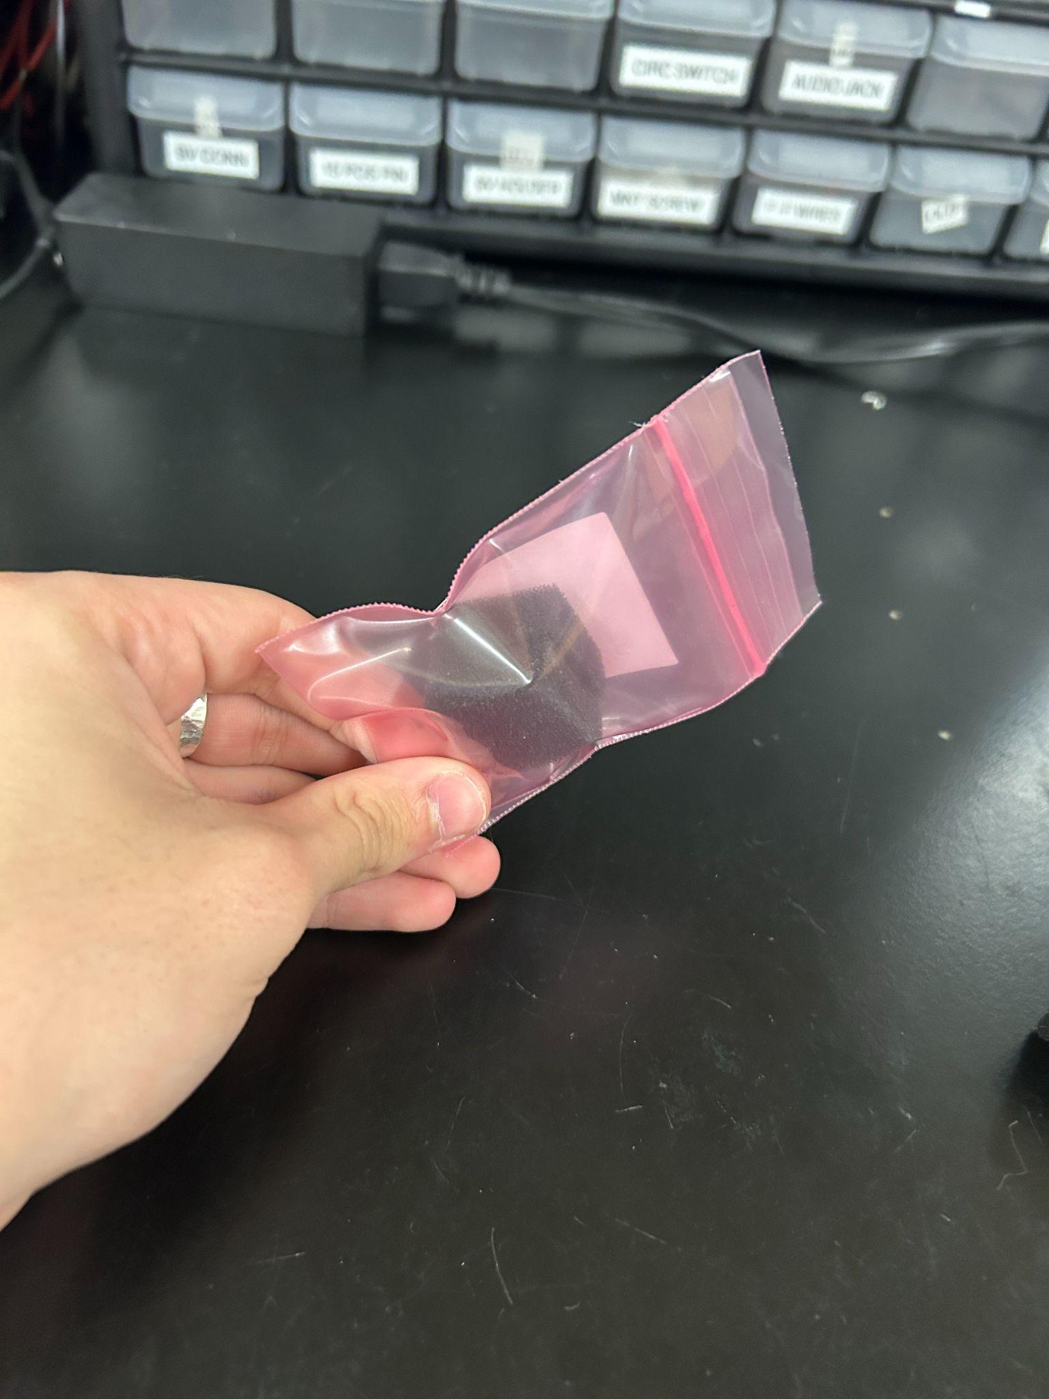

Package the LMC555 and TL5001 chips in about a square inch of foam so the legs are safe.

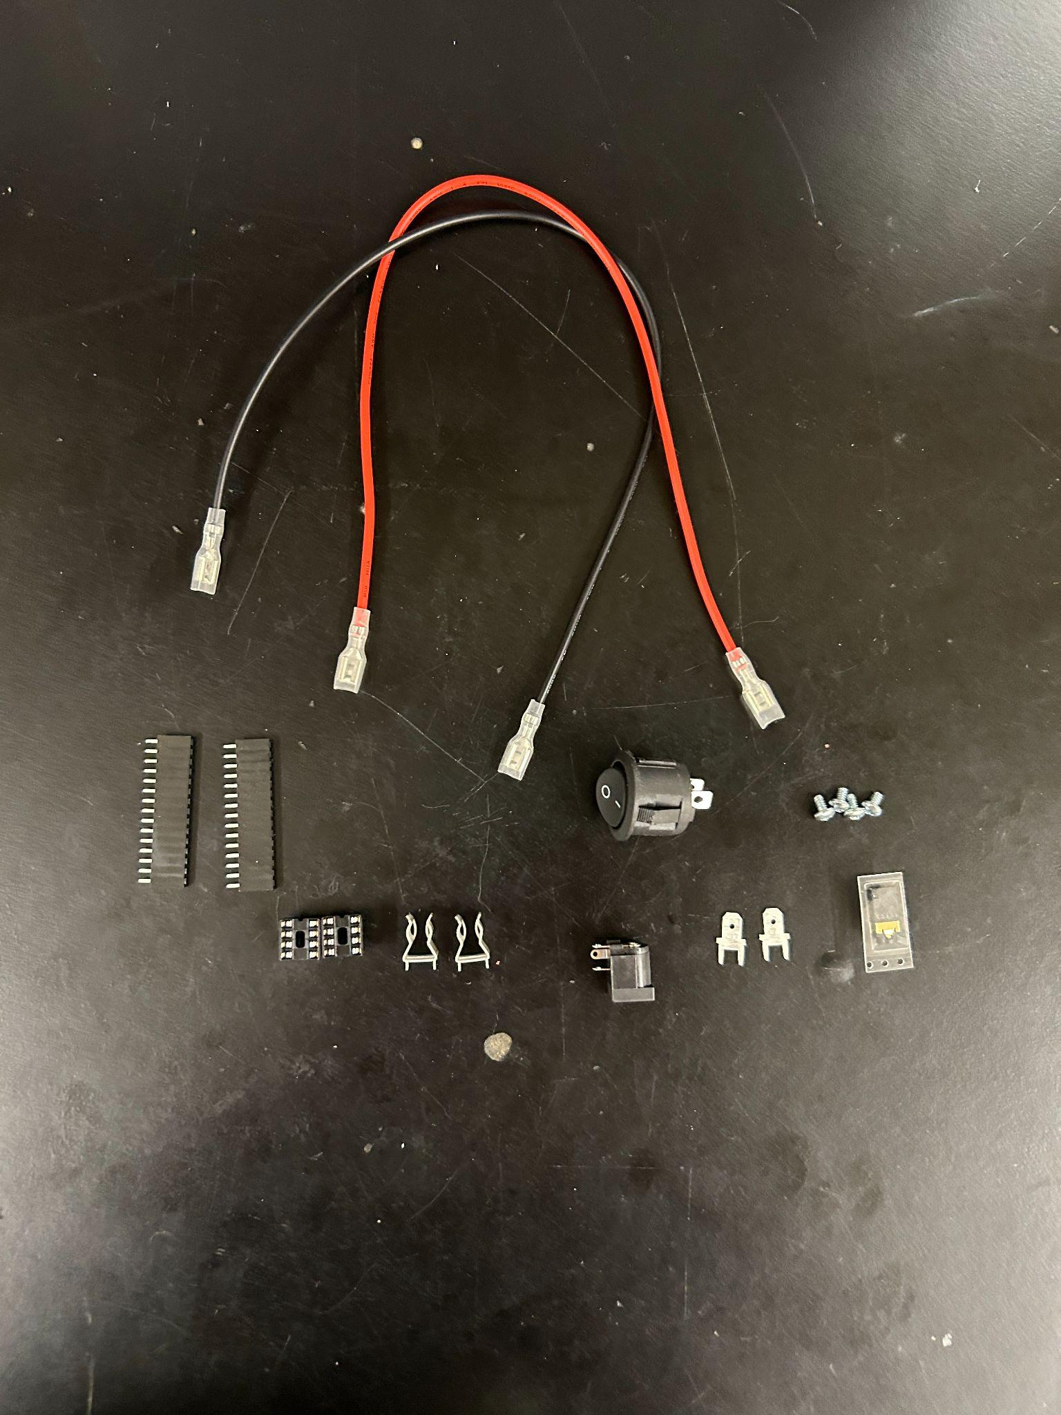

Put all components shown here in one pink bag (misc)

* DIP-8 (2)
* Fuse Clips (2)
* Spades (2)
* Audio Jack (1)
* SCREW 2, (for board mounting) (4)
* F-F Wires (2)
* 15 Pos Header (2)
* Switch (1)
* PWR Jack (optional) (1)

Everything else not mentioned is a sensitive component and should be put in its own pink bag, you should have something that looks like this at the end.

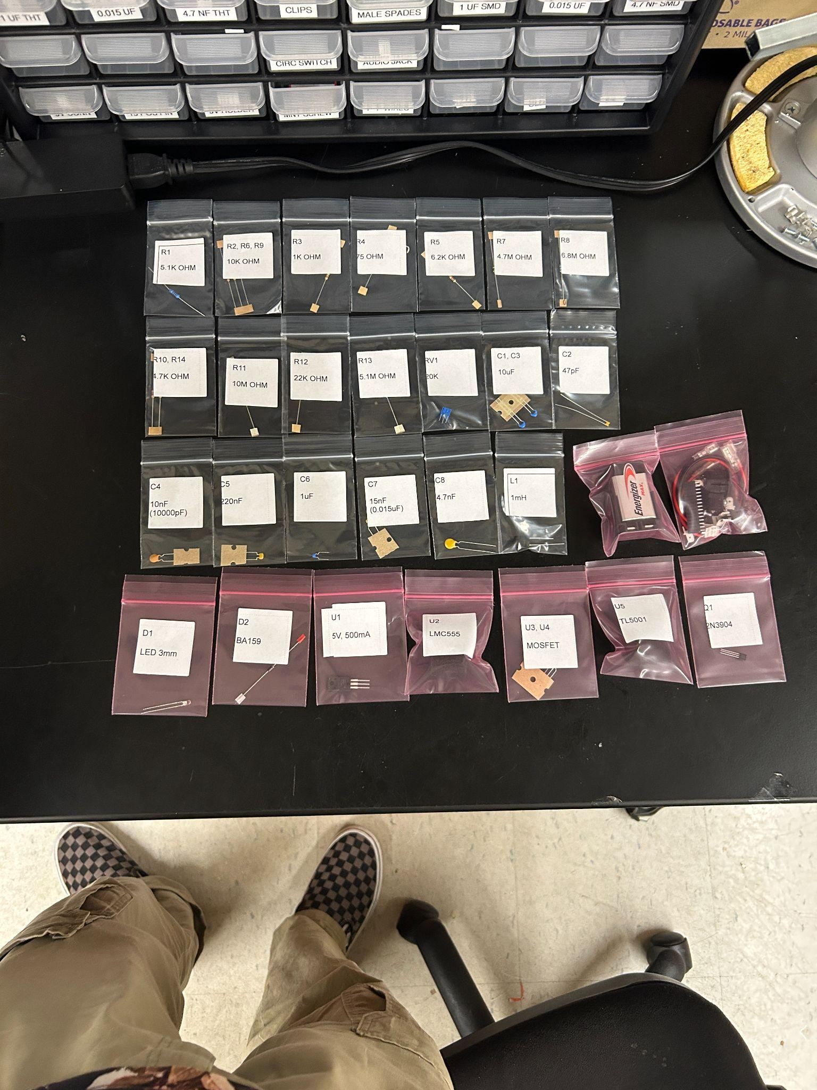

Make sure to check your bill of materials to make sure you’re not missing anything

**Step 7:**

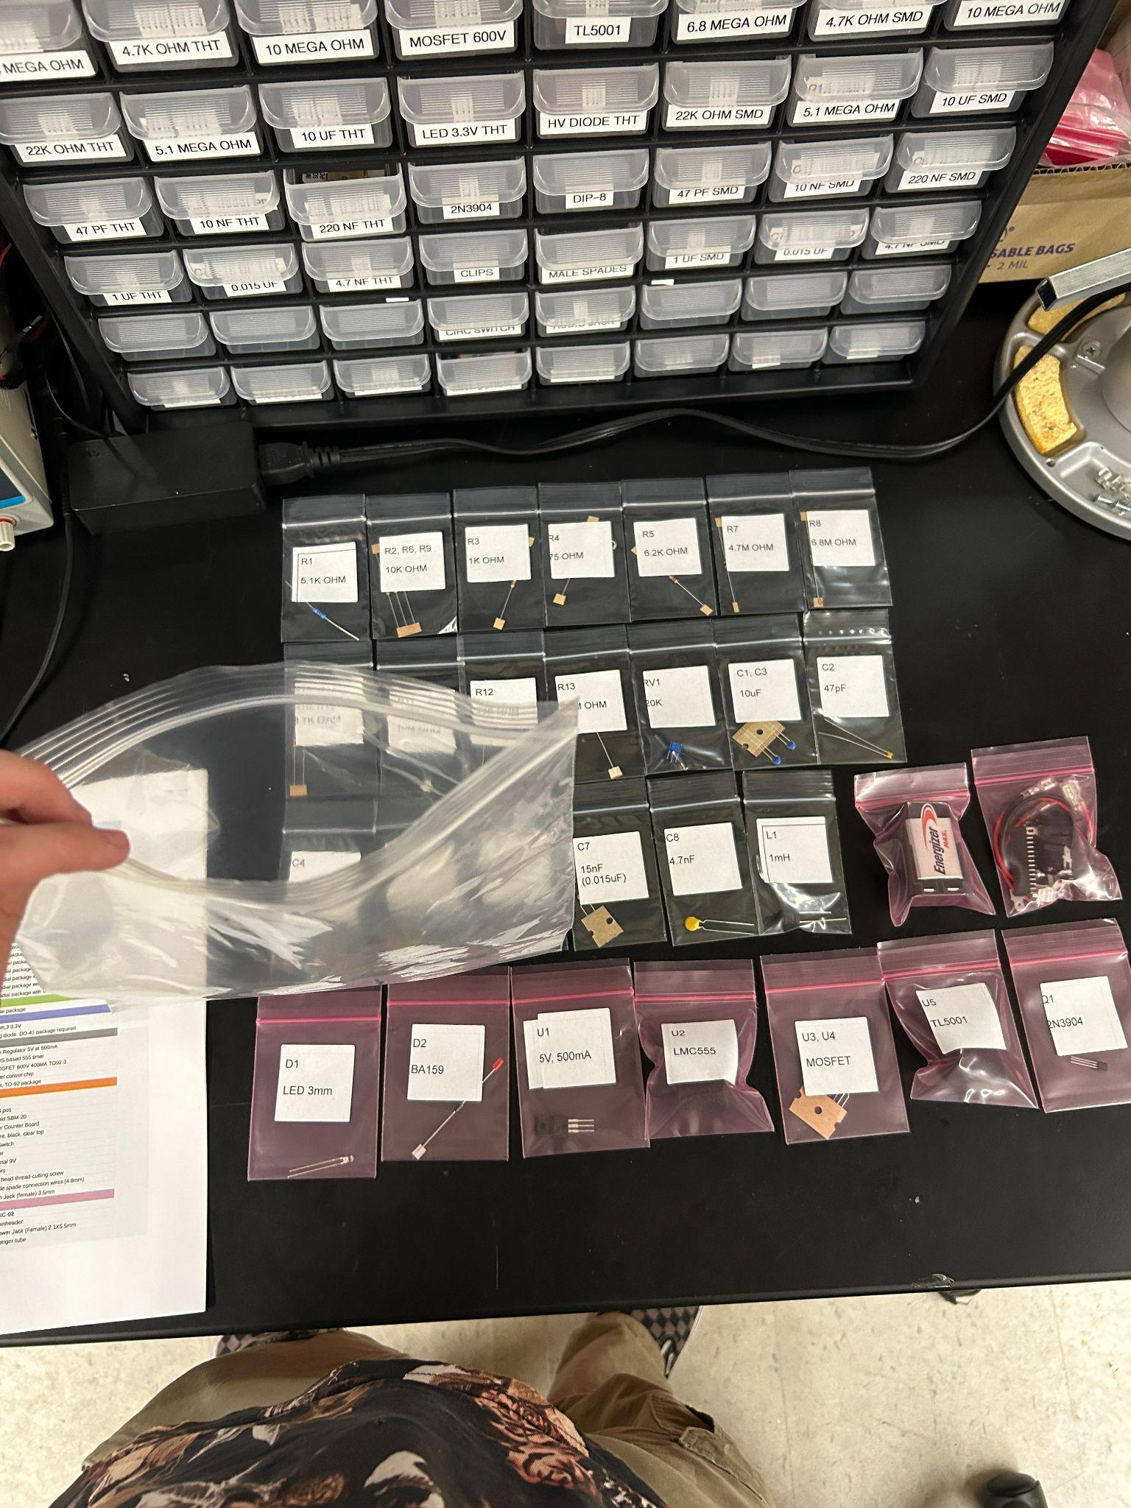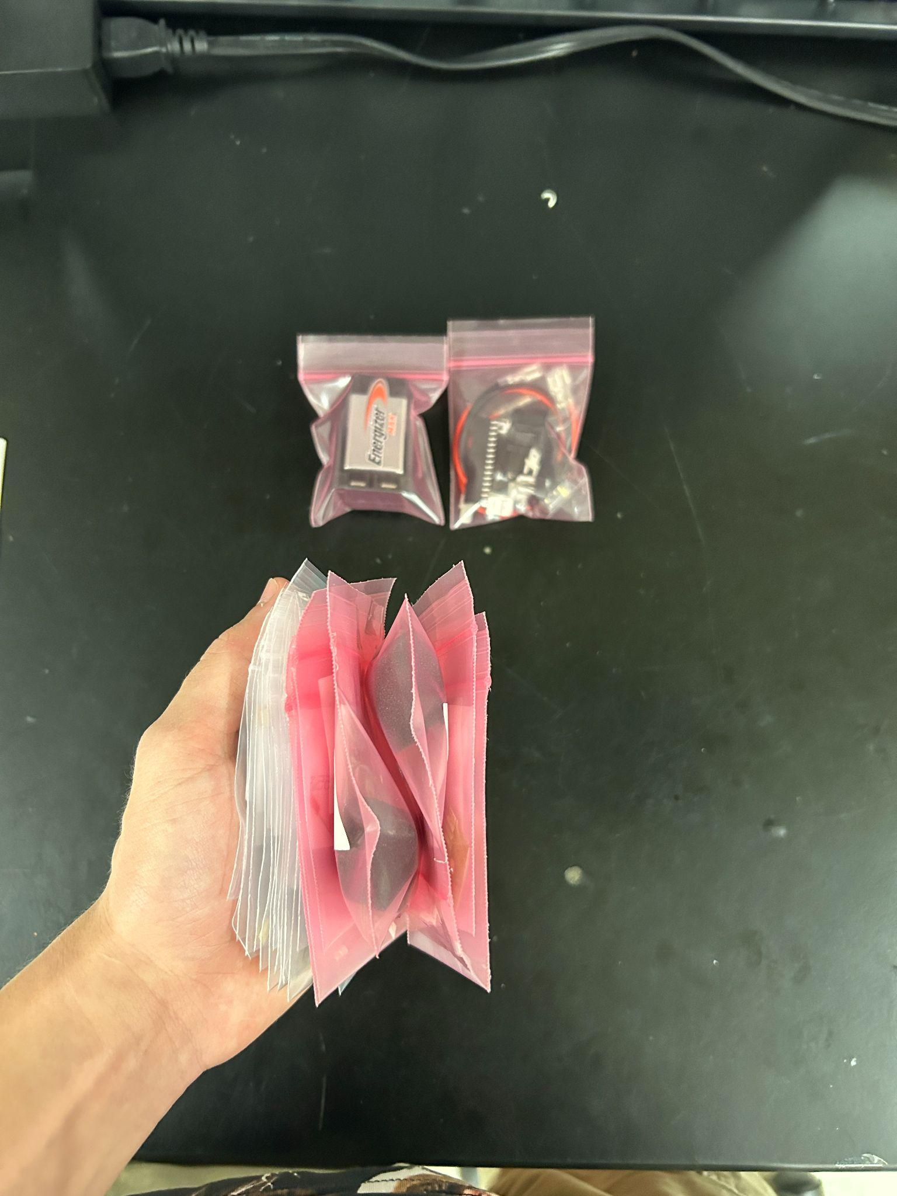

Open the large bag and collect all little bags that are not the battery bag or misc bag and put it to one side of the larger bag. Put the battery and misc bag on the other side of the big bag

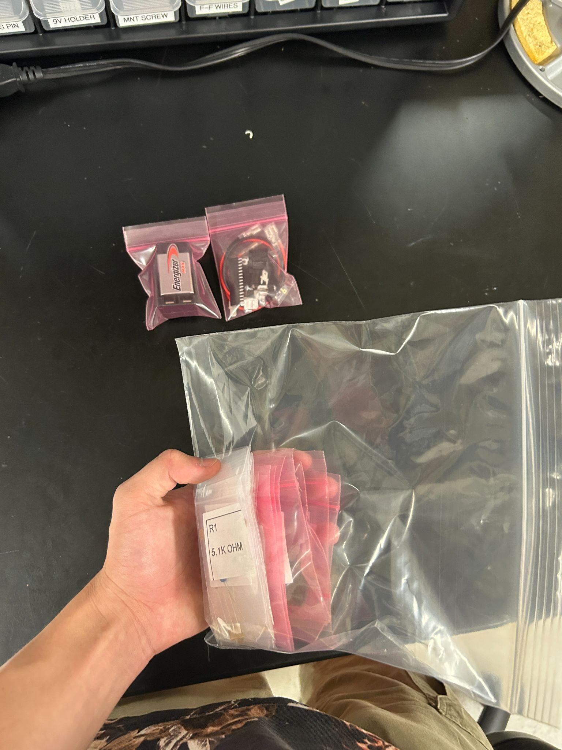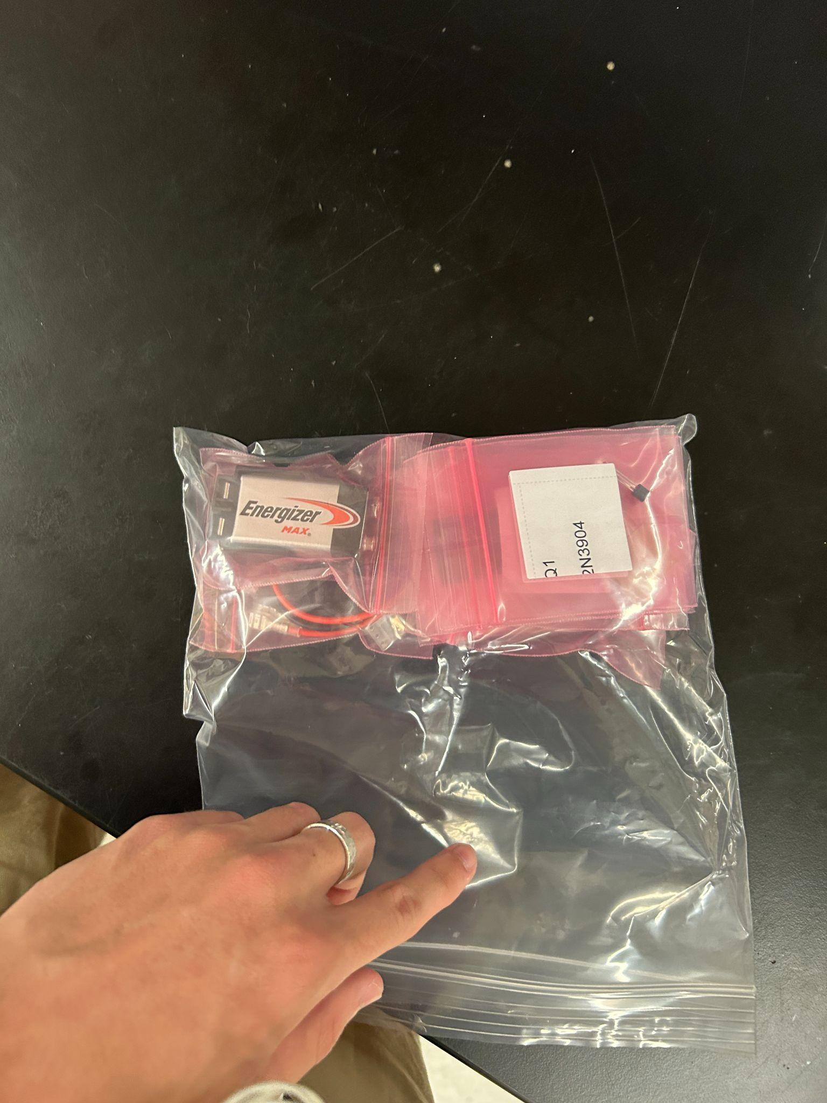



Roll the bag up and put it in the top area of the box as shown

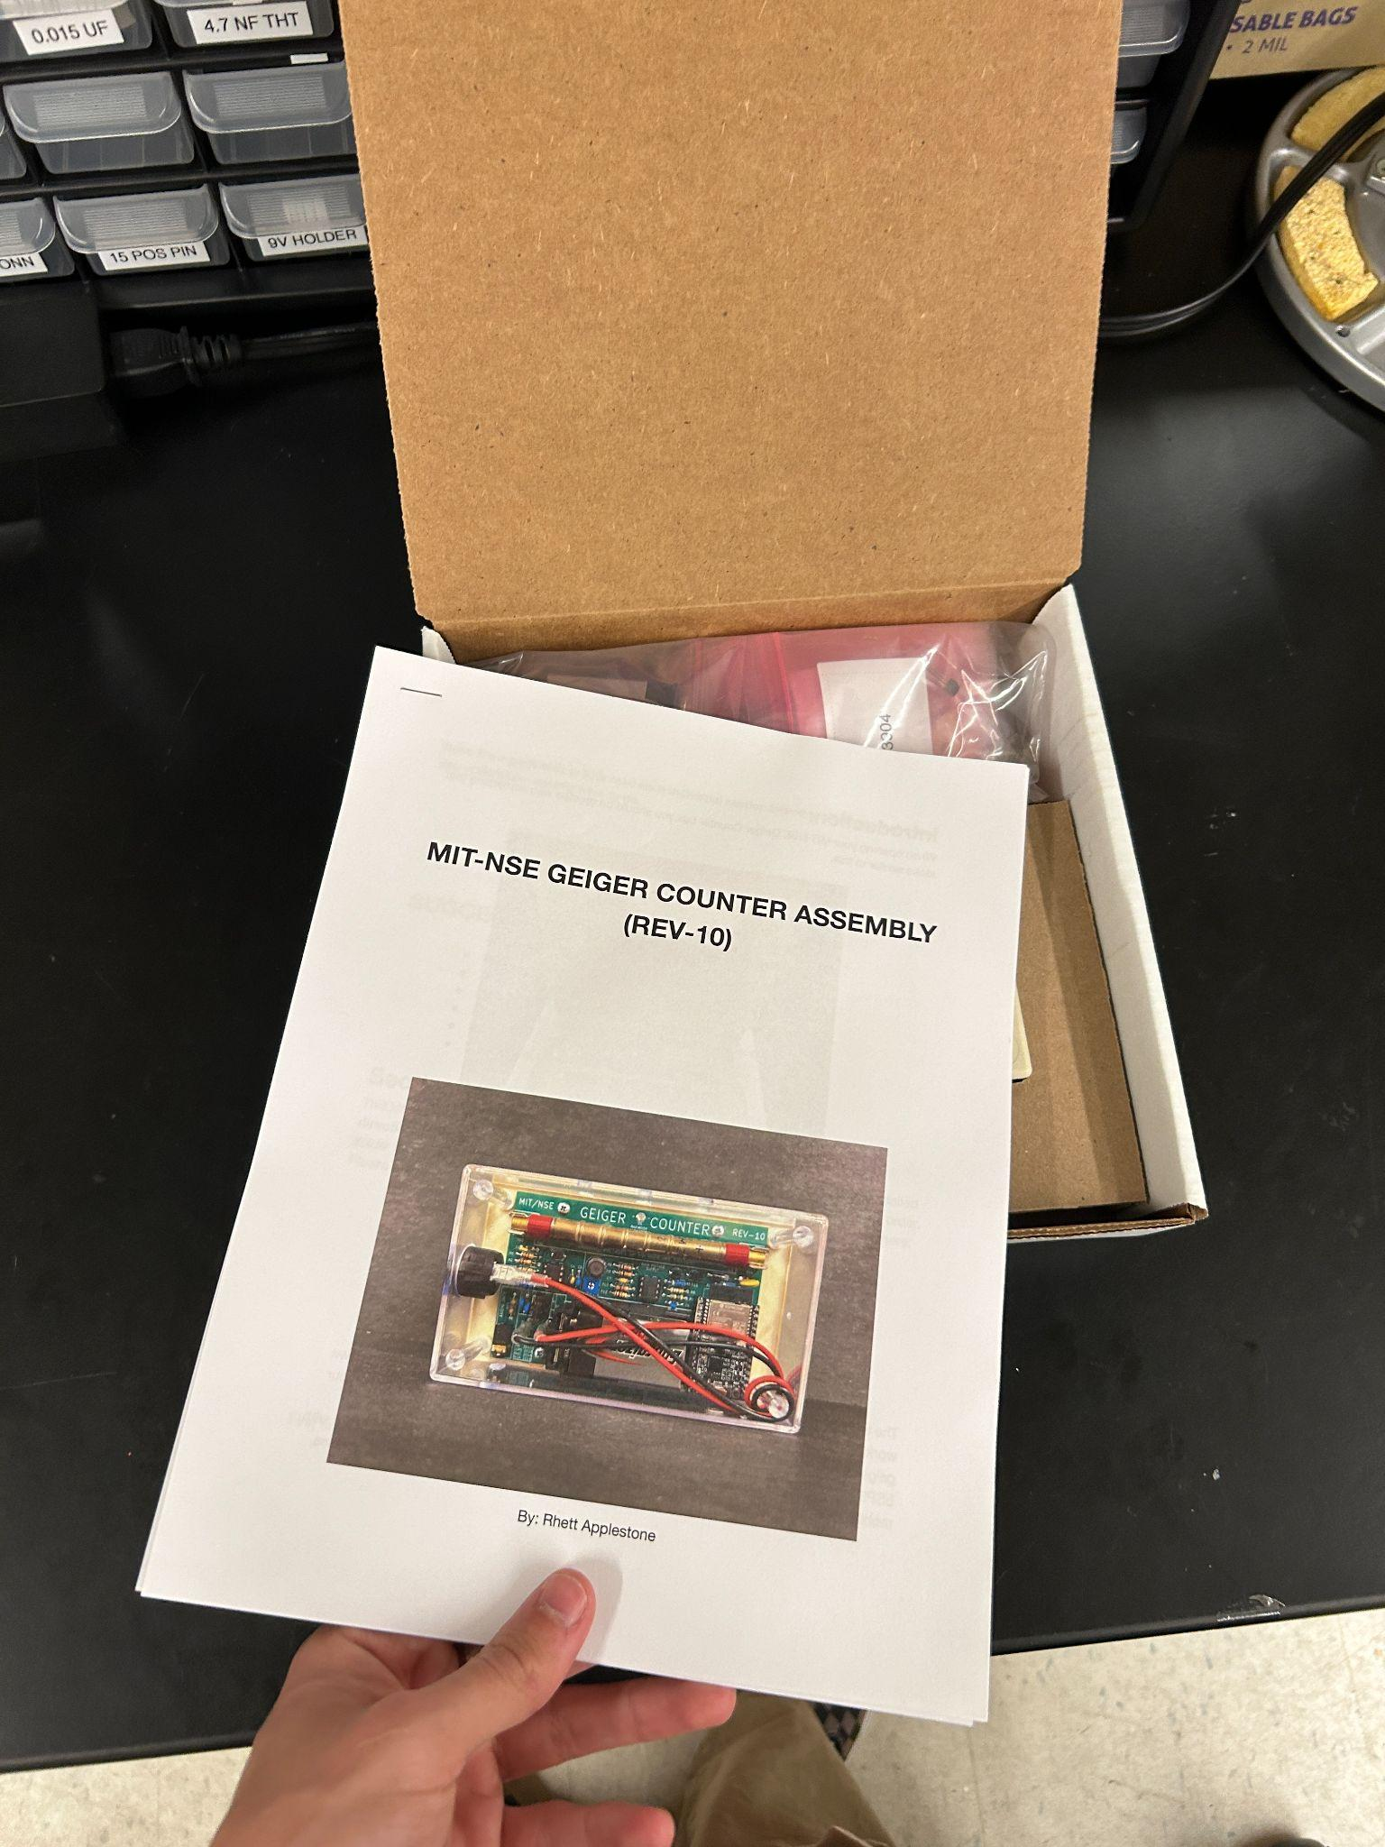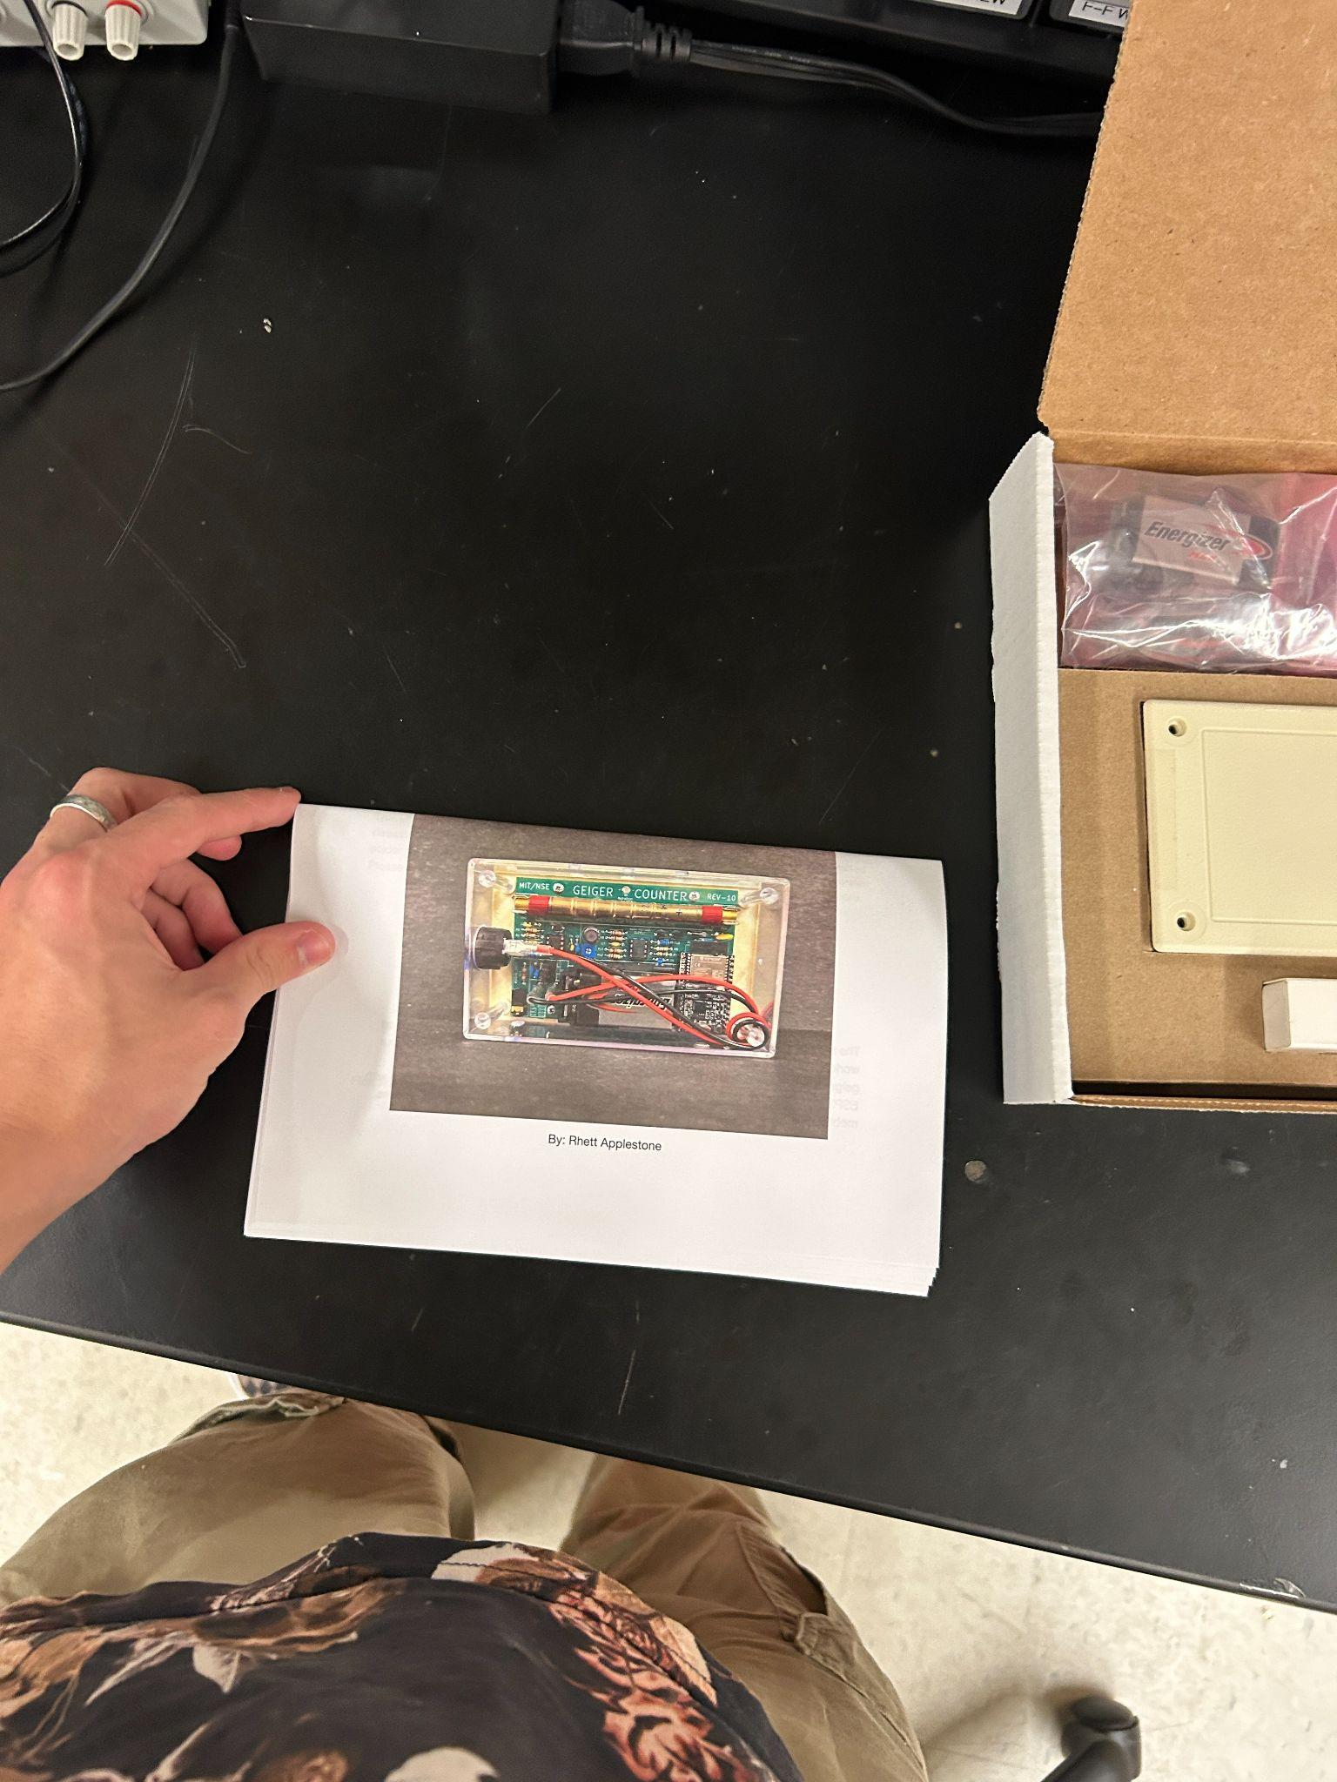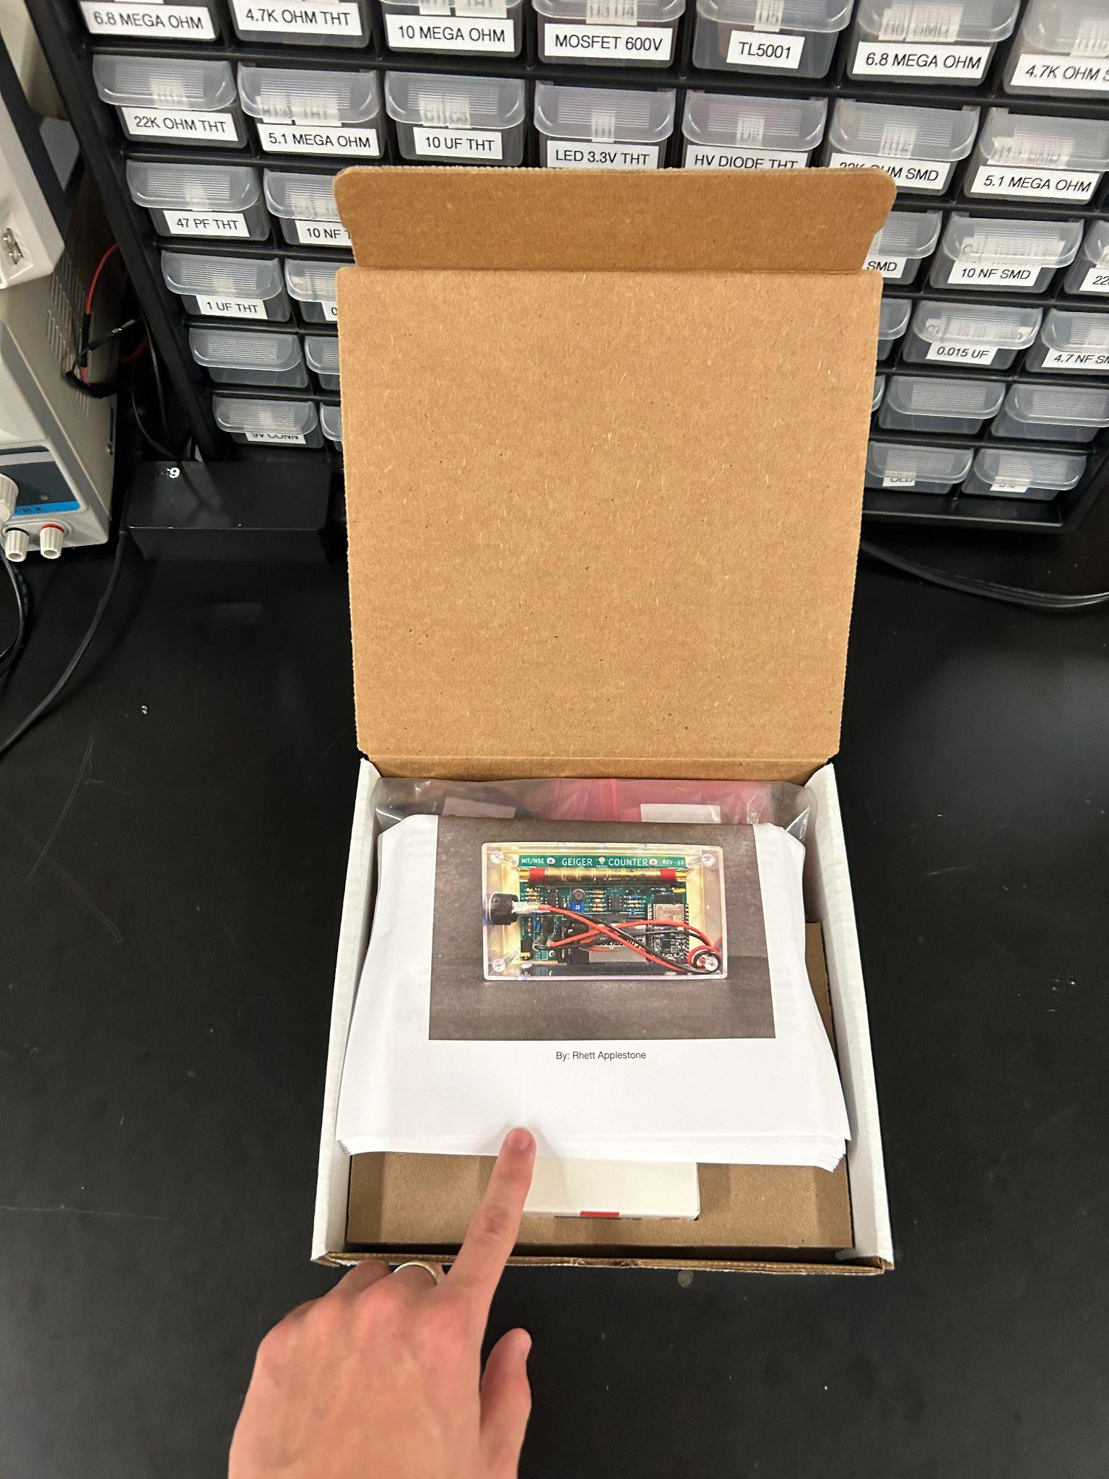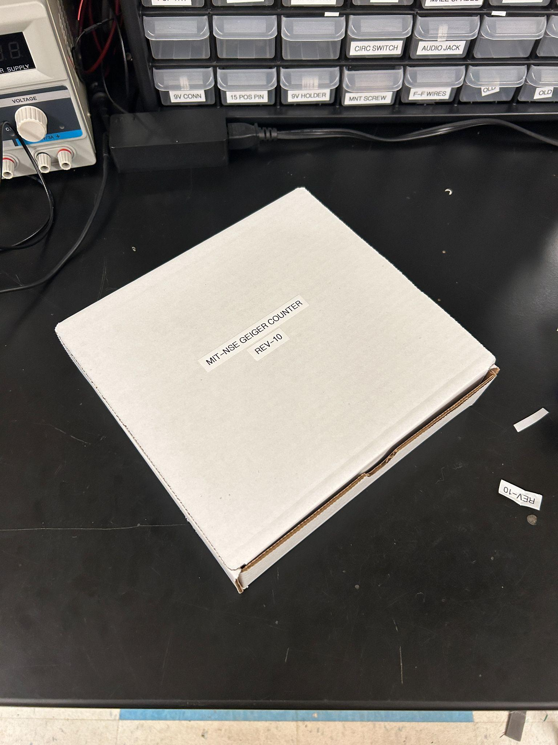

Take the instruction sheet, fold it like so, fold the edges a bit, and put it in the box, (optional, put a nice label on the box)